BIT05

Databases and data management

Introduction

**lecturer:** [cedric.hermans2@howest.be](mailto:cedric.hermans2@howest.be)

**exam:**  theoretical part – 35%

practical part – 65%

**2 types of data**

1. **Structured data**

* You can think of it as an excel file: can be displayed in rows and columns and relational databases.
* Numbers, dates and strings.
* Requires less storage.
* Approx. 20% of data.

1. **Unstructured data**

* The excel file itself is unstructured, when opening it in a word processor would give strange symbols.
* Cannot be displayed in rows, columns and relational databases.
* Images, video, audio, word processing files, e-mails, spreadsheets.
* Requires more storage.
* Approx. 80% of data.

**Database**

* Mechanism (program) to store information.
* Collection of data (numbers, dates, text, ….).
* **Structured** storage of data.
* Allows efficient interaction with data.
* Use CRUD (Create, Read, Update, Delete) commands.
* Used everywhere.

Database system consists of 4 major parts:

1. The users
   1. Require authentication (login to the system) and authorization (which parts can they access)
   2. Administrator has more rights than the end-user
2. Hardware
   1. Consists of a processor and internal memory
   2. Can be a server or a personal laptop
3. Software
   1. Most important part of the software is the Database Management System (DBMS), necessary for:
      1. Data storage
      2. Data retrieval
      3. Data manipulation
4. Data
   1. Must be structured
   2. Have little redundancy
   3. Can be shared or not (single user vs multi-user)

A good database system

* Has sufficient storage capacity.
* Easily accessible (centralized system).
* Secured against non-users (per-user rights). Ensure one users data is protected from other users and non-users.
* Easily maintainable: add, edit and delete data.
* Controlled input: all data in the same format.
* Quick with little redundancy: do not store data twice (application dependable, in some cases it can be useful to have some redundancy. E.g. to speed up queries).
* Has a clear structure.

**Database management system (DBMS)**

* Software application that manages the data.
* Interacts with the user, other applications and the database itself, to capture(retrieve)/ /analyze data.
* Shields users from hardware and storage details.
* Most important software component (but not the only one)
* Used for:
  + data storage,
  + data retrieval,
  + data manipulation and
  + authentication & authorization (who can access the data)

Has 3 levels:

1. Physical level
   1. How/where is the data stored (blocks of storage in memory)
2. Logical level
   1. What data is stored (fields and attributes)
3. View level
   1. User interaction with the database system, what the user actually sees

Types of DBMS:

Structured Query Language systems (SQL): e.g. MySQL, MariaDB, Access, SQLite, ….

No Structured Query Language systems (NoSQL): e.g. mongoDB, Apache CouchDB relax, ….

NewSQL Systems: combine both.

MySQL

**MySQL systems are relational databases:**

→ They have a rigid structure with 2-dimensional tables with rows (records) and columns (fields).

→ They model objects (entities or records) and their relationships

For example

One entity can be the customers with their attributes (name, address, telephone number, etc.)

Another entity can be the products with their attributes (name, price, etc.)

The relationship can then be sales: relation between each customer and what products they are buying with attributes (quantity, timestamp, etc.).

→ In a relational database there are two rules, these are enforced by the Relational Database Management Systems (RDBMS)

1. Constraints on columns

→ to enforce data integrity

e.g. for a specific column it always has to be a certain type of value (integer or string), or for a certain column it has to be an integer and can never be NULL

1. Constraints on relations

→ to enforce referential integrity

e.g. The index used as an ID, has to be a number in all entities and has to be a number for all entities

→ Codd’s 12 rules is a set of thirteen rules (numbered from zero to twelve) that are proposed by Edgar F. Codd and they define how to build up a relational database system

→ MariaDB is a relational db

*(MySQL is from Oracle and uses a different engine, the MariaDB is a more up-to-date version of the classic MySQL)*

**Installing MySQL on your system**

Download from: <https://mariadb.com/downloads/#mariadb_platform>

**Install MariaDB on Fedora:**

$sudo dnf install mariadb mariadb-server

**Start MariaDB:**

$systemctl start mariadb

**Check status:**

$systemctl status mariadb

**Stop mariaDB:**

$systemctl stop mariadb

**Start MariaDB on boot:**

$systemctl enable mariadb

**Is MariaDB running correctly?**

$ps -ef | grep mysql

mysql 6391 1 0 10:14 ? 00:00:00 /usr/libexec/mysqld --basedir=/usr

$sudo netstat -ltpn | grep mysql

tcp6 0 0 :::3306 :::* LISTEN 6391/mysqld

**Configure MariaDB:**

→ Root MariaDB user not the same as the system root user!

$sudo mysql_secure_installation

Switch to unix_socket authentication **n**

Set password for root account y (choose a password)

Remove anonymous-user accounts y

Remove remote root login y

Remove test database y

Reload privilege tables now y

***Password for root = howest2020***

**Extra security settings:**

Prevent any external access to the database server, can be useful when setting up a local, protected database. This will make it so the database can only be accessed from your own laptop:

→ add to **/etc/my.cnf.d/mariadb-server.cnf**

*[mysqld]*

*Bind-address=127.0.0.1*

Restart mariaDB and check:

$systemctl restart mariadb

$sudo netstat -ltpn | grep mysql

tcp 0 0 127.0.0.1:3306 0.0.0.0:* LISTEN 5541/mysqld

**MariaDB**

Database users are not the same as the OS users.

→ when no user specified, OS username is used. If the username is the same for MariaDB you can log in to the db, but does not always work.

→ Superadmin: root@localhost (has all rights on database, including dropping databases)

→ Don’t use root for normal usage!

**Create a new user**

**<- login as root user**

**$mysql -uroot -p**

**mysql**  command; can also be substituted with mariaDB

**-u**  argument: user

**root** name of the user. Can also be with space= -u root. You need root privileges to create a new user.

**-p** argument: password. This will allow you to login using a password, needs to be given after the command

**<-- set username and password -->**

**MariaDB [(none)] > CREATE USER ‘user’@’localhost’ IDENTIFIED BY ‘password’;**

**CREATE USER** the command to create a user (after logging in with root priviliges)

**‘user’@’localhost’** ‘user’: username for the new user (between ‘’)

‘localhost’: system name

**IDENTIFIED BY**  the command to create a password for the user

**‘password’**  the password

**; every command for mariaDB needs to be closed using a semicolon (;)**

***User = guest, password = howest2020***

**<-- User has limited rights. Give users rights to the database -->**

**MariaDB [(none)] > GRANT prv ON db.tbl TO ‘user’@’localhost’;**

**GRANT**  the command to grant rights

**Prv**  which privilege to grant

**ON db.tbl** on which part of the database to grant this privilege. Db is the database; tbl is a table from the database

**TO ‘user’@’localhost’** to which user to grant priviliges

**MariaDB [(none)] > GRANT ALL ON *.* TO ‘guest’@’localhost’;**

→ this will grant ALL rights (full access) to user named guest on all databases (*) and all (*) tables in the databases.

To log out of the database system

**MariaDB [(none)] > exit**

→ or use **ctl + c**

Avoid need to login in the options (configuration) file:

→ **.my.cnf**

→ in the options file you can create a predefined user (user name and login). This will be used by default when logging into the db. This way you don’t have to give a username and pw every time.

→ you need to create this file yourself in the home directory.

**<-- go to the home directory -->**

**$cd**

**<-- create a file named .my.cnf -->**

**$nano .my.cnf**

**In the file put:**

**[client]**

***user=guest***

***password=howest2020***

→ Protect from other users: **$chmod 600**

Important when on a server; prevents other users from seeing your password and user name

→ File contains key-value pairs.

When loging in this file will be checked, so now you do not need to specify the username and pw everytime:

**<-- login to MariaDB -->**

**$mysql**

**SQL = Structured Query Language**

Contains 4 sublanguages:

1. **Data Definition Language (DDL)** statements: everything to do with designing a database (create, alter, drop, …)

CREATE TABLE, DROP DATABASE

1. **Data Manipulation Language (DML)** statements: anything to do with the data itself, manage the data in the database.
   1. **C**reate: add new data
   2. **R**ead: collect data
   3. **U**pdate: alter data
   4. **D**elete: remove data

SELECT, INSERT, UPDATE, DELETE

1. **Data control language (DCL)** statements: manage database rights.

GRANT, REVOKE

1. **Transaction control language (TCL)** statements: manage DML tasks (commit, undo, ….). Mainly used in graphical user interfaces.

**Structure:**

**UPDATE clause SET clause WHERE clause**

UPDATE movies SET rating = rating+1 WHERE name = ‘USA’; **statement**

**expression expression**

**predicate. Predicate predicate**

**Statements**: effect on schema and data, control transactions, connections, ….

Commands that are given, always end with a semicolon (;)

**Queries**: SELECT statement. Retrieve data based on specific criteria.

**Clauses**: components of statements and queries. Keywords (commands themselves).

**Predicates**: conditions or Booleans, used to limit the effect of statements and queries (arguments). What the keyword (clause) acts on.

**Expressions**: produce scalar values, or tables consisting of columns and rows of data.

**Whitespace**: generally ignored, used for readability. Whitespace is necessary between commands, predicates and expressions. However multiple whitespaces will be ignored and can be added as much as you want to improve readability. New lines can be used, as long as the statement is not ended by the semicolon.

**MySQL Monitor**

**Several ways to execute SQL statements using the MySQL monitor:**

Interactively (when logged in):

**$mysql [database] mysql > statement**

From the command line (without login, but still need to provide your credentials):

**$mysql** **[database] -e ‘statement’**

From a file or pipe (stdin):

**$mysql [database]** **< statement_file**

**$cat statement_file** **| mysql [database]**

**Creating a database**

→ only database users with **right privileges** can create databases!

Command line:

**$mysqladmin [opt] create dbname**

**example**

**$mysqladmin -uroot -p CREATE dbname**

**$mysqladmin -uguest -p CREATE dbname**

From within the mysql monitor (after login):

**mysql > create database** dbname

**Import data**

→ insert using statements

→start from an existing sql-file:

**$mysql database < statement_file**

**Exercises**

* As root@localhost, create database ‘biodb’.
* Grant all privileges to the database user you created before.
* Download the 1.sql from Leho and take a look at the contents.
* Use the file to execute the sql statements inside in the biodb databank you just created.

***<-- login to the MariaDB -->***

**$**mysql

***<-- create db called biodb -->***

*MariaDB [(none)]>* create database biodb;

***<-- give all privileges to the database user guest -->***

*MariaDB [(none)]>* GRANT ALL ON biodb.* TO ‘guest’ ;

***<-- to read the 1.sql file into the database biodb, first log out -->***

*MariaDB [(none)]>* exit

***<-- from the command line, make sure you are in the dir where the file is located, or use -->***

***<-- path to the file from the current working directory -->***

**$**mysql biodb < 1.sql

***<-- you can check which databases exist after logging back into the mariaDB -->***

**$**mysql

*MariaDB [(none)]>* **show databases;**

You will see that there are now four databases present: biodb and three others:

information schema

mysql

performance schema

→ these three are automatically generated by the MariaDB and should NOT be deleted. They are necessary for functionality of the system!

***<-- change to the newly created database, with the use dbname command. -->***

***<-- The name in the prompt is changed from none to the name of the database-->***

*MariaDB [(none)]>* **use biodb;**

*MariaDB [(biodb)]>*

<-- check contents (table) with the show tables command -->

*MariaDB [(biodb)]>* **show tables;**

<-- remove contents (table) with the drop tables command -->

*MariaDB [(biodb)]>* **drop table tbl;**

**The hierarchy of a MySQL database:**

* A single MySQL service can have multiple databases:

*mysql >* SHOW databases;

* A database can have multiple tables:

*mysql >* USE db;

*mysql >* SHOW tables;

* A table can have multiple columns/fields:

*mysql >* SHOW columns from tbl;

*mysql >* SHOW CREATE table tbl;

**Relational databases with MySQL**

* MySQL is a collection of tables
  + a table is a set of columns with specific types
    - Number, text, date, ….
    - There always has to be a value (can be NULL)
    - Each column in same format (one type)
    - Only one value per field

e.g. Name can only contains one name, so not Jean Louis, but Jean.Louis

**Column types:**

* Numeric data
  + INT
    - Integer
    - Signed: can be a value from -2 147 483 648 to 2 147 483 647

(Can be negative)

* + - Unsigned: can be a value from 0 to 4 294 967 295 (= 2^32)
    - TINYINT (0 to 2^8)
    - SMALLINT (0 to 2^16)
    - MEDIUMINT (0 to 2^24)
    - BIGINT (0 to 2^64)

→ using different types can be useful to limit disk space to store the values. Values represent bytes.

* FLOAT and DOUBLE
  + Numbers with a decimal point
  + FLOAT = accurate up to 7 digits after the decimal point
  + DOUBLE = accurate up to 15 digits after the decimal point

→ they can have more than 7 or 15 digits after the decimal point, but they won’t be accurate!

* Date and time
  + DATE
    - YYYY-MM-DD
  + TIME
    - HH:MM:SS.ssssss
  + DATETIME
    - YYYY-MM-DD HH:MM:SS
  + TIMESTAMP
    - YYYY-MM-DD HH:MM:SS
    - Values between ‘1970-01-01 00:00:01’ (UTC) and ‘2038-01-19 03:14:07 (UTC)
    - After the final date is reached the values will be reset! Not recommended to use anymore, think Y2K.
    - Uses Unix Time Code (UTC)
  + YEAR
    - YYYY
* Strings
  + CHAR
    - Can be up to 255 characters
    - Has a fixed length, spaces will be added to reach the length of characters that are predefined.

e.g. char(10) means a character of 10, but if you give text of four letters, it will still use space of 10 characters (by adding the white spaces) = not efficient.

CHAR(10)

char(10)

|  |  |  |  |  |  |  |  |  |  |
| --- | --- | --- | --- | --- | --- | --- | --- | --- | --- |
| T | E | X | T |  |  |  |  |  |  |

* + VARCHAR
    - Can be up to 65 535 characters
    - Will only use the space for the actual characters used, plus one extra

e.g. if you provide a word of four letters, it will use five spaces, four for the letters of the word and an extra at the beginning being an integer declaring the size of the word.

VARCHAR(10)

|  |  |  |  |  |
| --- | --- | --- | --- | --- |
| 4 | T | E | X | T |

→ VARCHAR is more efficient, but CHAR is faster for reading. Which one to use depends on what matters the most, disk space or speed.

* + TEXT
    - Up to 65 535 characters
    - Used if text isn’t queried often, is much slower to query!!!
    - Different variations to increase/decrease the length:

TINYTEXT, MEDIUMTEXT, LONGTEXT, JSON (=LONGTEXT)

* + BLOB
    - Up to 65535 bytes
    - Binary data (image, etc.)
    - Cannot be searched
    - TINYBLOB, MEDIUMBLOB, LONGBLOB
  + ENUM
    - Enumeration
    - List with fixed number of possible values
    - Very efficient and fast to search
    - Similar to factors in R
    - Creates two tables, one with the data itself but using indexes and a table with the index keys.

**Constraints:**

**Every row must be unique!**

DBMS needs to be able to distinguish separate rows.

Done by using a primary key

* Column that makes sure every row is unique
* Usually the first column, but doesn’t have to be
* Of type INT
* Often has autoincrement: adds 1 to each new record and can be automatically created. Starts at 1. If there is already data and there are gaps in the data, it will take the largest number and add 1.

Each column has to be of a certain data type, this is another constraint. The type it needs to be is specified by the creator.

Additional requirements can be set per column:

* Primary key
  + 1 PK per table, all values must be unique. Can be a combination of multiple columns. As in the combination of the values in these columns are unique and used as the primary key.
* UNIQUE
  + All values (or combinations) must be unique, but this is not the primary key.
* NOT NULL
  + Field cannot be empty (NULL) when adding data to the table.
* Default
  + Default value for a field, if no data is provided, the default value will be used.
* Foreign key
  + Column used for linking data (reference to another table)
  + Same constrained as the referenced column

**Summary:**

MySQL service → database(s) → table(s) → column(s) → column type and constraints

**Add new rows INSERT**

*MariaDB [(dbname)] >* **INSERT INTO tbl (col1, col2) VALUES (val1, val2) ;**

→ Not all columns need to be included. Unmentioned columns are given the default value for the column, or NULL if no default value is specified!

→ Columns with NO NULL constraint require a value!

→ **Strings are written between quotes.**

**Retrieve rows SELECT**

*MariaDB [(dbname)] >* **SELECT col1, col2 FROM tbl ;**

*MariaDB [(dbname)] >* **SELECT genus, species FROM modorg ;**

*MariaDB [(dbname)] >* **SELECT * FROM tbl ;**

* Columns
  + List of columns separated by a comma.
  + * : wildcard, use to select all columns.
  + You can use arithmetic operators (+, -, *, /, ….) and other functions (min, max, ….) on columns.
  + Not case sensitive
* Table
  + Single table or multiple tables joined together (see later)
  + Can also be a view (see later)
  + Subquery
* Not case sensitive

*MariaDB [(dbname)] >* **SELECT col FROM ( SELECT * FROM tbl ) ;**

**Order or sort by rows ORDER BY or SORT**

*MariaDB [(dbname)] >* **SELECT columns FROM tbl ORDER BY col1 [asc|desc]**

-> **[ ,col2 [asc|desc] ….] ;**

*MariaDB [(dbname)] >* **SELECT Name, Last_name FROM Students ORDER BY Birthday**

-> **desc, Last_name ;**

Here you select Name and Last_name, but sorted by Birthday in descending order and then again sorted by Last_name in ascending order = double sorting.

* When using SELECT: data is displayed in the order of insertion

-> use ORDER BY clause

* ORDER BY colx [asc|desc]
  + colx: columns to sort the data on
  + asc: in ascending order (default, no need to specify)
  + desc: descending order (need to specify)

**Calculated rows**

NUMBERS

* You can add calculated columns in a query using columns from the same row
* Lots of functions and operators are readily available
  + mysql > SELECT 6*7;
  + mysql > SELECT concat(class, “ “, genus) FROM modorg;
  + mysql > SELECT now();

→ returns the current data and time

* operators
  + +, -, /, *, %
* Functions
  + sqrt()
  + power(x, y)
  + exp(x)
  + ln(x)
  + sin(x)
  + cos(x)
  + round(x, n)
  + ceil(x)
  + floor(x)
  + rand(), rand(x)
  + ….
* Full list: <https://mariadb.com/kb/en/numeric-functions/>

STRINGS

* Functions
  + length(s)
  + concat(s1, s2, ….)
  + upper(s), lower(s)
  + trim(s), ltrim(s), rtrim(s)
  + substr(s, ….)
  + reverse(s)
  + truncate(s)
* Full list: <https://mariadb.com/kb/en/string-functions/>

DATES

* Functions
  + currentdate()
  + now()
  + year()
  + month(d)
  + day(d)
  + week(d)
  + dayofmonth(d), dayofweek(d)
  + hour(d)
  + minute(d)
  + second(d)
* Full list: <https://mariadb.com/kb/en/date-time-functions/>

Exercise

Show

* All model organisms full name (as one column): genus + species
* Genome size (as Gb, standard: Mb), rounded to 4 digits
* Average chromosome size
* Publication year

Of all rows sorted by average chromosome size (largest on top)

*MariaDB [(dbname)] > select concat(genus, “ “ , species) as “name”,*

*-> round(gsize/1000, 4) as “gsize (Gb)”,*

*-> round(gsize/nchr, 2) as “avgchr”,*

*-> year(draft) as “year”,*

*-> from modorg*

*-> order by “avgchr” desc;*

**Column aliases**

*MariaDB [(dbname)] >* **SELECT col AS alias FROM …. ;**

* Columns can be renamed using the AS clause and specifying the new name (alias).

The selection you specified is renamed, this name can then be used in further subsets or calculations. Give your calculation a name and then use this name to do further calculations.

* You cannot use . in an alias, e.g. min.gsize doesn’t work, use min_gsize in stead.
* Aliases can be used in the ORDER BY clause
* Can also be used on calculations

SELECT 6*7 AS sum;

* Like creating a subset!

**Filter rows WHERE**

*MariaDB [(dbname)] >* **SELECT col FROM tbl WHERE condition(s) [ORDER BY sortcol] ;**

**Conditions:**

* One or more conditions combined with AND, OR, NOT, XOR;
* Only rows where conditions = TRUE are selected;
* Can’t use aliases!
* WHERE cannot be after ORDER
* NOT case sensitive

**Numerical comparison operators:**

* =
* != or <>
* <, <=, >, >=
* BETWEEN x AND y → (this will include x and y, works on dates)

Example

*MariaDB [biodb] >*SELECT genus, species FROM modorg WHERE nchr > 10;

*MariaDB [biodb] >*SELECT genus, species FROM modorg WHERE nchr BETWEEN 6 AND 20;

**String comparison operators:**

* =
* != or <>
* <, <=, >, >= (lexical)

If you for example want an alphabetical list of words, but only from f to z: >= f

* like “pattern”
  + Matches a pattern
  + _(single character)
  + %(zero or more characters)
* rlike “regex”
  + Matches a regular expression pattern (MySQL specific)

Example

*MariaDB [biodb] >*SELECT genus, species FROM modorg WHERE class = “mammals”;

**Dealing with NULL values**

→ NULL values will by default not be shown, needs to be specified.

* Testing for NULL
  + **SELECT … WHERE col IS NULL;**
  + **SELECT … WHERE col IS NOT NULL;**
* Substitute NULL-values
  + **SELECT ifnull(col, new_value) ….;**
  + This returns:
    - Col if col is NOT NULL
    - New_value of col is NULL
    - It will not change the data in the columns, will be a calculated column

Example

SELECT genus, species**,** ifnull(nchr, 0) FROM modorg;

→ don’t forget to put the comma (,); you are selecting the column together with genus and species in this example

**BOOLEAN logic**

* NOT x

TRUE if x = FALSE

* x AND y

TRUE if x and y are TRUE

* x OR y

TRUE if x is TRUE and/or if y is TRUE

* x XOR y

TRUE of x is TRUE or y is TRUE, but NOT BOTH

Exercise

1. **Select all mammals with genomes published after 2005**

*MariaDB [biodb] >*select * from modorg where class = “mammals” and draft = “2005-01-01”;

<-- also works -->

*MariaDB [biodb] >*select * from modorg where class = “mammals” and draft = “2005”;

<-- also works -->

*MariaDB [biodb] >*select * from modorg where class = “mammals” and year(draft) = 2005;

***→ note that the data also has to be between quotation marks!***

***→ note the from modorg always comes after the select clause.***

1. **Select all organisms that have an average chromosome size between 10 and 100 Mbp**

*MariaDB [biodb] >*select *, round(gsize/nchr, 2) as avgchr from modorg where round(gsize/nchr, 2) between 10 and 100;

→ select *, round(gsize/nchr, 2) as avgchr from modorg

You select all columns, but have to calculate the average chromosome size (gsize/nchr) and round this to 2 digits after the decimal point, is easier to read!

Here an alias is created to show the result for the calculation in a separate column called avgchr

→ where round(gzize/nchr, 2) between 10 and 100;

To select between 10 and 100 Mbp, you have to include the calculation again! The filter will not work on the alias!

→ would also work without the round function, but would not be as exact!

→ but this also includes 10 and 100!

*MariaDB [biodb] >*select *, round(gsize/nchr, 2) as avgchr from modorg where round(gsize/nchr, 2) > 10 and round(gsize, nchr, 2) < 100;

→ here you would not include 10 and 100

→ you have to do the calculation each time!

*MariaDB [biodb] >*select *, round(gsize/nchr, 2) as avgchr from modorg where gsize/nchr > 10 and gsize, nchr < 100;

→ would also be okay!

1. **Select all organisms whose genus starts with A, B, C, D or E**

*MariaDB [biodb] >*select * from modorg where genus between “A” and “F”;

→ if you specify between “A” and “E” than you would not include anything with an E in front.

→ in between “A” and “F” would also include F

→ so NOT the right solution

*MariaDB [biodb] >*select * from modorg where genus < “F” and genus >= “A”;

→ here you will include anything starting with A up to F

→ if you only say where genus < “F”, then you would also include anything smaller than “A”!

*MariaDB [biodb] >*select * from modorg where genus rlike “^[A-E]”;

**→ use regex: ^ means from the start and [A-E] from A to E!**

**Duplicate rows**

* Eliminate duplicate rows

→ each combination of columns id unique

→ DISTINCT() function

*MariaDB [biodb] >* **SELECT DISTINCT (cols) FROM …. ;**

→ you can use distinct on multiple columns but than you do NOT use it as a function but as a keyword, also works for just one column!

*MariaDB [biodb] >* **SELECT DISTINCT col1, col2 FROM …. ;**

→ you can also use distinctrow()

* Limit the number of results to be displayed by n number of rows

*MariaDB [biodb] >* **SELECT** … **LIMIT** n ;

→ you can add OFFSET r to specify r rows to be skipped

*MariaDB [biodb] >* **SELECT** … **LIMIT** n **OFFSET** **r**;

→ result is limited to a maximum of n rows

→ if offset r is given, first r rows are skipped

Exercise

* Give an overview of all (unique) organism classes in the dataset (sorted alphabetically)

*MariaDB [biodb] >* select distinct(class) from modorg order by class;

* Show the organism names of the top 3 largest genome sizes

*MariaDB [biodb] >* select concat (genus, “ “, species) as name from modorg

-> order by gsize desc limit 3;

* Show the organism names of the top 3 smallest genome sizes, not showing NULL values

*MariaDB [biodb] >* select concat (genus, “ “, species) as name from modorg

*-> where gsize is not NULL*

-> order by gsize asc limit 3;

**→ important that where gsize is not NULL comes after the FROM modorg clause**

**Aggregation**

* Queries are concentrated on particular rows
* Possible to calculate a single result across multiple rows e.g. maximum genome size
* SQL allows to
  + Specify criteria to group rows together
  + Calculate a single value per group
  + Filter grouped data
* Functions:
  + count(col), count(*), count(distinct col)
  + sum(col)
  + min(col), max(col)
  + avg(col), stddev(col), var(col)
* **GROUP BY**
  + Sort data into groups for aggregation purposes

**SELECT [col,] aggregatefuntions FROM src [WHERE cond] GROUP BY col [ORDER BY ….] ;**

Example

*MariaDB [biodb] >* **select max(gsize) from modorg where gsize is not null group by class;**

* + All rows with the same value in col are grouped
  + For each group, the aggregate function(s) is/are calculated
  + You can only select the column on which you grouped and calculated columns. You cannot select another column, cause the values from these columns will be grouped, so requires some calculations. You can select them, but won’t make any sense!!!!
  + You can also use keywords acs|desc
* **HAVING clause**
  + Filter results based on the results of the aggregate function(s) using HAVING clause
  + Column aliases can be used in cond2

**SELECT [col, ] aggregatefuntions FROM src [WHERE cond1] GROUP BY col HAVING cond2 [ORDER BY ….] ;**

Exercises

1. ***All these queries return a row count. What is the result and why?***

SELECT count(*) FROM modorg;

Result = 10

→ counts the number of rows in modorg

SELECT count(nchr) FROM modorg;

Result = 9

→ counts the number of rows from nchr, BUT leaves out the NULL values. In this case there is one NULL value in this column

SELECT count(class) FROM modorg;

Result = 10

→ counts the number of rows from class column, here there are no NULL values. So 10 rows

SELECT count(DISTINCT class) FROM modorg;

Result = 6

→ counts only the unique values in the column!

1. ***How many mammals are in the database?***

*MariaDB [biodb] >* select count(class) from modorg where class = “mammals”;

1. **How many organisms are present in the dataset for each class? Note how they are sorted!**

*MariaDB [biodb] >* select class, count(class) from modorg group by class;

→ They are displayed in the same order they appear in the original column, so not alphabetically.

1. **Show the minimum and maximum genome sizes for each class. Take only the organisms into account for which the sizes are known. Sort the results such that the biggest maximum genome size is on top.**

*MariaDB [biodb] >* select class, min(gsize), max(gsize) from modorg

*->* where gsize is not null

*->* group by class

*->* order by max(gsize) desc;

**IMPORTANT: order by max(gsize) NOT gsize as is!!!!!!!!!!!!!!!!!!!**

1. **Show the minimum and maximum genome sizes for each class. Take only the organisms into account for which the sizes are known. Sort the results such that the biggest maximum genome size is on top.**

**=> Show only the results where the minimum genome size >= 100 and maximum genome size < 1000.**

*MariaDB [biodb] >* select class, min(gsize), max(gsize) from modorg

-> where gsize is not null

-> group by class

-> having min(gsize) >= 100 and max(gsize) < 1000

-> order by max(gsize) desc;

**IMPORTANT: order by max(gsize) NOT gsize as is!!!!!!!!!!!!!!!!!!!**

**<-- you can also use aliases! -->**

*MariaDB [biodb] >* select class, min(gsize) as gsize_min, max(gsize) as gsize_max

-> from modorg

-> where gsize is not null

-> group by class

-> having gsize_min >= 100 and gsize_max < 1000

-> order by gsize_max desc;

**OVERVIEW**

SELECT

[ALL | DISTINCT | DISTINCTROW ]

[HIGH_PRIORITY]

[STRAIGHT_JOIN]

[SQL_SMALL_RESULT] [SQL_BIG_RESULT] [SQL_BUFFER_RESULT]

[SQL_CACHE | SQL_NO_CACHE] [SQL_CALC_FOUND_ROWS]

**select_expr** [, **select_expr** ...]

[FROM **table_references**

[WHERE **where_condition**]

[GROUP BY {**col_name** | **expr** | **position**}

[ASC | DESC], ... [WITH ROLLUP]]

[HAVING **where_condition**]

[ORDER BY {**col_name** | **expr** | **position**}

[ASC | DESC], ...]

[LIMIT {[**offset**,] **row_count** | **row_count** OFFSET **offset**}]

[PROCEDURE **procedure_name**(**argument_list**)]

[INTO OUTFILE '**file_name**’

[CHARACTER SET **charset_name**]

**export_options**

| INTO DUMPFILE '**file_name**’

| INTO **var_name** [, **var_name**]]

[FOR UPDATE | LOCK IN SHARE MODE]

INTO OUTFILE ‘file name’

→ can be used to send the output to an output file

**Execution order**

1. FROM – input columns are determined
2. WHERE – input columns are filtered
3. GROUP BY – sorting & grouping of filtered input
4. Aggregation functions are calculated
5. HAVING – aggregation functions are filtered
6. ORDER BY – output is sorted
7. LIMIT/OFFSET – output is chopped

**Exercises**

1. **For each class with more than 1 organism, show the average number of chromosomes.**

*MariaDB [biodb] >* select class, avg(nchr) from modorg

-> where nchr is not NULL

-> group by class

-> having count(class) > 1;

1. **Sort the result such that the biggest average is on top**

*MariaDB [biodb] >* select class, avg(nchr) from modorg

-> where nchr is not NULL

-> group by class

-> having count(class) > 1

-> order by avg(nchr) desc;

*MariaDB [biodb] >* select class, avg(nchr) as avg_nchr from modorg

-> where nchr is not NULL

-> group by class

-> having count(class) > 1

-> order by avg_nchr desc;

→ It is always faster to use aliases, that way you don’t have to count things twice!

→ unless explicitely asked, do not include the where is not NULL statement.

**Database upgrade**

* Download bioinf_testdb.sql from Leho
* Create a new database bioinf_testdb
* Grant your user all rights on the database
* Create the tables and insert the data

**Exercises: Bioinf_testdb**

1. **Find the gene named HOTAIR in the gene table. In addition to the name and chromosomal position, return the size of the gene.**

*MariaDB [bioinf_testdb] >*select gene_name, chromosome, seq_region_start,

-> seq_region_end, seq_region_end – seq_region_start **+ 1** as -> gene_size

*->* from gene where gene_name = “HOTAIR”;

**→ you need to add +1 to be correct!**

1. **Find the known lincRNA that is located the most distal on the p-arm of chromosome 14 (see figure for a hint).**

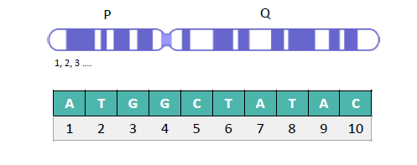

*MariaDB [bioinf_testdb] > select min(seq_region_start), biotype, gene_name*

*-> from gene*

*-> where chromosome = 14 and biotype = “lincRNA”;*

*Answer = AL589183.1*

*Alternative:*

*MariaDB [bioinf_testdb] > select biotype, gene_name*

*-> from gene*

*-> where chromosome = 14 and biotype = “lincRNA”*

*-> order by seq_region_start limit 1;*

1. **Find genes related to prostate cancer (use description field).**

*MariaDB [bioinf_testdb] >* select gene_name, description from gene

*->* where description rlike “prostate cancer”;

**→ NOT A GOOD SOLUTION**

*MariaDB [bioinf_testdb] >* select gene_name, description from gene

*->* where description like “%prostate%cancer%”;

1. **Return a list of genes located on chromosome X in alphabetical order.**

*MariaDB [bioinf_testdb] >* select gene_name from gene where chromosome = “x”

-> order by gene_name asc;

1. **How many occurences does each biotype have in the gene table?**

*MariaDB [bioinf_testdb] >* select biotype, count(*) from gene

-> group by biotype;

*MariaDB [bioinf_testdb] >* select biotype, count(*) from gene

-> group by biotype;

**→ you can just use the asterisk in the count function**

1. **A mutation was found on chromosome 20, position 44002590. Which gene(s) have an overlap with this position?**

*MariaDB [bioinf_testdb] >* select gene_name from gene where chromosome = 20

-> having seq_region_start <= 44002590 and

-> seq_region_end >= 44002590;

*MariaDB [bioinf_testdb] >* select gene_name from gene where chromosome = 20

-> having 44002590 between seq_region_start and

-> seq_region_end;

1. **Which chromosome has the second most genes?**

*MariaDB [bioinf_testdb] >* select chromosome, count(*) from gene

-> group by chromosome

-> order by count(*) desc

-> limit 1 offset 1;

1. **On which chromosome strand lie the most genes?**

*MariaDB [bioinf_testdb] >* select seq_region_strand, count(*) from gene

-> group by seq_region_strand

-> order by count(*) desc

-> limit 1;

1. **What is the most common biotype for novel transcripts?**

*MariaDB [bioinf_testdb] >* select status, biotype, count(*) from transcript

*-> where status = “novel”*

-> group by biotype

-> order count(*) desc limit 1;

1. **For each biotype with more than 10 known transcripts, give the lowest start position and the highest end position.**

*MariaDB [bioinf_testdb] >* select biotype, status, count(*),

*->* min(seq_region_start),

*->* max(seq_region_end) from transcript

-> group by biotype, status

-> having status = “known” and count(*) > 10;

*MariaDB [bioinf_testdb] >* select biotype, status, count(*),

*->* min(seq_region_start),

*->* max(seq_region_end) from transcript

*-> where status = “known”*

-> group by biotype

-> having count(*) > 10 order by count(*) desc;

1. **How many exons have a different end_phase than their current phase?**

*MariaDB [bioinf_testdb] >* select count(*) from exon

*->* where phase != end_phase;

**Recap exercises: Bioinf_testdb**

1. **Return a list of the 3 biotypes with the most genes. Which biotype is a close fourth?**

*MariaDB [bioinf_testdb] >* select biotype, count(*) as gene_number from gene

-> group by biotype order by gene_number desc limit 3;

*MariaDB [bioinf_testdb] >* select biotype, count(*) as gene_number from gene

-> group by biotype order by gene_number desc limit 1, offset 3;

1. **Return a list of the number of genes per status**

*MariaDB [bioinf_testdb] >* select status, count(*) from gene

-> group by status;

1. **Combining the 2 previous results, which biotype is most known?**

*MariaDB [bioinf_testdb] >* select biotype, status, count(*) from gene

-> group by biotype, status having status = “known”

-> order by count(*) desc limit 1;

**→ you can also use where status = “known”, but than you first filter on known before grouping. In this case you do not need to group by status!!!!! This use less computation because you do not have to do the extra grouping and all the calculations!!!!!!!!!!!!!!!!!**

*MariaDB [bioinf_testdb] >* select biotype, count(*) from gene where status = “known”

-> group by biotype

-> order by count(*) desc limit 1;

1. **Select only those biotypes that cover at least 3% of the human genome (hint: ‘size’ from last week, human genome is approx. 3 billion bp) and return this percentage.**

*MariaDB [bioinf_testdb] >* select biotype,

<- sum(seq_region_end – seq_region_start + 1)/3000000000*100 as size from gene

<- group by biotype having size >= 3;

<-- using scientific notation, use the power() function -->

*MariaDB [bioinf_testdb] >* select biotype,

<- sum(seq_region_end – seq_region_start + 1)/(3*power(10, 9))*100 as coverage from <- gene group by biotype having coverage >= 3;

→ this will not give you rounded numbers

<-- using scientific notation, use the power() function -->

*MariaDB [bioinf_testdb] >* select biotype,

<- round(sum(seq_region_end – seq_region_start + 1)/(3*power(10, 9))*100, 2)

<- as coverage from gene group by biotype having coverage >= 3;

**Upgrade database**

* Download 2.sql
* Create a new database biodb2
* Grant rights to your user
* Insert the 2.sql into biodb2

**JOIN**

Expanding a database with additional information, can cause redundant information to be created and can be error prone!

**Solution**: split the table → relational databases with a **Foreign Key (FK)**. The foreign key is a reference to another table!

Here you will have a column in each entity (table) that is the same and will serve as a **linked column**.

→ Linked columns must be equal!

→ The foreign key is typically the primary key of the referenced table (the second table being referenced).

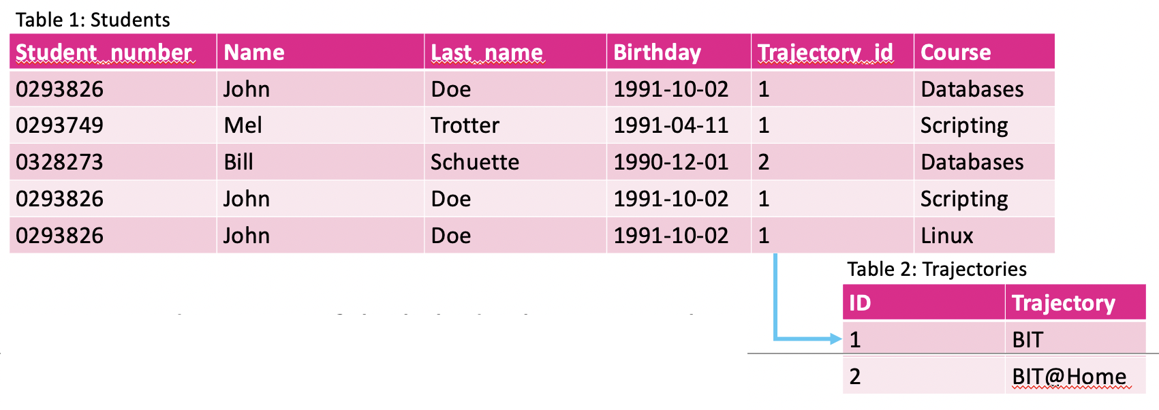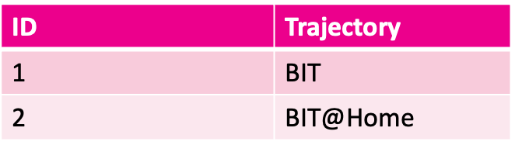

Advantage is that you don’t need as much redundant information in your tables and that you make the database less error prone!

Example: John Doe appears three times in the table. By splitting the tables, you only need to have name, last name, birthday to appear one time, this makes it less likely to for example make a mistake in the spelling of a name in one of the three rows.

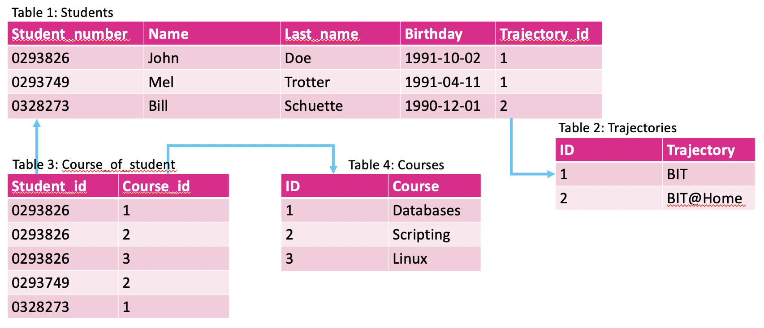

**Database model = Entity Relationship Diagram (ERD)**

→ visualization of how the database looks like, of the relations between the different tables.

→ there are different ways of describing the relationship between the tables:

* **One-to-many relationship (1:n)** = entry from table 1 can only reference one value in two, but entry from table two can have multiple referenced values in table 1

**Example:** Each student from students table can only follow one trajectory (trajectories table), but a trajectory will have multiple students.

* **Many-to-many relationship (n:m)** = entry from table 1 can reference multiple rows from table 2 and vice versa.

This requires a cross-reference table (xref-table); this will be an intermediate table linking the other two together. The reference table will only have 1:n relationships with the 2 tables;

**Example**: Student_number from students table will appear multiple times in the Course_of_student table, but only one time in the Students table (1:n). Course_ID will only appear once in the courses table but multiple times in the Course_of_student table (1:n). Course_of_student is the xref-table. Student from Students table will have multiple course, and multiple courses will have multiple students.

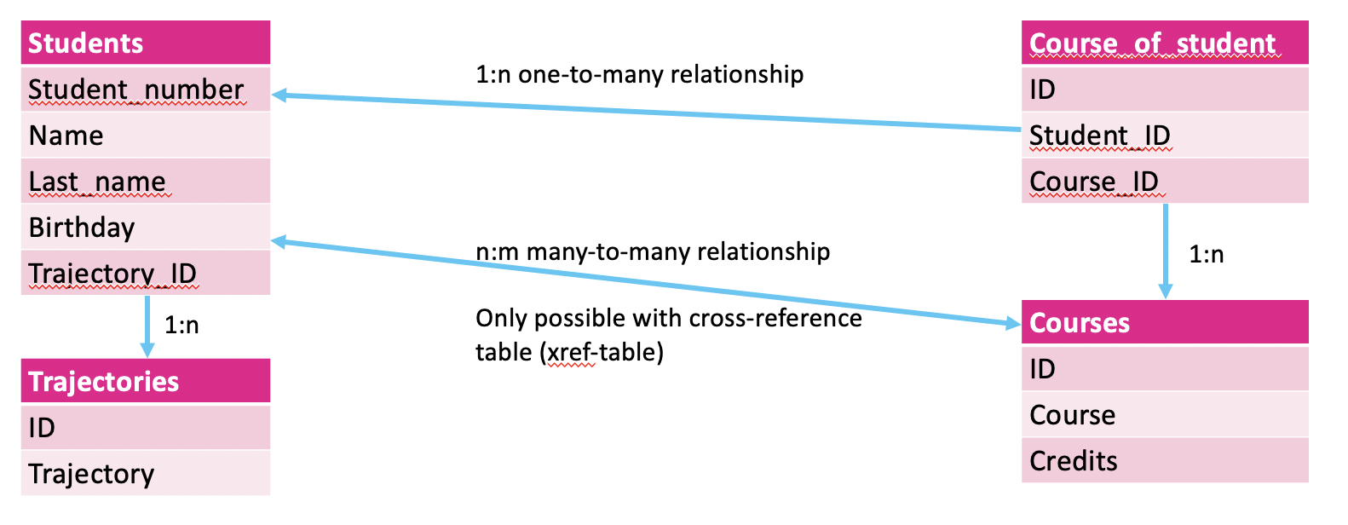

For the relation look for a direct or indirect link between tables. A 1:n will always have a foreign key linking the tables. This foreign key will appear once in one table, but multiple times in the other! A m=n relation will always be indirect, there is no foreign key linking the tables directly, but there is some intermediary linking the two tables.

The information will be spread across different tables. But what the user sees will be different from how data is stored:

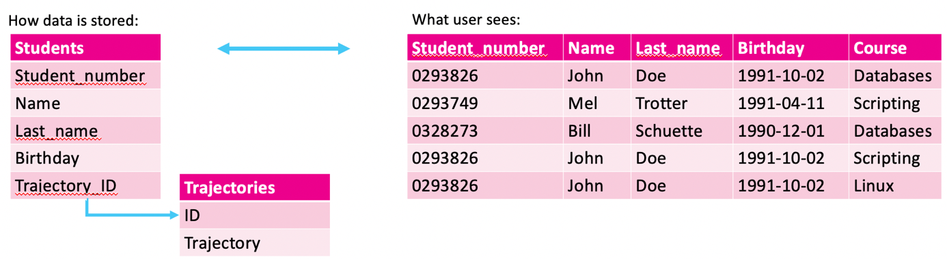

You can create a script that will combine data, but this is not a good idea, since MySQL can join tables using a query (**JOIN clause**):

*mysql >* **SELECT * FROM tbl1**

-> **JOIN tbl2 ON tbl1.col_name = tbl2.col_name;**

**→ tbl.col_name = name of the table and name of the column separated by a dot (.)**

**Note**: in stead of using select col from tbl, you can also in queries use this tbl.col

**For biodb2:**

**table**.*column*

* **modorg**.*class_id* is a foreign key that references **class**.*id*
* **gene**.*mo_id* is a foreign key that references **modorg**.*id*

Multiple tables in a query : database server generates all possible combinations ***= the cartesian product.***

* Table class has 6 rows, table modorg has 10 rows

***mysql >* select * from modorg, class;**

→ will give 60 rows as a result

* You can filter the cartesian product, by specifying the tables:

***mysql >* select * from modorg, class where modorg.class_id = class.id;**

* MySQL provides a more understandable version of this: JOIN

***mysql >* select * from modorg join class on modorg.class_id = class.id;**

* Avoid ambiguity (columns with same name)!id exists in both class and modorg

***mysql >*** **SELECT id, name, genus, species FROM modorg**

**->** **JOIN class ON modorg.class_id = class.id;**

*ERROR 1052 (23000): Column 'id' in field list is ambiguous*

*→ you will always get this error when you have a column that has same name in both tables!!!!*

* **Mention the tables from ambiguous columns**. Optionally: choose an alias.

***mysql >* SELECT modorg.id as modID, name, genus, species FROM modorg**

***->*** **JOIN class ON modorg.class_id = class.id;**

→ to ensure you never have this problem, you can always mention the table names.

* Join table with itself or select data from a subquery. Use alias for data source.

***mysql >* SELECT** **a.col, b.col** **FROM** **src1 [AS] a, src2 [AS] b** **WHERE** **… ;**

**Or**

***mysql >* SELECT** **a.col, b.col FROM** **src1 [AS] a JOIN** **src2 [AS] b ON** **… ;**

→ this makes it easier to keep track of multiple tables in your JOIN query.

Example

*mysql >* select a.id from modorg as b join class as a on b.class_id = a.id;

→ by renaming the sources (modorg and class) as a and b, you can use a and b for the whole query (you have to!!!!!).

**Example**

For each class, give the class name, organism name and date of the organism that was sequenced first.

→ Select minimum draft date for each class

*mysql >* SELECT class_id, min(draft) AS dr FROM modorg GROUP BY class_id;

→ Add class name: join with table class

*mysql >* SELECT class.name AS class, min(draft) AS dr FROM modorg

*->* JOIN class ON class.id=modorg.class_id GROUP BY class_id;

It is important to know that you always first join every table you need before filtering!

For each class, give the class name, organism name and date of the organism that was sequenced first. Add organism name: join with table modorg.

*mysql >* SELECT class.name AS class, concat(genus,” “, species) as organism,

-> min(draft) AS dr FROM modorg

*->* JOIN class ON class.id=modorg.class_id GROUP BY class_id;

**This will NOT give you the correct result: some of the organisms don’t match with the draft dates!!**

*mysql >* SELECT selection.class, concat(modorg.genus,’ ‘,modorg.species) AS organism,

*->* selection.dr FROM

*->* **(SELECT class.name AS class, min(draft) AS dr FROM modorg JOIN class ON**

*->* **class.id=modorg.class_id GROUP BY class_id) as selection**

*->* JOIN modorg on selection.dr = modorg.draft;

**Exercise**

For all rows in table “gene”, show:

* Organism name (genus + species)
* Class name
* Accession number of the gene
* Length of the gene
* Description of the gene

mysql > select class.name as class, selection.organism, selection.acc, selection.descr,

-> selection.len from (**select class_id, acc, descr, len, concat(genus, “ “, species) as**

**-> organism from gene join modorg on gene.mo_id = modorg.id)** as selection join class

-> on class.id = selection.class_id;

**You can just join multiple tables:**

**mysql > select class.name as class, concat(genus, “ “, species) as organism,**

**-> gene.acc, gene.len, gene.descr**

**-> from modorg join class on modorg.class_id = class.id**

**-> join gene on gene.mo_id = modorg.id;**

**4 types of JOIN:**

1. INNER JOIN

→ only rows present in both tables

→ this is the default

***mysql >* SELECT cols FROM tbl1 [INNER] JOIN tbl2 ON tbl1.col = tbl2.col;**

1. LEFT JOIN

→ all rows from left table, even if no matching in right table

→ the order is important!

→ empty cells will be NULL

***mysql >* SELECT cols FROM tbl1 LEFT JOIN tbl2 ON tbl1.col = tbl2.col;**

1. RIGHT JOIN

→ all rows from right table, even if no matching in left table

→ the order is important!

→ empty cells will be NULL

***mysql >* SELECT cols FROM tbl1 RIGHT JOIN tbl2 ON tbl1.col = tbl2.col;**

1. OUTER JOIN

→ all rows from both tables

→ does NOT exist in MySQL, but you can create one by combining a left and right join)

***mysql >* SELECT cols FROM tbl1 LEFT JOIN tbl2 ON tbl1.col = tbl2.col**

***-> UNION***

***->* SELECT cols FROM tbl1 RIGHT JOIN tbl2 ON tbl1.col = tbl2.col;**

**characteristics**

* Join without keyword = INNER join
* * is used for all columns from all tables
* Use tbl.col to specify column (avoid redundancy)
* Very inefficient
  + Takes a lot of memory/time
  + If you don’t need to use a join, don’t!
* Use ON to specify linked columns (foreign key of main table + linked column of joined table, often primary key)

**Execution order**

1. Input columns are determined  
   a. JOIN clause
2. WHERE – input columns are filtered
3. GROUP BY – sorting & grouping of filtered input
4. Aggregation functions are calculated
5. HAVING – aggregation functions are filtered
6. ORDER BY – output is sorted
7. LIMIT/OFFSET – output is chopped

**Exercises (bioinf_testdb)**

1. **Examine the tables of the bioinf_testdb. How are they connected?**

Gene -> gene_id linked to gene_id in transcript table

Transcript -> transcript_id linked to transcript_id in exon_transcript table

Exon -> exon_id linked to exon_id in exon_transcript

Exon_transcript = cross-reference table, links exon and transcript together in a n:m relation.

1. **How many transcripts does the MALAT1 gene have?**

*mysql ->* select gene_name, count(*) from gene

*->* join transcript on gene.gene_id = transcript.gene_id where gene_name = “MALAT1”;

1. **Return the position (chrom, start, end) of the exons of transcript 237999.**

*mysql ->* select transcript.transcript_id, exon.exon_id, gene.chromosome,

-> exon.exon_region_start as start,

-> exon.exon_region_end as end from transcript

-> join exon_transcript on exon_transcript.transcript_id = transcript.transcript_id

-> join gene on gene.gene_id = transcript.gene_id

-> join exon on exon.exon_id = exon_transcript.exon_id

-> where transcript.transcript_id = 237999;

1. **Return the transcripts of the TP53 gene.**

*mysql >* select gene.gene_name, transcript.transcript_id from gene

-> join transcript on gene.gene_id = transcript.gene_id

-> where gene.gene_name = “TP53”;

* + **Expand the previous exercise to show the exons as well.**

*mysql >* select gene.gene_name, transcript.transcript_id, exon_transcript.exon_id from gene

-> join transcript on gene.gene_id = transcript.gene_id

-> join exon_transcript on transcript.transcript_id = exon_transcript.transcript_id

-> where gene.gene_name = “TP53”;

* + **Find the longest spliced transcript of TP53 (taking in account the intron-exon structure = sum of length of exons).**

*mysql >* select gene.gene_name, transcript.transcript_id,

-> sum(exon.seq_region_end – exon.seq_region_start + 1) as transcript_length

-> from gene

-> join transcript on gene.gene_id = transcript.gene_id

-> join exon_transcript on transcript.transcript_id = exon_transcript.transcript_id

-> join exon on exon.exon_id = transcript.exon_id

-> where gene.gene_name = “TP53” group by transcript.transcript_id

-> order by transcript_length desc limit 1;

* + **How many exons does each transcript have?**

*mysql >* select gene.gene_name, transcript.transcript_id, count(exon_transcript.exon_id)

-> from gene

-> join transcript on gene.gene_id = transcript.gene_id

-> join exon_transcript on transcript.transcript_id = exon_transcript.transcript_id

-> where gene.gene_name = “TP53”;

1. **What is the name of the gene associated with transcript 260392?**

*mysql >* select transcript.transcript_id, gene.gene_name from gene

-> join transcript on gene.gene_id = transcript.gene_id

-> where transcript.transcript_id = 260392;

1. **A mutation was found on chromosome 20, position 44002590. Which gene(s) overlap(s) with this position? Only genes with overlapping exons.**

*mysql >* select gene.gene_name, transcript.transcript_id, exon.exon_id,

-> exon.seq_region_start as start, exon.seq_region_end as end

-> from gene join transcript on gene.gene_id = transcript.gene_id

-> join exon_transcript on exon_transcript.transcript.id = transcript.transcript.id

-> join exon on exon.exon_id = exon_transcript.exon_id

-> where chromosome = 20 and

-> 44002590 between exon.seq_region_start and exon.seq_region_end;

1. **Both the gene and the transcript table have a biotype column. Are there transcripts that have a different biotype than the gene? If so, what are the names of the biotypes?**

*mysql >* select **distinct** gene.biotype, transcript.biotype from gene

-> join transcript on gene.gene_id = transcript.gene_id

-> where gene.biotype != transcript.biotype **group by gene.biotype, transcript.biotype**;

1. **Which chromosome hast the most genes? How many?**

*mysql >* select chromosome, count(*) as gene_nr from gene group by chromosome

-> order by gene_nr desc limit 1;

1. **Which exon is the largest in the genome? How many base pairs are there?**

*mysql >* select exon_id, seq_region_end – seq_region_start + 1 as length from exon

-> order by length desc limit 1;

1. **Which transcript has the most exons and how many are there?**

*mysql >* select transcript.transcript_id, count(*) as exon_nr

-> from transcript

-> join exon_transcript on exon_transcript.transcript_id = transcript.transcript_id

-> join exon on exon.exon_id = exon_transcript.exon_id

-> group by transcript.transcript_id

-> order by exon_nr desc limit 1;

**Efficiency and speed**

* Complex queries will
  + Have a large system load
  + Will be slow (slow interface), users have to wait
* Mind choices of column types (text can be stored in different formats for example) and included columns in the query
* Frequently used queries can be sped up
  + Views
  + Indices
  + Allow redundancy

**Views**

**Re-use the same query.** Query will be saved as a special table-like object (virtual table, not an actual table).

Is read-only (in most cases), you cannot write to it.

Speed gains depends on the use case, will not always be faster. Mostly useful for complex queries, using joins, etc. Not necessarily useful for speed gains, but useful when you have to use the same query multiple times and do different calculations on the same query (table).

MySQL and MariaDB:

* Virtual table
* Used to server up data in an orderly fashion

Oracle

* Uses materialized view (result of select query is stored)
* Very efficient

**Create a new view:**

***mysql >* CREATE VIEW viewname AS SELECT … ;**

**Use a view as a table:**

***mysql >* SELECT FROM viewname WHERE … ORDER BY … ;**

**Show the view:**

***mysql >* SHOW TABLES ;**

**Remove a view:**

***mysql >* DROP VIEW viewname ;**

**Exercises**

1. **Create a view named ‘genevw’ from the query of the last exercise on slide 39.**

*mysql > create view genevw as*

*->* select transcript.transcript_id, count(*) as exon_nr

-> from transcript

-> join exon_transcript on exon_transcript.transcript_id = transcript.transcript_id

-> join exon on exon.exon_id = exon_transcript.exon_id

-> group by transcript.transcript_id

-> order by exon_nr;

1. **Select all genes containing hemoglobin in the description and sort the result set by gene length. Store this query as a view.**

*mysql >* create view hemo_ln as

-> select *, seq_region_end – seq_region_start + 1 as length

-> from gene where description like “%hemoglobin%”

-> order by length;

* + **What is the minimum and maximum gene length?**

*mysql >* select min(length), max(length) from hemo_ln;

* + **What is the average gene length?**

*mysql >* select avg(length) from hemo_ln;

* + **What is the standard deviation of the length?**

*mysql >* select std(length) from hemo_ln;

1. **Do the views show up when using:** SHOW TABLES;

**YES!**

**Index**

→ like a primary or foreign key, a sort of tag put on each row of a column.

* Quickly find certain rows.
* Stored separately. In a separate table. Is in essence a foreign key! You will not be able to see this table.
* Golden rule: use indices on columns you will use in your WHERE/JOIN clause.
* Only one index per query is used! You can have multiple indexes in a table, but you can only use one in a query.
* Foreign key
  + Index used to speed up JOIN queries
  + Not essential

***mysql >* CREATE INDEX indexname ON tbl (col) ;**

With index an alphabetical table-like object is created. When doing a query or a join MySQL will first search through the index table for that column and use efficient algorithms to search in alphabetically sorted lists.

**Allow redundancy**

Redundancy can create problems (errors introduced). But a schema with least redundancy is not always the quickest. **Allow redundancy to reduce the number of JOINS required**.

More redundancy will require more storage space. **Always need to weight the need for speed versus the storage capacity limits.**

E.g. in an online store you want real-time reporting of items in stock. Do not want to wait seconds/minutes when you click on a product to see if it is in stock.

**Snowflake (fewer storage space) vs Star (more speed) schema**.

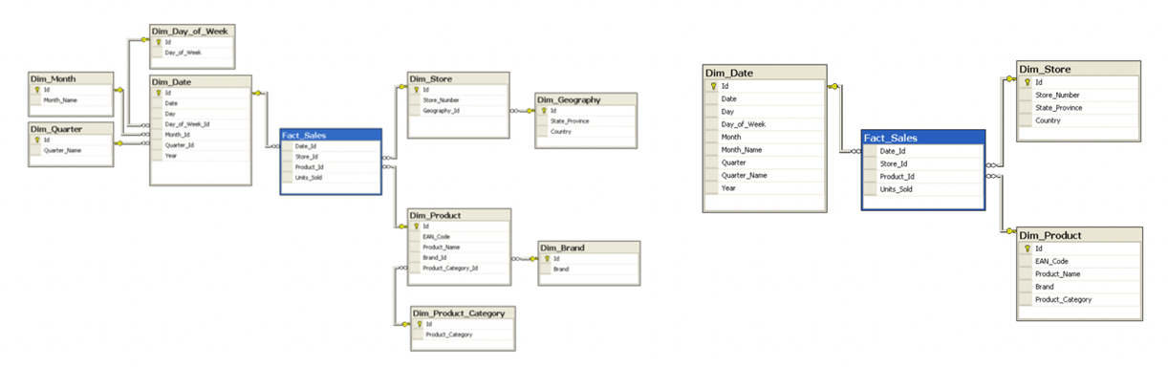

Left is snowflake schema: has a lot more separate tables which will require a lot more joins (each link is a join) necessary to obtain the entire database. But here you will have less redundancy (some redundancy will always be required to have the ids necessary for linking all the tables together).

|  |  |  |
| --- | --- | --- |
|  | Snowflake | Star |
| Redundancy | No/limited redundancy | A lot of redundancy |
| Maintenance | Easy to maintain/change | Harder to maintain/change (all redundant data needs to be changed) |
| Queries | Complex queries | Easier queries |
| Speed | Slower (more JOINS) | Faster |
| Space efficiency | More efficient (less space) | Less efficient (data is stored more than once) |

Right is the star schema: has fewer tables, but a lot more redundancy in each and between each table. Will be much faster, but requires more storage space.

Most of the time a database is a mix of both, for some tables you can give a lot of redundancy (when you want to query this a lot), but others can be less redundant.

**Each schema has two types of tables:**

* Fact tables: numerical data, indexes, millions of data points
* Dimension tables: attributes of facts, redundancy is allowed (Fact_Sales)

**→ links the others together!**

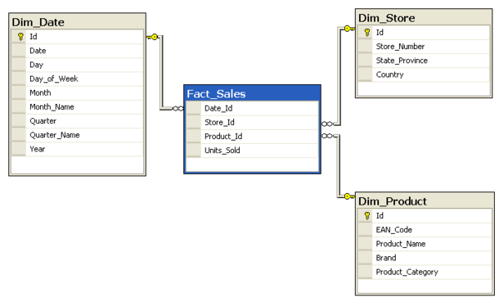

**Database backups**

Dump an entire database to a text file (.sql) from the command line:

**$ mysqldump [opt] db > db.sql**

**[opt]** can be **-u *username* -p**, but not necessary when you have ***.my.cnf*** file with login and pw

Includes:

* Statements for creating the database if the option --databases is used.

→ will include the create databases statements, but when trying to recreate the db you will need to do this from an account that has the correct priviliges!

* Statements for creating tables, views, etc.
* Statements for inserting data

Restore a database (may need to be created first):

**$ mysql db < db.sql**

**Exercises**

1. **Create a dump file for the biodb2.**

**$** mysqldump biodb2 > biodb2.sql

1. **Check the contents of the file.**

Note: /* comment */ will not be executed!

1. **Drop biodb2 database.**

**$**mysql

*MariaDB >* drop database biodb2;

1. **Recreate the database with the dump file.**

*MariaDB >* create database biodb2;

*MariaDB >* exit

**$** mysql biodb2 < biodb2.sql

MySQL workbench

**MySQL monitor (now MaxScale 2.2)**

* Server monitoring (e.g. when database goes down: send an email).
* For advanced users.

**GUI**

* HeidiSQL
* MySQL workbench

**$ sudo dnf install mysql-workbench-community**

**OR**

**$ wget**[**https://dev.mysql.com/get/Downloads/MySQLGUITools/mysql-workbench-community-8.0.23-1.fc33.x86_64.rpm*(Links to an external site.)***](https://dev.mysql.com/get/Downloads/MySQLGUITools/mysql-workbench-community-8.0.23-1.fc33.x86_64.rpm (Links%20to%20an%20external%20site.))

**$sudo dnf install mysql-workbench-*.rpm**

**Start the GUI with:**

**$mysql-workbench**

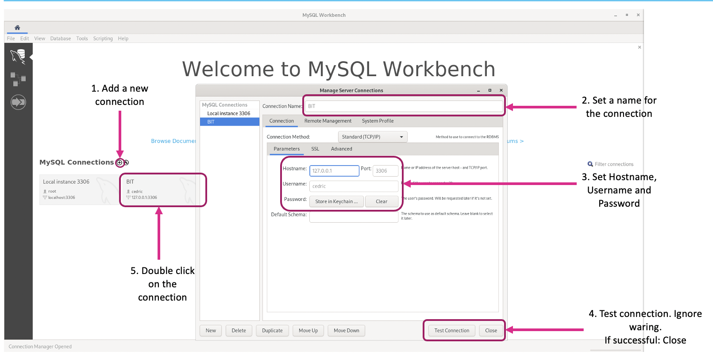

First create a connection: click on the + sign next to MySQL connections (1), set a name (2) and set a Hostname (can be left as default: 127.0.0.1; if it does not work use Localhost), Username (guest) and Password (howest2020) (3). Test connection (4).

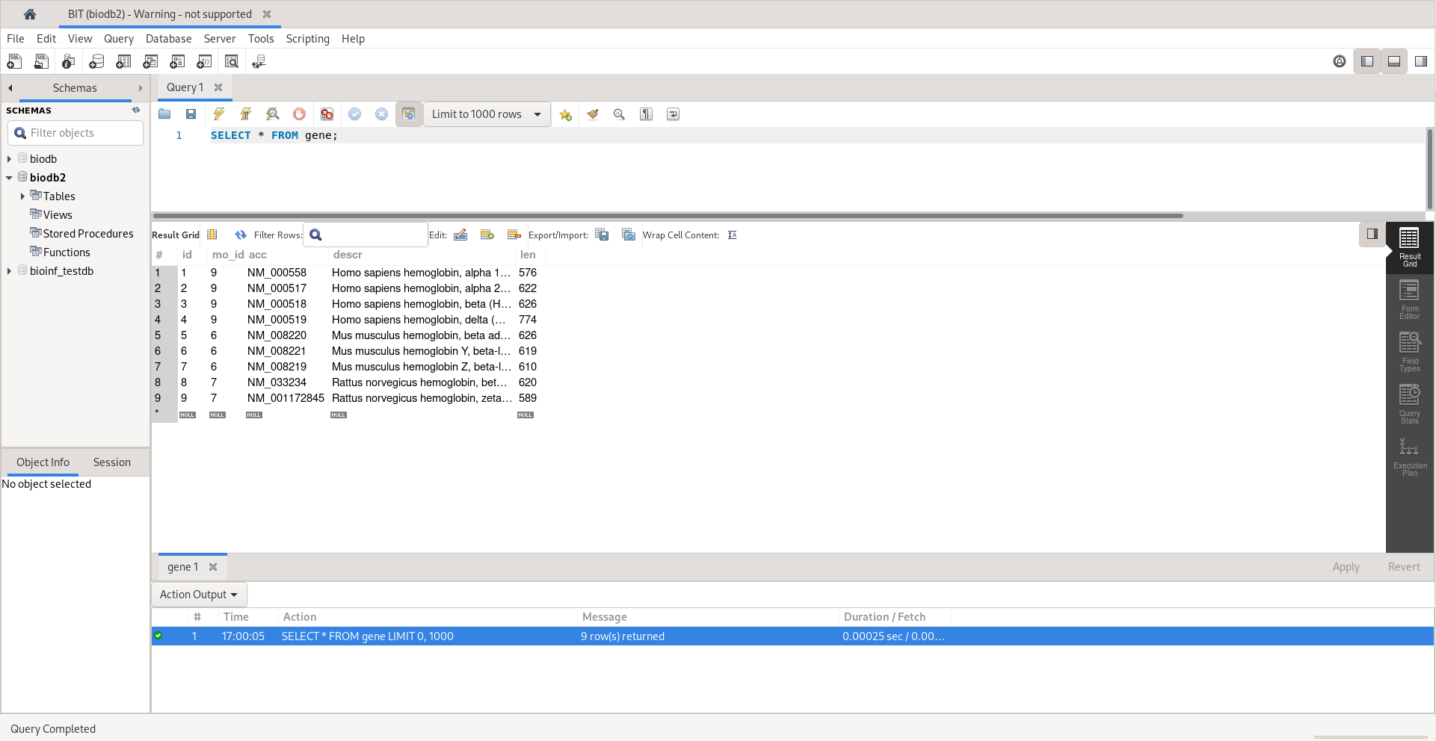

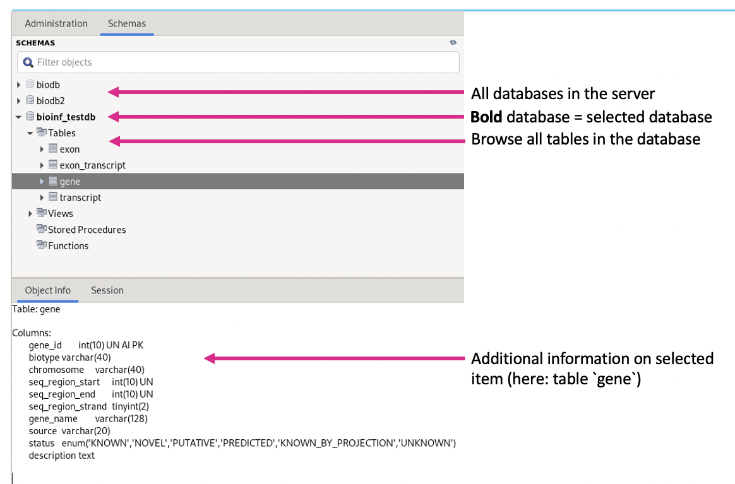

Use the same commands as on the command line!

Use **ctl + enter** to execute a command!

**Creating databases/tables.**

Use the “model” interface in MySQL workbench.

Click on the home button (1). Click in the left on the models button (2). Click on the + sign to create a new model (3).

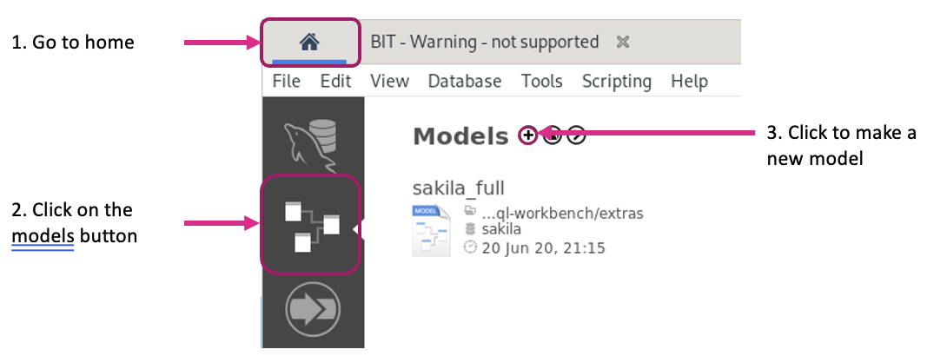

DDL statements will be automatically generated. Tables can be placed anywhere and dragged around. Foreign keys will be displayed as lines and arrows.

On the next screen double click on ***Add diagram***. A diagram is a visual representation of your database. By double clicking the database name on the left you get a menu that allows you to change the name of the database.

In the grid you can start building the database by adding items. Double click on the items to select and click in the grid to place. You can apply template by selecting them.

Double click on the item to set name, restrictions, etc. by using the different tabs:

* **Table**: give the table a name, leave other setting at default.
* **Columns**:
  + Double click on **Column Name** to add a column and give it a name.
  + Select a **Datatype**.
  + And add restrictions:
    - PK = Primary Key (first column you make will be by default the primary key, but can be unchecked).
    - NN = Not NULL
    - UQ = unique values
    - BIN = Binary
    - UN = Unsigned
    - ZF = Zero Fill
    - AI = Auto-increment
    - G = Generated
* For every next column the default datatype will be VARCHAR(45).

**Note:** Primary Key will always be unique and not null and maybe auto-increment

When you have multiple tables you will need to link them together to be able to JOIN them.

* **Foreign Keys tab** 
  + Foreign Key Name: give the key a name that describes the link in an obvious way.
  + Referenced table: to which table will it be linked
  + Foreign Key Columns: column from the current table that will be linked

**Note:** the 2 columns always need to be of the same type!

* + Referenced Column: column in the reference table to which the previous column should be linked. By default the program chooses the primary key from this table. Change if necessary.

**Note:** a dotted line will appear between the two tables that are linked. By hovering over the line you will highlight the columns that are linked.

**Alternatively**, you can just select the icon in the left with the relationship (dotted line, with 1:n, etc.) and place it between two tables. **First click on the table with the many and then the table with the one relationships**. This will automatically create a column with indexes in the correct data type, constraints, etc. in the initial table (where the foreign key needs to be). So you do not need to create it yourself. The **arrow points from many to one!**

**Note:** you don’t need to use the solid lines. Only the dashed line.

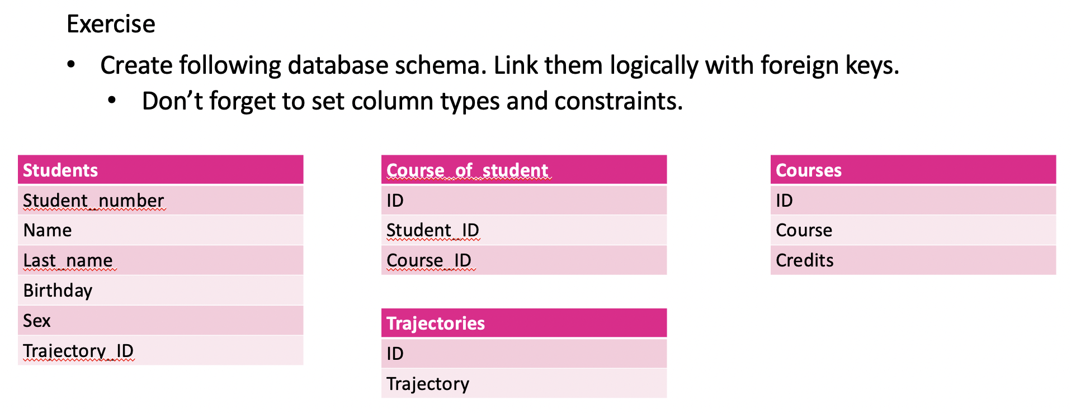

**Start from home > models > + (new model)**

**Students**

Student_number = INT → PK, NN, UQ, UN, AI

Name = VARCHAR(45) → NN

Last_name = VARCHAR(45) → NN

Birthday = DATE

Sex = ENUM(“M”, “F”, “X”)

Trajectory_ID = INT → NN, UQ

**Note:** to make a column type ENUM(), you always have to specify the options between the brackets, use quotation marks (“ “).

**Course_of_student**

ID = INT → PK, NN, UQ, UN, AI

Student_ID = INT → NN, UQ

Course_ID = INT → NN, UQ

**Note:** this is a cross-reference table

**Trajectories**

ID = INT → PK, NN, UQ, AI

Trajectory = VARCHAR(45) → NN

**Courses**

ID = INT → PK, NN, UQ, AI

Course = VARCHAR(45) → NN

Credits = INT

**Important is that the primary keys are defined and have the correct restraints: PK, NN, UQ, UN, AI**

The other constraints are (in this exercise) optional, as in not asked for in the exercise.

**Foreign keys**

**Students.Trajectory_ID** references **Trajectories.ID** in a one-to-many relation: one student can have one trajectory, but a trajectory can have multiple students. Mind the direction!!!!! The **foreign key is created in the Students table!**

When using the arrows to create this, pick 1:n and first click on Students and then on Trajectories. Do NOT create the column Trajectory_ID in the Students table when doing this, this will be automatically generated!!!!!!!

Students.Trajectory will link via a cross-reference table (Course_of_student) to Courses in a **many-to-many relation**. The easiest way to do this is to just select the n:m arrow and connect the two tables, this way the cross-reference table will be automatically generated!!!!!!!!!!!!!

You can then change the name and add the PK to the Course_of_student table.

Or you can generate the table and create a one-to-many relation between **Students**.**Student_number** and **Course_of_student**.**Student_ID**. Foreign key in the Course_of_students table. And a one-to-many relation between the **Course_of_student**.**Course_ID** and **Courses**.**ID**, with a Foreign key in the Course_of_student table.

**Note:** you can insert data into the database using the Inserts tab in each table. Insert the data and press: ***apply changes***

**Forward engineering**

After creating the model (e.g. the exercise above) you can make the model into an actual database.

Generates SQL code to create/modify a database based on your model.

**Important**: always change the name of the database before forward engineering.

→ When creating the model, on the left in the navigator click on mydb (default name) and change to an appropriate name!

Database > Forward Engineer

* Select database connection (stored connection)

→ select how you are logged in: guest or root. Always ensure you use an account that has sufficient rights to create a database!!

→ click next

* Change options if needed

→ several options you can choose from

→ If you already created (inserted) data beforehand you have to check:

***Generate INSERT statements for tables***

To have the data included when the db is created.

→ most of the time just leave as is

→ click next

* Choose what you want to export

→ Export MySQL Table Objects (default)

→ You can also include Views if you created them beforehand.

→ You can also include triggers (e.g. send an email if someone new is added, etc.)

→ Click next

* Here you can see the code that will be created.

→ you can also save the code to a file (Save to File …)

→ Or copy to clipboard (Copy to Clipboard)

→ Click next

* Now the code will be executed.

→ errors can occur, will be shown in the Message Log:

e.g. duplicate columns means there are columns that have the same name.

→ you will need to fix any errors that occur and try to forward engineer until executed correctly

**Note**: errors often occur because of poorly defined constraints of foreign keys in your tables. Always ensure that the foreign key and your referenced column have the same type and constraints!

**Important**: MySQL version 8.0 will by default add VISIBLE and UNVISIBLE tags to the code, but MariaDB does NOT use this. This will result in an error of type: SYNTAX problem. This is because the MariaDB does NOT recognize the syntax of these tags. This can be fixed by changing the Default Target MySQL to an earlier version:

***Edit > Preferences > Modeling > MySQL > Default Target MySQL Version > 5.7***

You can add data to the database from the MySQL Monitor. Select the database and select * from a table. In the Viewer you can now just add data. Click apply to apply the data to the table.

A better way is to import data from a file: click on the icon ***Import records from an external file***

→ You can import from an Excel, .CSV, .JSON, etc.

**Reverse engineer**

Create an EER (Enhanced Entity-Relationship) from an existing database.

Database > Reverse Engineer

* Select a connection
* Select a schema you would like to create an EER from
* Select the objects you would like to include
* Execute

**Exporting data**

* Full database: from command line

**$mysqldump [option] db > db.sql**

* Useful to make a backup of your database.
* You can also make a selection from you database and export the result in different formats: JSON, CSV, Excel, HTML, XML, ….

You can do this directly from the MySQL Workbench.

→ click on icon ***Export recordset to an external file***

**Import data**

* Import dump file from command line

**$mysql database < file.sql**

* Import data from file: click on the icon ***Import records from an external file***

→ You can import from an Excel, .CSV, .JSON, etc.

**Exercise**

1. **Export the data in from one of the tables from the previous exercise**
2. **Empty the table (Right click the table in the schema panel: Truncate Table…)**
3. **Import the exported data in the table**

MySQL and other programming languages

**PHP**

* MySQLi extension
  + Works only with MySQL based systems (including MariaDB)
  + Options for procedural and object-oriented queries

$sudo dnf install php-mysqli

* PDO (PHP data objects)
  + Works with 11 different SQL based systems
  + Only object oriented

**Connecting to a database**

→ create a file: mysql_connect.php containing the following php code:

**<?php**

**$servername= "localhost";**

**$username="username";**

**$password = "password";**

**$conn=mysqli_connect($servername,$username,$password [,$database]);**

**?>**

username = guest

password = howest2020

[ ,$database] = optional, here you can specify a database name, this allows you to directly connect to a database without have to use the USE command.

→ execute the script using php:

**$php -f mysql_connect.php**

→ or by running a local webserver:

**$php -S localhost:8888**

**Checking the connection**

**<?php**

**if (!$conn) {**

**die("Connection failed: ".mysqli_connect_error());**

**}**

**echo "Connected successfully\n";**

**?>**

Add this code to the previous script!

**note:** $conn is the variable into which the connection is stored in the mysql_connect.php file!

**Performing a query**

**<?php**

**$sql = "SELECT * FROM biodb2.class";**

**$result = mysqli_query($conn,$sql);**

*# check if there is a result: num_rows is number of results, if there are results*

*# (num_rows >0 then you can loop through the results and print them to the*

*#screen*

**$num_rows=mysqli_num_rows($result);**

**if($num_rows>0) {**

**while($row = mysqli_fetch_assoc($result)) {**

**foreach ($row as $key => $value) {**

**echo $key.": ".$value."\t";**

**}**

**echo "\n";**

**}**

**}**

**?>**

**Note:**

**$sql = "SELECT * FROM biodb2.class";**

When you specify the database in the mysql_connect.php file, you can just use **“SELECT * FROM class”;**

**Note:**

**Alternatively you can access the values by key:**

**echo “ID: “.row[“id”].”\tName: ”.row[“name”];**

**Insert data into a database**

**<?php**

**$sql = “INSERT INTO MyGuests (firstname, lastname, email) VALUES (‘John’, ‘Doe’,’john@example.com’)”;**

#this will check and echo the last id that has been inserted, or give an error if

# the insertion didn’t succeed

**If (mysqli_query($conn,$sql)) {**

**$id = mysqli_insert_id($conn);**

**echo “New record created successfully inserted. ID is: “.$id;**

**} else {**

**echo “Error: “. $sql . “\n” . mysqli_error($conn);**

**}**

**?>**

**Prepared statements**

→ necessary to keep the database secure. The previous way of inserting data can be misused via MySQL injection attacks. Here a user can insert data, e.g. a name as:

Robert\’\)\; DROP TABLE Students\;

The bracket will close the function with the semicolon using the backslash excapes. What comes after this will be executed as code: DROP TABLE Students\; leading te deletion of the whole table from the database!

→ using a prepared statement instead can prevent this from happening. This is especially important when you have a publicly available database!

→ Prepared statements will escape special characters (the backslash, brackets and semicolons). In the example above the name of the child would literally be :

“Robert’;DROP TABLE students;

→ You need to first initialize a prepared statement with the mysql initializer function: **mysqli_stmt_init()**

→ After you are done the script needs to close the connection using the **mysqli_close()** function!

→ you prepare the statement itself in between using the **mysqli_stmt_prepare($stmt, “statement”)** function!

**<?php**

**$stmt = mysqli_stmt_init($conn);**

#prepare the statement: the values are given with three question marks

#indicating that the values will be given later in the bind function!

**mysqli_stmt_prepare($stmt,“INSERT INTO MyGuests (firstname, lastname, email) VALUES (?,?,?)”);**

#the mysqli_stmt_bind() function will add the values to the original statement

**mysqli_stmt_bind($stmt,”sss”,$firstname,$lastname,$email);**

**$firstname=“John”;**

**$lastname=“Doe”;**

**$email=“john@example.com”;**

#execute the statement using the mysqli_stmt_execute() function and echo #success!

**mysqli_stmt_execute($stmt);**

**Echo “New record created successfully!”;**

**mysqli_stmt_close($stmt);**

#never forget to close the connection!!!!!!

**mysqli_close($conn)**

**?>**

**For the mysqli_stmt_bind() function:**

* The variables (in this example $firstname, $lastname and $email) can be defined before the bind function. Or after, this allows you to create a loop where you can provide multiple records at once!
* These variables could also be obtained for example via a $_POST or $_GET .
* “sss” is necessary to specify which variable type each variable has. S is string, I is integer. Change accordingly!

**PHP – Connect, Query, Insert – Object Oriented**

**<?php**

**$conn = new mysqli($servername, $username, $password);**

**$sql = "CREATE DATABASE myDB";**

**$conn -> query($sql);**

**$sql = "INSERT INTO MyGuests (firstname, lastname, email) VALUES ('John', 'Doe', 'john@example.com’)”;**

**if ($conn->query($sql) === TRUE) {**

**$last_id = $conn->insert_id;**

**echo "New record created successfully. Last inserted ID is: " . $last_id;**

**}**

**?>**

**PHP – Insert – Object Oriented – Prepared**

**<?php**

**$stmt = $conn->prepare("INSERT INTO MyGuests (firstname, lastname, email) VALUES (?, ?, ?)");**

**$stmt->bind_param("sss", $firstname, $lastname, $email);**

**$firstname = "John";**

**$lastname = "Doe";**

**$email = "john@example.com";**

**$stmt->execute();**

**echo "New records created successfully";**

**$stmt->close();**

**$conn->close();**

**?>**

**Exercises**

1. **Make a php script or webpage that shows the class name, genus and species of every organism in the biodb2 database**

<?php

*#connect to the database*

$servername = “localhost”;

$username = “guest”;

$password = “howest2020”;

$conn = mysqli_connect($servername, $username, $password, “biodb2”);

*#check the connection*

If (!$conn) {

die(“Connection failed: “ . mysqli_connect_error());

}

echo “Connected successfully\n”;

#perform the query

$sql = “select class.name, modorg.genus, modorg.species from class join modorg on class.id = modorg.class_id”;

$result = mysqli_query($conn, $sql);

#echo the result to the terminal

$num_rows = mysqli_num_rows($result);

If ($num_rows > 0) {

while ($row = mysqli_fetch_assoc($result)) {

foreach ($row as $key => $value) {

echo $key . “: “ . $value . “\t”;

}

echo “\n”;

}

}

#close the connection

mysqli_close($conn);

1. **Optionally: make a php webpage that shows the class name, genus and species of every organism in the biodb2 database, but you can filter on class name through a select box**

<?php

*#connect to the database*

$servername = “localhost”;

$username = “guest”;

$password = “howest2020”;

$conn = mysqli_connect($servername, $username, $password, “biodb2”);

*#check the connection*

If (!$conn) {

die(“Connection failed: “ . mysqli_connect_error());

}

echo “Connected successfully<br><br>”;

#perform the query

$sql = “select class.name, modorg.genus, modorg.species from class join modorg on class.id = modorg.class_id”;

$result = mysqli_query($conn, $sql);

#echo the result to the terminal

$num_rows = mysqli_num_rows($result);

If ($num_rows > 0) {

while ($row = mysqli_fetch_assoc($result)) {

foreach ($row as $key => $value) {

echo $key . “: “ . $value . “\t”;

}

echo “<br>”;

}

}

#close the connection

mysqli_close($conn);

**MySQL and other programming languages**

**phpMyAdmin**

* Database written in php
* Supports most MySQL features
* Import data from CSV and SQL files
* Export data to CSV, SQL, XML, PDF, IOS/IEC 26300 etc.

Works and looks similar to MySQL, but is written in php. Is basically an interface in your webbrowser that links to your database(s).

$ sudo dnf install phpMyAdmin => install phpMyAdmin

**$ systemctl start httpd => run apache webserver**

(if not installed: sudo dnf install httpd)

**$ firefox localhost/phpMyAdmin => or surf to “localhost/phpMyAdmin”**

**→ you get a login screen in firefox: use guest and howest2020 to login**

**→ use the SQL tab to perform queries.**

**Python**

* mysql.connector

import mysql.connector

cnx = mysql.connector.connect(user='username', database='myDD')

cursor = cnx.cursor()

query = ("SELECT id, firstname, lastname FROM MyGuests")

cursor.execute(query)

cursor.close()

cnx.close()

→ you open a connection with cnx = and close with cnx.close().

→ first create a cursor with cnx.cursor(), create a query with query = …. Execute with cursor.execut(query) and close the cursor with cursor.close().

* MySQLdb

import MySQLdb

db =

MySQLdb.connect(host="localhost",user=”username",passwd=”password",db=”myDB”)

cur = db.cursor()

cur.execute("SELECT id, firstname, lastname FROM MyGuests")

db.close()

**Install**

* mysql.connector

$pip install --user mysql.connector

* MySQLdb

$sudo dnf install python-devel mysql-devel

$pip install --user mysqlclient

**Execute a script**

$python script.py

NORMALIZATION

**Data model**

Determines the structure of the data. Created in different steps.

* Conceptual data model
  + Structure of entities and the relationships between them
  + The actual data that will be in your database without any further specifications
  + No attributes or primary keys are specified

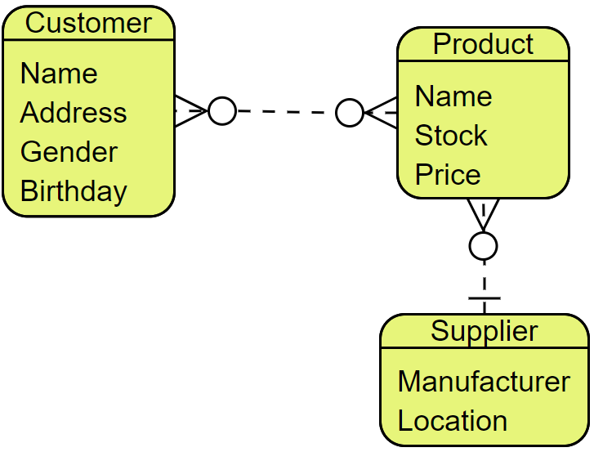

* Logical data model
  + Attributes and primary key for each entity
  + Constraints can be added
  + Foreign keys are specified
  + Normalization is performed

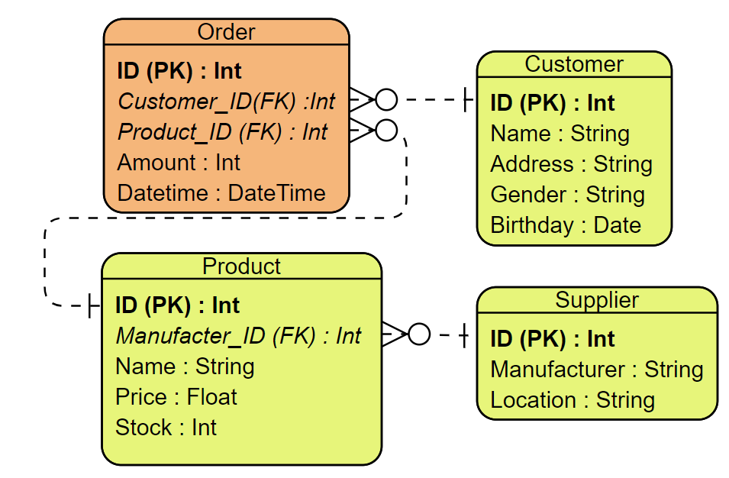

* Physical data model
  + Data types are fully specified in this step. In the previous step types are sort of determined e.g string or integer, but here you further deepen this e.g. varchar(45) or tinyint(10)
  + Blueprint of the database (based on the DBMS you use), this will be the final model of how your database will look like before you forward engineer
  + Physical means by which data is stored (partitions, CPU, ….) are determined.

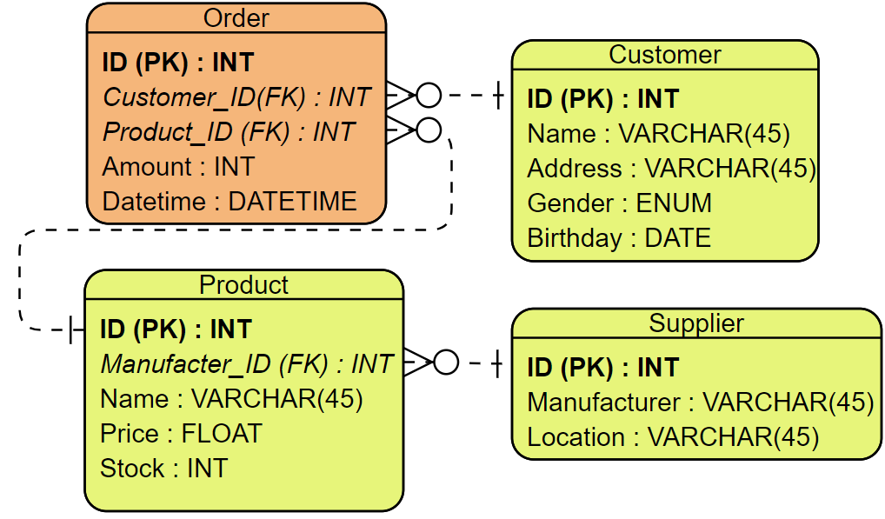

**Database model**

Not the same as the data model. Data model defines how our database is organized, what type of data it contains, etc. The database model is our database itself. E.g. MySQL or NoSQL.

**Types of database models**

* Flat Model
  + Single two-dimensional array of data elements
  + E.g. spreadsheet
  + No relations
* Hierarchical Model
  + Data is organized in a tree-like structure
  + Records are connected through links
  + E.g. files on a computer
  + One parent, multiple children
* Network Database Model
  + Similar to the hierarchical model
  + Multiple parents, multiple children
* Relational Database Model
  + Tables are relations
  + Any table related to any other table based on one field of that table (=key)
  + MySQL and other deviations
* Object-relational Model
  + Relational model with object-oriented features
  + PostgreSQL
  + Mix of relational database model and object oriented model
* Object Oriented Model
  + Data is represented in the form of objects
  + Usage like object-oriented programming language
* Document-oriented Database
  + Entities are stored in documents
  + XML, YAML, JSON, BSON
  + E.g. MongoDB
  + NoSQL
  + Objects don’t need to have every attribute

**Normalization**

Organizing columns and tables.

* Reduce redundancy
* Less error prone
* Improve integrity

Normal forms of data

* UNF
* 1NF
* 2NF
* 3NF
* BCNF
* ….
* 6NF

**UNF – unnormalized form**

This will be the first stage of your data. This will be unstructured, can still contain empty fields and repeating groups.

***Rules:***

* Unstructured data
* Repeating groups

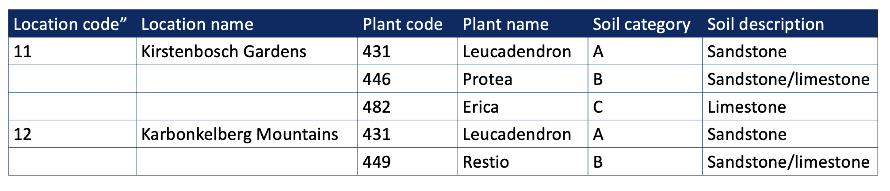

In this example the location code and location name are not yet filled in everywhere. Here the location code and name is duplicated for all underneath that are not filled in. So to be able to enter this in a database you would first need to fill in the empty rows (copy from above)? Another thing is that there will be lots of redundancy, e.g. for soil description you will have a lot of repeats of the same data over and over again.

You can write down the structure of your database as follows:

**DB(Location code, Location name, [(Plant code, Plant name, Soil category, Soil description),(Plant code, …),…])**

DB is some databasename. Folowed by the composition. Here you will have location code and location name and then a list for each plant in this location as specified between brackets containing the plant code, plant name, soil category and soil description.

So step 1 in obtaining the normalized database is to fill in all empty (missing) values and have no repeating groups. The repeating groups here are the location code and name. As in for each code and name there follows a list of plants.

**1NF – 1st Normal Form**

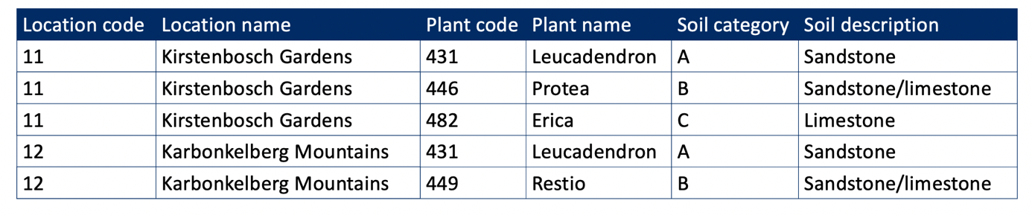

***Rules:***

* There are no repeating groups.
* All the key attributes are defined (=all data is present). All columns that are to go into the db need to be defined and all fields have values.
* All attributes depend on the primary key (define the primary key). Here there is no ID column (would be easier).

→ So you need to identify some column(s) that make each row unique. Here there is no single column that is unique! So you could define the PK as a combination of columns: Location code and Plant code!

**DB(*Location code*, Location name, *Plant code*, Plant name, Soil category, Soil description)**

The primary key you can specify by putting it in bold, italic (like here) or between asterisks, etc.

**2NF – 2nd Normal Form**

***Rules:***

* It’s in the 1NF – 1st normal form
* No partial dependencies: every attribute is dependent on the entire primary key

This means you need the entire primary key to be able to identify each other column (not part of the primary key) individually.

So here, e.g. Location Name can be identified by only the Location Code. You do not need the entire primary key (Location Code and Plant Code) to now the value in the Location Name column. **This is a violation of the 2NF rule.**

→ Check every attribute that isn’t part of the PK:

* + “Location name” → only dependent on “Location Code” = NOT OK!
  + “Plant name” → only dependent on “Plant Code” = NOT OK!
  + “Soil category” → only dependent on “Plant Code” = NOT OK!
  + “Soil description” → only dependent on “Plant Code” = NOT OK!

→ we can solve this by splitting up the table, make new tables from the partial primary key.

* Take the location name and location code and make it a separate table. The Location Name column can then be removed from the original table.

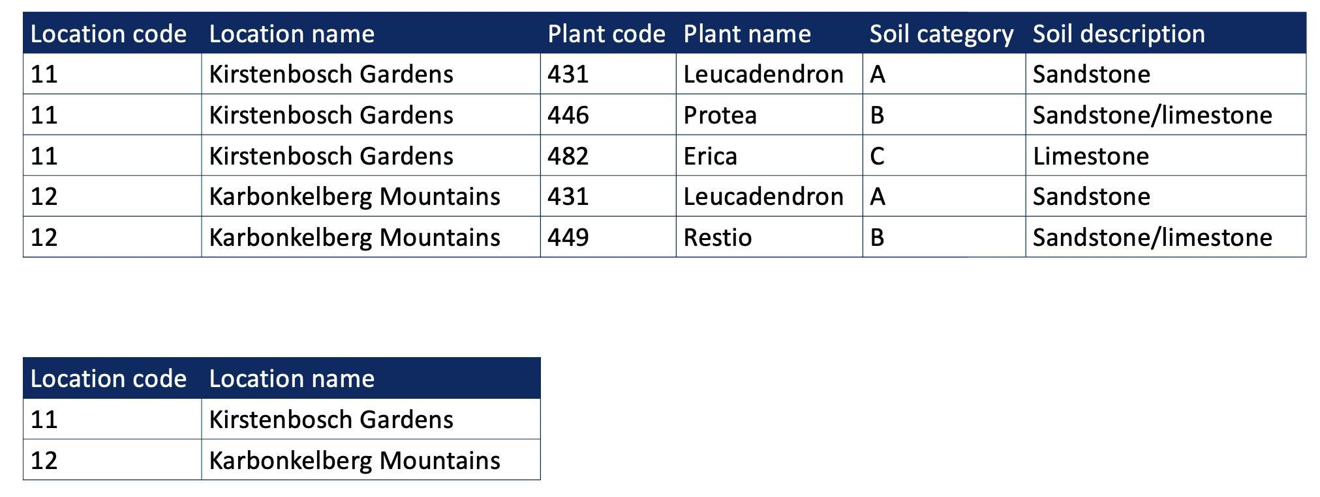

* Do the same for Plant Code, Plant Name, Soil Category and Soil Description

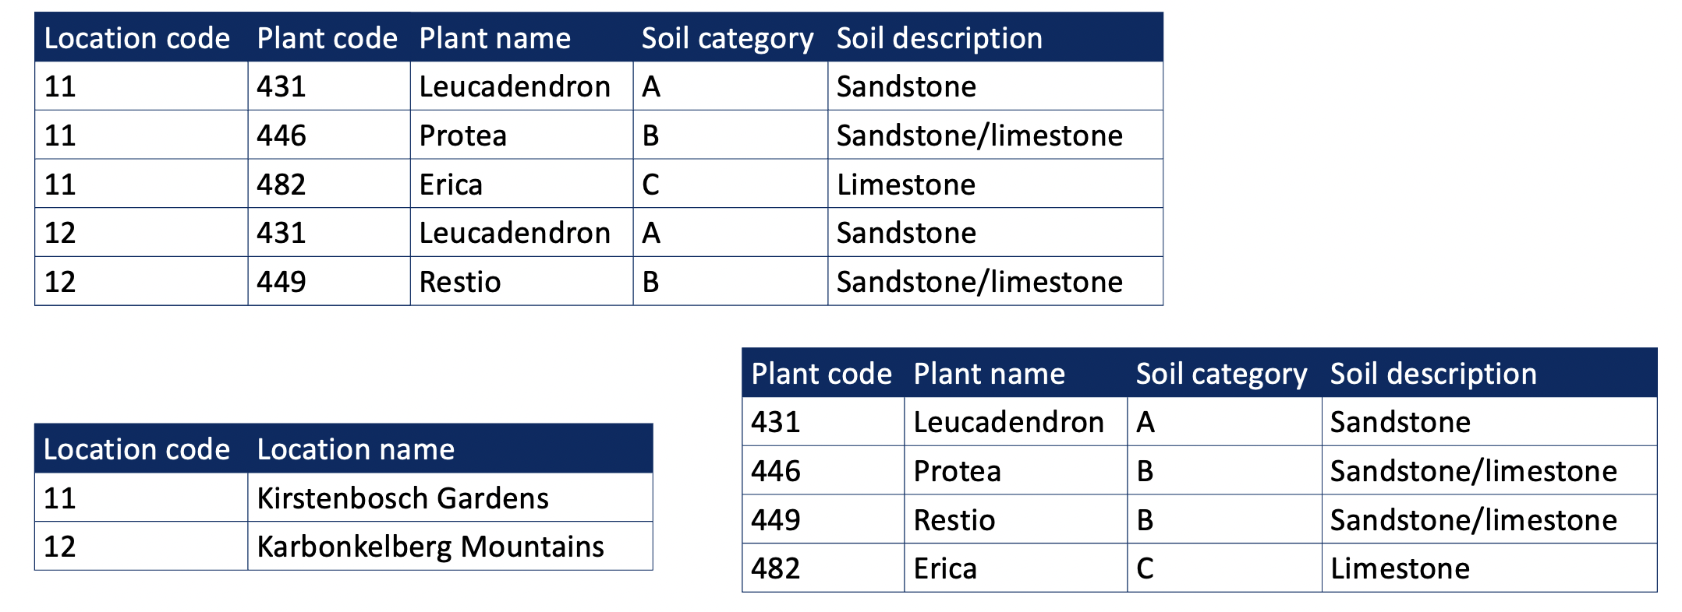

**Final 2NF form:**

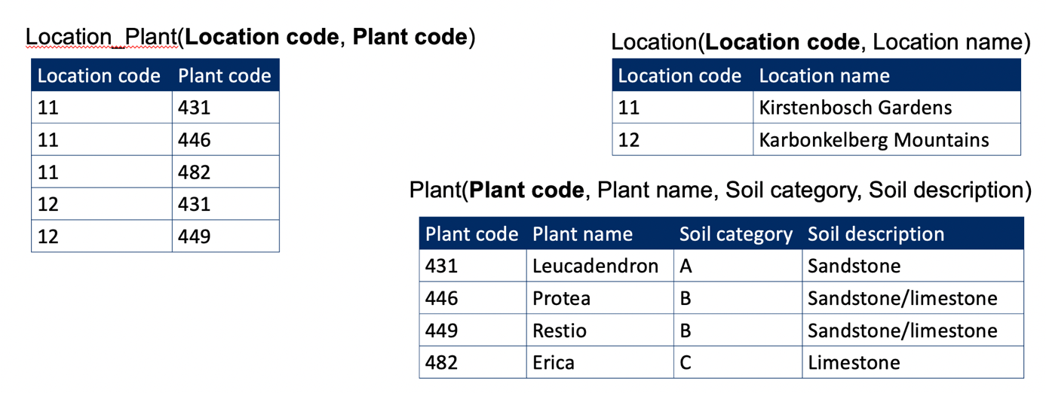

**3NF – 3rd Normal Form**

***Rules:***

* It’s in the 2NF – 2nd normal form
* Table has no transitive dependencies
  + Transitive dependency: a non-key attribute is dependent on another non-key attribute
  + Check every table for these dependencies!

Location_Plant table:

Every attribute is part of the primary key → nothing to do!

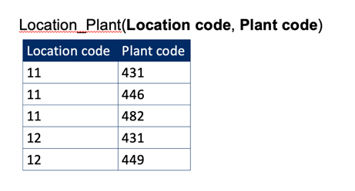

Location table:

Location code = primary key

Location Name = dependent on primary key, but no other non-key attributes it can be dependent on = OK!

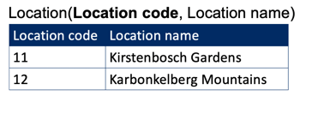

Plant table:

Plant code = primary key

Plant name = dependent on primary key and independent of soil category and soil description

Soil category = dependent on primary key, BUT is dependent on plant name, if you know the plant name you know the soil category, however it does not make sense that you would split up the table to have a separate table with plant name and soil category. You do have to make some logical distinction in how to split up your tables.

but dependent on soil description = NOT OK, here it does make sense to split up the table into a soil table!!!!

Soil description = dependent on primary key, independent of plant name, but dependent on soil category = NOT OK

You can easily see that plant code and name make one table and that soil category and soil description as a separate table with category as the ID.

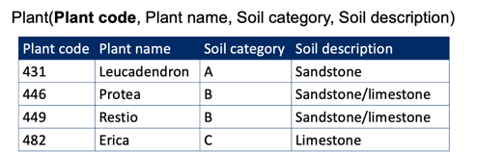

→ solve by splitting the plant table

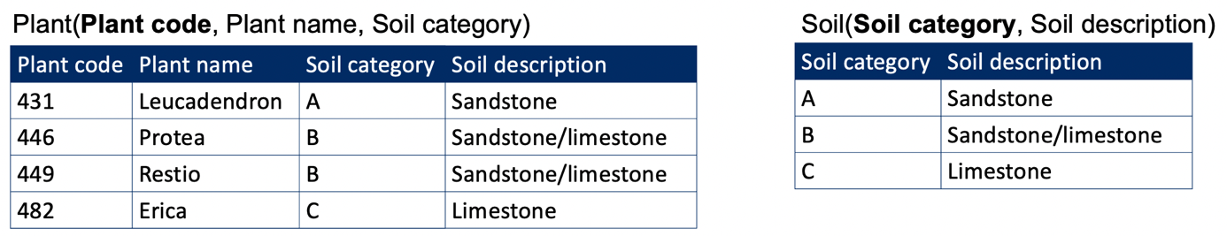

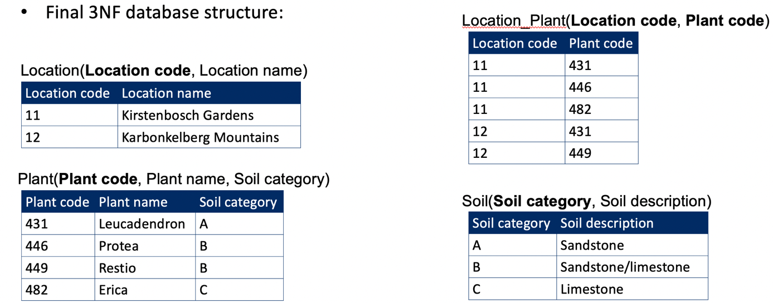

**BCNF – Boyce-Codd Normal Form**

Also known as the **3.5th Normal Form**.

***Rules:***

* Table is in 3rd Normal Form
* Each determinant is a candidate key
  + ***Determinant*** is an attribute that determines the value of another attribute. Does knowing the value from one column mean you also know the value of another column!
  + ***Candidate key*** is either the key or an alternative key (it could be a key for the table)

**Example**

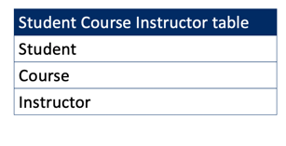

* Assume for the table that:
  + Each instructor only gives one course
  + Each course can have one or more instructors
  + Each student only has one instructor per course
  + Each student can take one or more courses

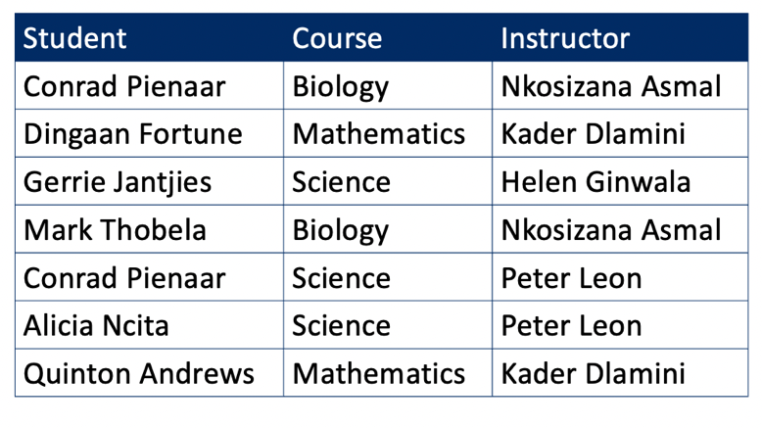

* Can a single feature be the primary key?
  + Is there one feature that has unique values for every row?
  + NO
* Can a combination of two features be the primary key?
  + Options:
    - Student + Course: YES. If you know the student and the course you also can identify the instructor!
    - Student + Instructor: YES. If you know the student and the instructor, you also know the course.
    - Course + Instructor: NO. If you know the course and instructor, you cannot determine the student!
* Take Student + Course as PK

Table(**Student**, **Course**, Instructor)

* Instructor is NOT a candidate key. By itself it cannot be used to identify each unique row. However, if we know the instructor, we know the course. **So it is a determinant!**

**→ BCNF violation! Determinant is not a candidate key!**

* Extract the instructor-course dependency to a new table.
* Remove redundancy: change primary key of initial table! Will now be **Student, Instructor**

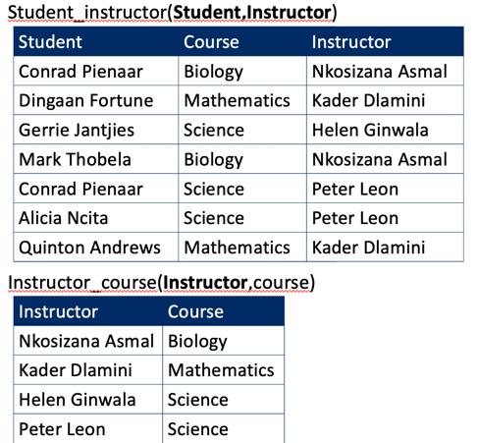

**Overview:**

* UNF: has repeating groups, unorganized
* 1NF
  + There are no repeating groups
  + All the key attributes are defined
  + All attributes depend on the primary key
* 2NF
  + 1NF + No partial dependencies
* 3NF
  + 2NF + Table has no transitive dependencies
* BCNF
  + 3NF + Each determinant is a candidate key

**Exercises**

**Exercise 1**

* Normalize to BCNF:
* Information:
  + Each patient can have up to 4 appointments
  + Appointment 1 is always at 9am or 1pm, 2 at 10am or 2pm, …
  + Can’t have 2 times same appointment
  + Patients in first half of the alphabet always go in the morning, second half in the afternoon

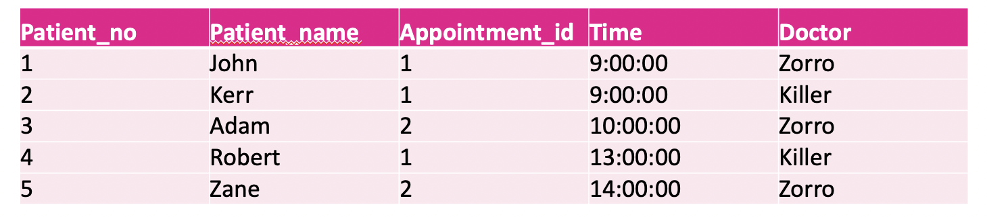

**1NF – 1st Normal Form**

Table is already in 1NF – 1st normal form. Only a primary key needs to be identified! In this case use Patient_no and Appointment_id. Be careful, you do need a combination, seeing that each patient can have multiple appointments!!!!

1NF final form: DB(*Patient_no*, Patient_name, *Appointment_id*, Time, Doctor)

**2NF – 2nd Normal Form**

Check for partial dependencies:

* Patient_name: only dependent on Patient_no = NOT OK
* Time: you need both to be able to know the time! So NOT partially dependent
* Doctor: dependent on both

Final form

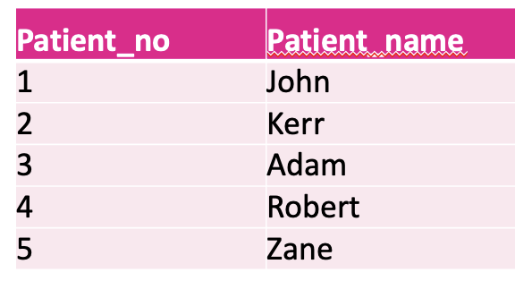

Patient(*Patient_no*, Patient_name)

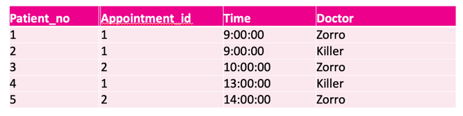

Appointment(*Patient_no*, *Appointment_id*, Time, Doctor)

**3NF – 3rd Normal Form**

Check for transitive dependencies:

Patient table:

* Patient_name can only be dependent on anything besides the key. There are no other non-key attributes

Appointment table:

* Time: independent of the doctor and vice versa

→ both tables already in the 3NF form!

**BCNF – Boyce-Codd Normal Form**

Each determinant is also a candidate key:

Patient table:

* OK, Patient name is determined by Patient_no and vice versa. Both can be used as a primary key.

Appointment table:

* Time is a determinant. If you know the time, you also know the appointment_id! (But NOT the other way around, knowing the appointment_id does not mean you also know the time, since there are always two options.)

Time however cannot be used as a candidate key.

**→ split up the table for the appointment_id and time and redefine the primary key for the original table!**

|  |  |
| --- | --- |
| Appointment_id | Time |
| 1 | 9:00:00 |
| 1 | 13:00:00 |
| 2 | 10:00:00 |
| 2 | 14:00:00 |

Appointment(Appointment_id, *Time*) → **note that time can here be used as the primary key! If you know the time, you also know the appointment_id!**

|  |  |  |
| --- | --- | --- |
| Patient_no | Time | Doctor |
| 1 | 9:00:00 | Zorro |
| 2 | 9:00:00 | Killer |
| 3 | 10:00:00 | Zorro |
| 4 | 13:00:00 | Killer |
| 5 | 14:00:00 | Zorro |

Patient_appointment(*Patient_no*, * Time*, doctor) **→ you keep Time and NOT appointment_id. Seeing as you can use Time as a foreign key to reference the appointment table but not appointment_id!!!!!**



Patient(*Patient_no*, Patient_name)

**Exercise 2**

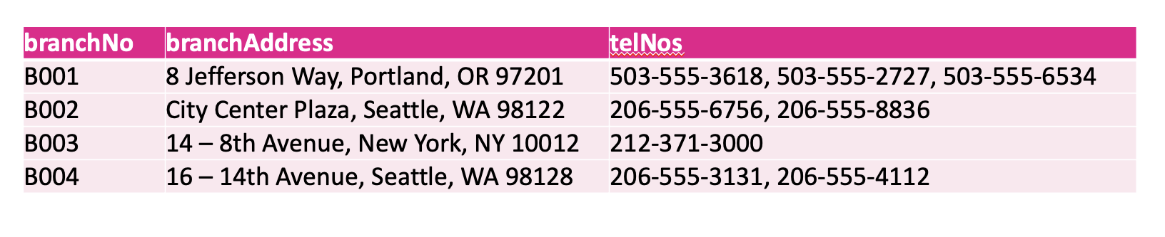

* Why is this table not in 1NF?

There are multiple values in the column telNOS = repeating groups!!!!! And there are different types of data in the branchAddress column!

* Normalize up to 3NF.

**1NF – 1th Normal Form**

|  |  |  |
| --- | --- | --- |
| branchNo | branchAddress | telNo |
| B001 | 8 Jefferson Way | 503-555-3618 |
| B001 | 8 Jefferson Way | 503-555-2727 |
| B001 | 8 Jefferson Way | 503-5555-6534 |
| B002 | City Center Plaza | 206-5555-6756 |
| B002 | City Center Plaza | 206-5555-8836 |
| B003 | 8th Avenue | 212-371-3000 |
| B004 | 14th Avenue | 206-5555-3131 |
| B004 | 14th Avenue | 206-5555-4112 |

DB(branchNo, branchAddress, *telNOS*)

→ telNOS is enough as PK

**2NF – 2nd Normal Form**

Only one PK so no problem of partial dependence.

**3NF – 3rd Normal Form**

Check transitive dependencies:

BranchAddress determines the branchNo and vice versa. They cannot be used as a candidate key.

|  |  |
| --- | --- |
| branchNo | branchAddress |
| B001 | 8 Jefferson Way |
| B002 | City Center Plaza |
| B003 | 8th Avenue |
| B004 | 14th Avenue |

Branch (*branchNo*, branchAddress)

|  |  |
| --- | --- |
| telNo | branchNo |
| 503-555-3618 | B001 |
| 503-555-2727 | B001 |
| 503-5555-6534 | B001 |
| 206-5555-6756 | B002 |
| 206-5555-8836 | B002 |
| 212-371-3000 | B003 |
| 206-5555-3131 | B004 |
| 206-5555-4112 | B004 |

TelNo(*telNo*, branchNo)

**Other exercises: see excel file**

**UNF**

Movies(Name, (Director(Genre,(Actor(Character, Chartype)), Rating, ReleaseDate))

1NF

Movies(*Name*, *Director*, *Genre*, *Actor*, *Character*, CharType, Rating, ReleaseDate)

2NF

Character(*Actor*, *Character*, Chartype)

Release(*Name*, Rating, ReleaseDate)

Movies(*Name*, *Director*, *Genre*, *Actor*)

3NF = 2NF

BCNF = 3NF

Director(*DirectorID*, Director)

Release(*ReleaseID*, Name, Rating, ReleaseDate)

Character(*CharID*, Actor, CharacterName, CharType)

Genre(*GenreID*, Genre)

Movies(*ID*, DirectorID, GenreID, CharID, ReleaseID)

NoSQL

Database Management System.

NoSQL databases do not have relations between tables (non-relational). They consist of separate entities.

More flexible and faster than SQL. You can store more (bigger) data in the database.

Used for Big-data and real-time web applications.

Lack of:

* Atomicity: you cannot show all data in one table.
* Consistency: you don’t need all attributes for all objects.

e.g. if you have a table with name and birthday, one person might have both while another will not have a birthday. This column will just be missing for that name. Will be less structured.

* Isolation: you cannot isolate a specific subset of the database. There are no joins of tables. You just get the whole database at once.
* Durability: changes to the data are more difficult, because of the lack of isolation

**Different categories of database systems:**

* **Column store**
  + Uses columns instead of rows
  + Tuples consist of 3 elements
  + Number of columns can change from row to row
  + E.g. Apache Cassandra
  + Syntax similar to SQL
* **Key-value store**
  + Data is stored in dictionary or hash
    - Similar to an array in PHP
    - Collection of objects or records
      * Different fields
  + Unique key per record
  + Single collection, different fields per record possible
  + Uses less memory, really fast
  + E.g. Oracle NoSQL Database
* **Graph store**
  + Nodes, edges and properties
  + Simple and rapid data retrieval
  + SPARQL
  + Shortest path queries
  + E.g. OrientDB
    - Has own commands + SQL commands
* **Multi model**
  + Multiple data models against a single, integrated backend
  + Document, graph, relational and key-value models supported
  + E.g. Couchbase (relational, document)
* **Document store**
  + Semi-structured data
  + Subclass of key-value store
    - You don’t have rows anymore, you now have documents in a collection.
    - Internal structure of the document
    - All information for a given object is stored in a single instance
    - Every stored object can be different from every other object. E.g. you can have a document with the name of a person and another document with his birthday.
* Web application
* Documents identified by a unique key
* Supports CRUD
* No predefined data formats, no constraints
  + Change in type and form has no effect on the database and existing stored documents
* No normalization
* E.g. MongoDB

**MongoDB**

* Free and open source.
* uses JSON-like objects
* Ad hoc queries: in real-time
  + You can use the fields, ranges and regex
* Support indexes to speed up queries
* Replication: you can have multiple copies in different servers, that can all be accessed. When one server is busy you can be switched to another server.
* Load balancing (load can be distributed over the different servers)
  + Sharding: when you have a query, this can be split up and divided over servers
* File storage
  + Uses Grid File System (GridFS): storage is divided into grids of 16 MB, meaning you can only store files of 16 MB as a whole. When a file is larger it will be split up and divided over multiple grids.
* Supports aggregation: you can perform aggregation functions and calculations on data
  + MapReduce: special feature. First map data to a specific field (e.g. a list of numbers of the age of people with same first name) and then reduce (e.g. calculate the mean age of persons with the same name). Is a very efficient way increasing speed of a query

**JSON format**

* JavaScript Object Notation
  + Data-interchange format: you can use this across different programming languages e.g. Python
  + Easy to parse and generate
  + Objects and arrays
    - Attribute-value pairs

**Installation**

* Linux (<https://docs.mongodb.com/manual/administration/install-on-linux/> )
  + $sudo nano /etc/yum.repos.d/mongodb-org-4.4.repo
  + Copy paste:

**[Mongodb]**

**name=MongoDB Repository**

**baseurl=https://repo.mongodb.org/yum/amazon/2013.03/mongodb-org/4.4/x86_64/**

**gpgcheck=1   
enabled=1**

**gpgkey=https://mongodb.org/static/pgp/server-4.4.asc**

* + Save
  + $sudo dnf install -y mongodb-org mongodb-org-server
* Windows
  + <https://docs.mongodb.com/manual/tutorial/install-mongodb-on-windows/>
* macOS
  + <https://docs.mongodb.com/manual/tutorial/install-mongodb-on-os-x/>

**Start, stop, restart and enable MongoDB**

$sudo service mongod start

$sudo service mongod stop

$sudo service mongod restart

$sudo systemctl enable mongod

**Mongo Shell**

Once installed and started, connect to mongoshell:

$mongo

Many options available, check the help

>help

Databases and collections

* Documents are internally stored as BSON (Binary JSON)
* Documents are stored in a collection, collections in databases
* You can think of a collection like a “table” and then each collection contains multiple documents which are the “rows”
* Select a database in the mongo shell:

> use myDB

→ database doesn’t have to exist yet, this will be created.

→ as long there is no data in the DB it will not show up in the db list (show databases)

* Insert data into the database:

>db.collectionName.insert({value1 : value, value2:value})

db. = start of the statement

collectionName = name of the collection (“table”) where you want to insert the data. The collection will be created if it doesn’t exist yet!

insert() = function used to insert the data

{valuename : value} = the value that is inserted. This is actually an object (document) and needs to be surrounded by curly brackets! The value can be any type of data, and can be different from other documents in the same collection. Use the semicolon (:) to assign a value to valuename.

>db.collectionName.insert({value1 : value, value2:value, list1:[“item1”, “item2”])

list1:[“item1”, “item2”] adds a list with multiple items, called an array. The array like a document does not have to contain items of the same data type.

>db.collectionName.insert({value1 : value, collection:{ value3 : value, value4 : value} })

collection:{ value3 : value, value4 : value} nests another collection inside the collection

> db.myNewCollection1.insert({x:1})

→ will create a collection called myNewCollection1 and insert a value (1) to x

>db.myNewCollection2.insert({x:1})

→ will create a collection called myNewCollection2 and insert a value (1) to x

>db.myNewCollection3.insert({name:”a1”, age:18, status:”D”, groups:[“politics”, “news”]})

→ will create a collection called myNewCollection2 and insert multiple values:

name: “a1”

age: 18

status: “D”

groups:[“politics”, “news”] → this will be a list as determined by the square brackets!

* To see available databases:

>show dbs

* Use database:

>use dbname

* See collections (similar to tables in MySQL)

>show collections

* To see the collection:

>db.collectionName.find()

>db.collectionName.find().pretty()

→ adding pretty() will give a more structured view

* To drop a database:

>db.dropDatabase()

→ drops the current (in use) database

**Documents**

* Contains fields and value pairs.
* Values of field may include other documents, arrays (lists) and arrays of documents.
* field:value

{

Name: “Sue” ,

Age: 26,

Status: “A”,

Groups: ["news”, “sports”]

}

* Advantages:
  + Corresponds to native data types in many other programming languages (e.g. python dictionaries and lists)
  + Less need for joins
  + Polymorphism (data type is not fixed). The data type for one table can be different for different objects.
* Field names
  + Similar to the columns in MySQL
  + Restrictions for the names
    - _id
      * Reserved for the primary key
      * Unique in the collection
      * Immutable: cannot be changed
      * Any type except array (cannot be a list)

e.g. can be a string, integer, or even a document

* Can’t start with $
* Cannot contain a dot (.) because of dot notation.
* Cannot be or contain a NULL value

**Dot notation**

* Dot is used to access elements of an array and to access fields of embedded documents
* Arrays are zero based: start counting at zero!
* Embedded documents: use field name
* **When using the dot notation: you have to always use quotation marks!**

Example:

var mydoc = {

_id: ObjectId("5099803df3f4948bd2f98391"),

name: { first: "Alan", last: "Turing" },

birth: **new** Date('Jun 23, 1912'),

death: **new** Date('Jun 07, 1954'),

contribs: [ "Turing machine", "Turing test", "Turingery" ],

views : NumberLong(1250000)

}

>mydoc.contribs[1]

Turing test

>mydoc.contribs.1

Turing test

>mydoc.contribs[0]

Turing machine

mydoc.name.first

Alan

**_id field**

* Primary key
* By default, mongoDB creates unique index on _id field during creation of collection
  + can change this to a custom primary field key (instead of the _id field), but needs to be defined when the document is created
  + Will always be the first field in your document
  + If not defined as first, moved to beginning by mongoDB
  + Holds an ObjectID
* May contain values of any BSON data type other than an array, including another document

**Data types**

var mydoc = {

_id: ObjectId("5099803df3f4948bd2f98391"),

name: { first: "Alan", last: "Turing" },

birth: **new** Date('Jun 23, 1912'),

death: **new** Date('Jun 07, 1954'),

contribs: [ "Turing machine", "Turing test", "Turingery" ],

views : NumberLong(1250000)

}

**_id** holds an **ObjectID**

**name** holds an **embedded document** that contains the fields first and last which each contain a **string**

**birth** holds a value of **Date type**

**death** holds a value of **Date type**

**contribs** holds an **array of strings**

**views** holds a value of the **NumberLong t**ype. Needs to specified, by default mongoDB turns numbers into floats.

**BSON data types**

* ObjectID
  + Small value
  + Likely unique
  + Fast to generate and ordered
  + Consists of:
    - 4-byte value representing the seconds since the Unix epoch
    - 5-byte random value
    - 3-byte incrementing counter, starting from a random value
* String
  + Between quotation marks
* Timestamp
  + Internal mongoDB use; mongoDB will automatically add a timestamp
* Date
  + Number of milliseconds since the Unix epoch

**Mongo shell**

* See all databases on the server

> show dbs

* Use database

> use db

* List all methods you can use on your db object

> db.help()

* See all collections in a database

> show collections

* List all methods you can use on your collection object

> db.collection.help()

* List all cursor methods

> db.collection.find().help()

**Create operations**

* Add new documents to a collection

> db.collection.insert()

→ will be insertOne() or insertMany() based on the syntax, type of data you are inserting into the collection

> db.collection.insertOne()

→ to insert one document, can include nested documents

> db.collection.insertMany()

→ to insert multiple different documents (not nested) at once

→ you have to provide an array (square brackets) containing the different documents.

**db.collection.insertMany(**

**[**

**{item: “envelopes”, qty: 60},**

**{item:”stamps”, qty: 110},**

**{item:”packing tape”, qty: 38}**

**]**

**);**

$mongo dbname < file.txt

→ you can add the insertMany() statement in a text file and use the above command to import the data

$mongoimport -d databasename -c collection file**.json**

→ you can use mongoimport from the command line to import data from a .json file into a database.

→ -d option can be used to specify an existing database, or to create a new database with the provided name. If not specified the collection will be created in the **test** database

→ -c option can be used to provide a name for the collection; if not specified the file name will be used

**Exercise**

1. Create a collection “users” and add yourself to it (name, age, sex, …).

>use testDB

>db.users.insert({name:”Jonathan”, age:37, sex:”M”})

1. Add some more users to the collection using a different command.

>db.users.insertMany(

[

{name:”Laura”, age:27, sex:”F”},

{name:”Vincent”, age:42, sex:”M”},

{name:”Liselotte”, age:36, sex:”F”},

{name:”Jan”, age:40, sex:”M”}

]

)

**Read operations**

Retrieve documents from a collection (SELECT statement in MySQL).

>db.collection.find()

>db.collection.findOne()

→ shows the first document

Example:

>db.users.find(

{age: {$gt: 18} },

{name: 1, sex: 1}

).limit(5).offset(1)

db.users.find() function to find (select) data from a collection

{age: {$gt: 18} } **query criteria** (WHERE statement), always between curly brackets.

{$gt: 18} → specifies greater than 18, again between curly brackets (is an embedded document).

{name: 1, sex: 1} **projection**: specifies what to show (subset)

.limit(5) limit() function to limit the output to a specified number, here 5 documents. This is called a **cursor modifier**.

.skip(1) skip() function to skip rows. Is a **cursor modifier**.

>db.users.find(

{age: 18},

{name: 1, sex: 1}

).limit(5)

→ here you will only show name and sex where age = 18.

→ in first example you will show name and sex where age is greater than 18

* db.collection.find() returns a cursor to the matching documents
* Optional fields are possible
  + Query filter (~= where in MySQL)
  + Query projection (~= column selection in MySQL: SELECT name,age FROM …)
* Cursor modifier if wanted (~= limit, offset in MySQL)

**Query filter**

* **Specify equality condition** (where x = “someValue”)

> db.collection.find(

**{<field1>:<value1>, …}**

)

<field1> specify the field

: equality sign (“where”)

<value1> equal to what value

* **Use query operators** ( where x < “someValue”)

> db.collection.find(

**{<field1>:{<operator1>:<value1>}, …}**

)

<field1> specify the field

: equality sign (“where”)

**{<operator1>:<value1>}**

{} embedded document with the query operator

<operator1> specify the operator (e.g. $gt)

: equatlity sign (“where”)

<value1> greater than what value

* **AND conditions** (where x=“someValue1” and y=“someValue2”)

→ Default when specifying multiple conditions

> db.collection.find(

**{<field1>:<value1>,<field2>:value2, …}**

)

<field1> specify the field

: equality sign (“where”)

<value1> equal to what value

, AND followed by next condition

<field2> specify the field

: equality sign (“where”)

<value2> equal to what value

* **OR conditions** (where x=“someValue1” or y=“someValue2”)

> db.collection.find(

**{$or:[**

**{<field1>:<value1>},**

**{<field2>:value2, …},**

**…]**

**}**

)

$or:[] the OR operator. Followed by an array of conditions, each one a separate embedded document!

**{<field1>:<value1>},** condition 1

**{<field2>:value2, …}** condition 2

* **Comparison**

|  |  |  |
| --- | --- | --- |
| **Name** | **Description** | **MySQL equivalent** |
| [$eq](https://docs.mongodb.com/v3.4/reference/operator/query/eq/) | Matches values that are equal to a specified value. | = |
| [$gt](https://docs.mongodb.com/v3.4/reference/operator/query/gt/) | Matches values that are greater than a specified value. | > |
| [$gte](https://docs.mongodb.com/v3.4/reference/operator/query/gte/) | Matches values that are greater than or equal to a specified value. | >= |
| [$lt](https://docs.mongodb.com/v3.4/reference/operator/query/lt/) | Matches values that are less than a specified value. | < |
| [$lte](https://docs.mongodb.com/v3.4/reference/operator/query/lte/) | Matches values that are less than or equal to a specified value. | <= |
| [$ne](https://docs.mongodb.com/v3.4/reference/operator/query/ne/) | Matches all values that are not equal to a specified value. | != or <> |

**{<field>:{<operator>:<value>}}**

**{<field>:{<operator>:[<value1>,<value2>,<value3>,…,<valueN>]}}**

|  |  |  |
| --- | --- | --- |
| **Name** | **Description** | **MySQL equivalent** |
| [$in](https://docs.mongodb.com/v3.4/reference/operator/query/in/) | Matches any of the values specified in an array. | IN |
| [$nin](https://docs.mongodb.com/v3.4/reference/operator/query/nin/) | Matches none of the values specified in an array. | NOT IN |

* **Logical**

**{<operator>:[**

**{<expression1>},**

**{<expression2>},**

…,

**{<expressionN>},**

**]}**

|  |  |  |
| --- | --- | --- |
| **Name** | **Description** | **MySQL equivalent** |
| [$and](https://docs.mongodb.com/v3.4/reference/operator/query/and/) | Joins query clauses with a logical AND returns all documents that match the conditions of both clauses. | AND |
| [$or](https://docs.mongodb.com/v3.4/reference/operator/query/or/) | Joins query clauses with a logical OR returns all documents that match the conditions of either clause. | OR |
| [$nor](https://docs.mongodb.com/v3.4/reference/operator/query/nor/) | Joins query clauses with a logical NOR returns all documents that fail to match both clauses. | NOT (… OR …) |

**{<field>:**

**{$not: {<operator-expression>}}**

**}**

|  |  |  |
| --- | --- | --- |
| [$not](https://docs.mongodb.com/v3.4/reference/operator/query/not/) | Inverts the effect of a query expression and returns documents that do *not* match the query expression. | NOT (…) |

* **Element**

**{<field>:**

**{$exists:<boolean>}**

**}**

* **<boolean> is true or false; you can also use 1 or 0**

|  |  |
| --- | --- |
| **Name** | **Description** |
| [$exists](https://docs.mongodb.com/v3.4/reference/operator/query/exists/) | Matches documents that have the specified field. |

**{<field>:**

**{$type:<type>}**

|  |  |
| --- | --- |
| [$type](https://docs.mongodb.com/v3.4/reference/operator/query/type/) | Selects documents if a field is of the specified type. |

**}**

**{<field>:**

**{$type:<type> |<type>}**

**}**

* **Array**

**{<field>:**

**{$all:[**

<val1>,

<val2>,…,

<valN>

**]}**

**}**

|  |  |
| --- | --- |
| **Name** | **Description** |
| [$all](https://docs.mongodb.com/v3.4/reference/operator/query/all/) | Matches arrays that contain all elements specified in the query. |

**{<field>:**

**{$elemMatch:**

**{<query1>,**

**<query2>,**

**…,**

**<queryN>}**

**}**

**}**

|  |  |
| --- | --- |
| [$elemMatch](https://docs.mongodb.com/v3.4/reference/operator/query/elemMatch/) | Selects documents if element in the array field matches all the specified [$elemMatch](https://docs.mongodb.com/v3.4/reference/operator/query/elemMatch/) conditions. |

**{<field>:**

**{$size: n}**

**}**

|  |  |
| --- | --- |
| [$size](https://docs.mongodb.com/v3.4/reference/operator/query/size/) | Selects documents if the array field is a specified size. |

$elemMatch example:

{ _id: 1, results: [ 82, 85, 88 ] }

{ _id: 2, results: [ 75, 88, 89 ] }

> db.scores.find( { results: { $elemMatch: { $gte: 80, $lt: 85 } } } )

→ asks for an array where **at least one element** is greater than or equal to 80 and less than 85! So between 80 and 85!

{ "_id" : 1, "results" : [ 82, 85, 88 ] }

**Query projection**

**{<field1>:<value>,<field2>:value, …}**

→ Value can be any of the following

* 1 or true
* 0 or false
* Expression using projection operators

**Projection operators:**

>db.collection.find( { <array>: <value> ... }, { "<array>.$": 1 } )

|  |  |
| --- | --- |
| **Name** | **Description** |
| [$](https://docs.mongodb.com/v3.4/reference/operator/projection/positional/) | Projects the first element in an array that matches the query condition. |

db.collection.find( { <array>: <value> ... },

{ <field>:

{ $elemMatch: { <query1>, <query2>, ... }

}

})

|  |  |
| --- | --- |
| [$elemMatch](https://docs.mongodb.com/v3.4/reference/operator/projection/elemMatch/) | Projects the first element in an array that matches the specified [$elemMatch](https://docs.mongodb.com/v3.4/reference/operator/projection/elemMatch/) condition. |

**Cursor methods**

Methods that modify the way the query is executed.

For a full list: [Methods](https://docs.mongodb.com/manual/reference/method/js-cursor/index.html).

* + **sort()**
    - Returns results ordered according to sort specification

>db.users.find({}).**sort({<field>:1})**

→ sort ascending → :1

>db.users.find({}).**sort({<field>:-1})**

→ sort descending → :-1

* + **count()** 
    - Returns the number of documents in result (without skip or limit)

>db.users.find({}).**count()**

→ count all documents

>db.users.find({}).**limit(2).count()**

→ limit() will NOT affect the count, it will only limit the output you see, but not the number of documents that are counted

* + **hasNext()**
    - Returns true if the cursor has documents and can be iterated

>db.users.find({}).**hasNext()**

→ will return true of the query you performed has results. So basically you can ask if there are results from your query, before looking at the result!

→ mostly useful when using other programming languages to query your database

* + **next()**
    - Returns the next document in a cursor

>db.users.find({}).**next()**

→ mostly usefull in a script together with hasNext(); while(hasNext():true) use next() to show the following document and perform some action

* + **limit()**
    - Constrains the size of a cursors result set

>db.users.find({}).**limit(n)**

→ limit the number of results shown by n

* + **skip()**
    - Returns a cursor that skips a number of documents

>db.users.find({}).**skip(n)**

→ skip the number of results shown by n

>db.users.find({})**.limit(m).skip(n)**

→ limit the results by m and skip the first n

* + **size()**
    - Returns a count of the document after limiting and/or skipping a number of document

>db.users.find({}).**limit(2).size()**

→ here the size will be limited by the limit() function, in contrast to the count() function!

>db.users.find({}).**limit(2).skip(2).size()**

→ **here the limit and skip functions both affect the size function!, If you only have three documents and you limit by 2 and skip 2 there will only be one document to show and thus the size() function will return 1**

**distinct()**

**>db.collection.distinct( 🡨 distinct() function; collection**

**“field”, 🡨 field between quotation marks**

**{query}, 🡨 optional query**

**{options} 🡨 additional options can be specified**

**)**

→ distinct will return an array; use .length to count the number of elements in the array:

>db.collection.distinct(“field”)**.length**

**Exercises**

1. **Populate the users collection using the contents of the file mongo1.txt.**

→ create the database and collection and copy paste from the file.

→ when using the insertMany() function don’t forget that you provide an array of records, so don’t forget the square brackets!!!!!

**→ you can also create the db directly from the file:**

**>mongo users < mongo1.txt**

>use users

>db.users.insertMany(

[

{

_id: 1,

name: "sue",

age: 19,

type: 1,

status: "P",

favorites: { artist: "Picasso", food: "pizza" },

finished: [ 17, 3 ],

badges: [ "blue", "black" ],

points: [

{ points: 85, bonus: 20 },

{ points: 85, bonus: 10 }

]

},

{

_id: 2,

name: "bob",

age: 42,

type: 1,

status: "A",

favorites: { artist: "Miro", food: "meringue" },

finished: [ 11, 25 ],

badges: [ "green" ],

points: [

{ points: 85, bonus: 20 },

{ points: 64, bonus: 12 }

]

},

{

_id: 3,

name: "ahn",

age: 22,

type: 2,

status: "A",

favorites: { artist: "Cassatt", food: "cake" },

finished: [ 6 ],

badges: [ "blue", "red" ],

points: [

{ points: 81, bonus: 8 },

{ points: 55, bonus: 20 }

]

},

{

_id: 4,

name: "xi",

age: 34,

type: 2,

status: "D",

favorites: { artist: "Chagall", food: "chocolate" },

finished: [ 5, 11 ],

badges: [ "red", "black" ],

points: [

{ points: 53, bonus: 15 },

{ points: 51, bonus: 15 }

]

},

{

_id: 5,

name: "xyz",

age: 23,

type: 2,

status: "D",

favorites: { artist: "Noguchi", food: "nougat" },

finished: [ 14, 6 ],

badges: [ "orange" ],

points: [

{ points: 71, bonus: 20 }

]

},

{

_id: 6,

name: "abc",

age: 43,

type: 1,

status: "A",

favorites: { food: "pizza", artist: "Picasso" },

finished: [ 18, 12 ],

badges: [ "black", "blue" ],

points: [

{ points: 78, bonus: 8 },

{ points: 57, bonus: 7 }

]

}

]

)

1. **Select all documents in the collection.**

>db.users.find()

1. **Select all documents in the collection where status has the value “A”.**

>db.users.find(

{status:”A”}

)

***Note:*** add ,{_id:1} to only show the IDs for each document instead of the entire document!

>db.users.find(

{status:”A”} , {_id:1}

)

→ documents 2, 3 and 6

1. **Select all documents in the collection where status has the value “A” and *either* age is less than 30 or type equals 1.**

>db.users.find(

{$and:[

{status:”A”},

{$or:[

{age:{$lt:30}},

{type:1}

]}

]}

)

OR

>db.users.find(

{status:”A”,

$or:[{age:{$lt:30}},

{type:1}

]

}

)

→ documents: 2, 3 and 6

1. **Retrieve all documents from the users collection where status equals either "P“ or "D”.**

>db.users.find(

{$nor:[{status:”P”},

{status:”D”}]

}

)

→ documents: 2, 3 and 6

Alternatively you can use the $in operator:

>db.users.find(

{status:{$in:[“D”, “P”]}

}

)

1. **Retrieve all documents where the favorites field is an embedded document that contains only the fields artist equal to "Picasso" and food equal to "pizza", in that order.**

>db.users.find(

{**“**favorites.artist**”**:”Picasso”, “favorites.food”:”pizza”}

)

→ FOR THIS SOLUTION IT DOES NOT LOOK AT THE ORDER

**Important:** when selecting fields from an embedded document or array, use dot notation. But **you always have to use the quotation marks!!!!** This is also the case in projections!!

**>db.users.find(**

**{favorites:{artist:”Picasso”, food:”pizza”}}**

**)**

**→ here you say that favorites has to match the embedded document: {artist:”Picasso”, food:”pizza”}**

**→ changing the order will give a different match!**

1. **Use the dot notation to match all documents where badges is an array that contains "black" as the first element.**

>db.users.find(

{“badges.**0**”:”black”}

)

→ arrays start counting at 0!

→ document 6

1. **Retrieve all documents where the finished array contains at least one element that is greater than 15 and less than 20.**

>db.users.find(

{finished:{$elemMatch:{$gt:15, $lt:20}}}

)

→ documents 1 and 6

1. **Afterwards: show only the first matching element.**

>db.users.find(

{finished:{$elemMatch:{$gt:15, $lt:20} } },

**{“finished.$”:1}**

)

*{“_id”:1, “finished”: [17]}*

*{“_id”:6, “finished”: [18]}*

**Note:** be careful; the following will also only show the first element for the arrays that match the query, BUT will still give you the documents for the other ones that don’t match, just not with the finished array (only the _ID)!

>db.users.find(

{},

{finished:{$elemMatch:{$gt:15, $lt:20} } }

)

*{“_id”:1, “finished”: [17]}*

*{“_id”:2}*

*{“_id”:3}*

*{“_id”:4}*

*{“_id”:5}*

*{“_id”:6, “finished”: [18]}*

**Update operations**

Modify an existing document in a collection:

**→ always a good idea to first start with the query itself to ensure that it is correct, so you don’t accidentally change the wrong records!**

> db.collection.update()

> db.collection.updateOne()  
> db.collection.updateMany()

>db.collection.update( 🡨 collection

{age:{$gt:18} }, 🡨 update criteria

{$set:{status: “A”} }, 🡨 update action

{multi: true} 🡨 update option

)

> db.collection.replaceOne()

→ NO replaceMany() or replace() option

→ replaces the first matching document completely to what you specified, but keeps the _ID

>db.collection.replaceOne( 🡨 collection

{filter}, 🡨 filter: same query options as find()

{replacement}, 🡨replacement document

{options} 🡨 additional options that can be specified

)

**Update operators**

{ $inc: {<field1>:<amount1>,<field2>:<amount2>,…}}

|  |  |
| --- | --- |
| [$inc](https://docs.mongodb.com/manual/reference/operator/update/inc/) | Increments the value of the field by the specified amount. |

{ <operator>: { <field1>:<value1>,…}}

|  |  |  |
| --- | --- | --- |
| [$set](https://docs.mongodb.com/manual/reference/operator/update/set/) | Sets the value of a field in a document. Does NOT need to exist yet. If not, it will be created. |  |
| [$unset](https://docs.mongodb.com/manual/reference/operator/update/unset/) | Removes the specified field from a document. | **Note: value=“”** |

For arrays only:

|  |  |  |
| --- | --- | --- |
| [$addToSet](https://docs.mongodb.com/manual/reference/operator/update/addToSet/) | Adds elements to an array only if they do not already exist in the set. |  |
| [$pop](https://docs.mongodb.com/manual/reference/operator/update/pop/) | Removes the first or last item of an array. | Note: value= -1: first, 1:last |
| [$pull](https://docs.mongodb.com/manual/reference/operator/update/pull/) | Removes all array elements that match a specified query. |  |
| [$push](https://docs.mongodb.com/manual/reference/operator/update/push/) | Adds an item to an array. | Note: adds to end of array |

**Exercises**

1. **Update all documents where Picasso is the favorite artist so that the value of the favorites.artist field is "Pisanello" and the value of the type field is 3.**

>db.users.update(

{“favorites.artist”:”Picasso”},

{$set:{“favorites.artist”:”Pisanello”, type:3}})

1. **Replace the *first* document that matches the filter name equals "abc" with the new document.**

**{ name: "amy", age: 34, type: 2, status: "P", favorites: { "artist": "Dali", food: "donuts" } }**

>db.users.replaceOne(

{name:”abc”},

{name: "amy", age: 34, type: 2, status: "P", favorites: { "artist": "Dali", food: "donuts"}}

)

1. **Replace the first document that matches the filter name equals "xyz" with the new document (do not use the same method as before).**

**{ name: "mee", age: 25, type: 1, status: "A", favorites: { "artist": "Matisse", food: "mango" } }**

>db.users.update(

{name:”xyz”},

{$set:{name: "mee", age: 25, type: 1, status: "A", favorites: { "artist": "Matisse", food: "mango" }}

)

→ this will keep the fields that are not specified like badges and points, solve by also including an unset operator for these fields!!!! With $unset you have to still specify a value for these fields, set to “”.

>db.users.update(

{name:”xyz”},

{$set:{name: "mee", age: 25, type: 1, status: "A", favorites: { "artist": "Matisse", food: "mango" },

$unset:{badges:””, points:””}}

)

**→ however if you just do NOT use an operator and instead specify a document, this will replace the existing document!**

>db.users.update(

{name:”xyz”},

name: "mee", age: 25, type: 1, status: "A", favorites: { "artist": "Matisse", food: "mango" }})

**Note:** when creating an embedded document you use quotations for the fields inside the embedded document!!

**Delete operations**

Remove documents from a collection:

> db.collection.remove() ~=deleteMany

> db.collection.deleteOne()

> db.collection.deleteMany()

>db.users.remove( 🡨 collection

{status:”D”}, 🡨 remove criteria

)

>db.users.remove( 🡨 collection

{status:”D”}, 🡨 remove criteria

{justOne:True} 🡨 option: if you only want to remove one

)

>db.users.remove( 🡨 collection

{status:”D”}, 🡨 remove criteria

True 🡨 option: if you only want to remove one

)

**Exercises**

1. **Remove all documents from the users collection where the status field equals "P”.**

>db.users.remove(

{status:”P”}

)

1. **Remove the first document from the users collection where the status field equals ”D” (2 ways).**

>db.users.deleteOne(

{status:”D”}

)

OR

>db.users.remove(

{status:”D”}, {justone:True}

)

OR

>db.users.remove(

{status:”D”}, True

)

**Query optimization**

→ how to speed up your queries:

* Create index
* Use selective query
  + Slowest part is actually the return of data, by selecting the data (subsetting) you can limit the amount of data that will be returned and speed up the query
  + Less selective = match with a larger percentage of documents
    - Less selective use of indexes
* Covered query
  + All fields in query are part of an index
  + All fields returned in result are in the same index
* Limit number of query results
  + limit() method
  + reduces network demand
* Return only necessary data
  + Use query projections

|  |  |
| --- | --- |
| **MongoDB** | **SQL** |
| Database | Database |
| Collection | Table |
| Document | Record/row |
| Field | Column |
| Index | Index |
| Primary key | Primary key |
| Embedded documents | joins |

**MongoDB vs SQL**

**Exercises**

→ Transform the following SQL statements into mongodb statements

1. INSERT INTO users(user_id, age, status) VALUES ("bcd001", 45, "A");

>db.users.insert(

{user_id:”bcd001”, age:45, status:”A”}

)

1. SELECT * FROM users WHERE status != "A”;

>db.users.find(

{status:{$not:{$eq:”A”}}}

)

OR

>db.users.find(

{status:{$ne:”A”}}

)

1. SELECT * FROM users WHERE age > 25;

>db.users.find(

{age:{$gt:25}}

)

1. SELECT * FROM users WHERE status = "A" ORDER BY user_id DESC;

>db.users.find(

{status:”A”}

).sort({user_id:-1})

→ do NOT forget the curly brackets

1. SELECT COUNT(*) FROM users;

>db.users.find(

{}

).count()

→ not necessary to put the curly brackets

>db.users.find().count()

→ you can also leave out the find()

**>db.users.count()**

1. SELECT COUNT(user_id) FROM users;

>db.users.find(

{user_id:{$exists:true}}

).count()

1. **SELECT DISTINCT(status) FROM users;**

**>db.users.distinct(“status”)**

**>db.collection.distinct( 🡨 distinct() function; collection**

**“field”, 🡨 field between quotation marks**

**{query}, 🡨 optional query**

**{options} 🡨 additional options can be specified**

**)**

1. SELECT * FROM users LIMIT 1;

<db.users.find().limit(1)

1. SELECT * FROM users LIMIT 5 OFFSET 10;

<db.users.find().limit(5).skip(10)

1. UPDATE users SET age = age + 3 WHERE status = "A”;

<db.users.update(

{status:”A”},

{$inc{age:3}}

)

1. DELETE FROM users WHERE status = "D”;

<db.users.remove({status:”D”})

**Aggregation**

* aggregate() method

>db.collection.aggregate(

[

{aggregate operator1:{} },

{aggregate operator2:{} },

{aggregate operator3:{} },

…

]

)

* example:

Return states with populations above 10 million:

MySQL:

select state, sum(pop) as totalPop from zipcodes group by state

having totalPop >= (10*1000*1000)

MongoDB:

db.zipcodes.aggregate(

[

{$group:{_id:”$state”, totalPop: { $sum: “$pop”}}},

{$match:{totalPop:{$gte:10*1000*1000}}}

]

)

* aggregate() uses an array [] to create a new record with a new _id.
* You have to define the fields from the collection as $field, with a $ sign, these are variables.
* $group is used to group and then include some “having” clause with the alias.
* $match is used to do some query: having statement.
* $sum:”$field” is an aggregation pipeline operator. NO quotation marks!
* Many [aggregation pipeline operators](https://docs.mongodb.com/manual/reference/operator/aggregation/) are available.
  + $sum, $avg, $group, $match, $limit, $skip, $sort, $concat, $first, $last, …

db.zipcodes.aggregate(

[

{$group:{_id:”$state”, totalPop: { $sum: “$pop”}}},

{$sort:{totalPop:-1}}

]

)

→ here you will sort by totalPop descending!

* **How to count cities.**

>db.zip.aggregate([

{$group:{_id:”$city”, **count:{$sum:1**}}}

])

→ use the count:{$sum:1} to count the number of values in each group!

* Which city names are more common:

>db.zip.aggregate([

{$group:{_id:”$city”, **count:{$sum:1}** } },

{$sort:{count:-1}}

])

→ by sorting ascending you will see the most common names

>db.zip.aggregate([

{$group:{_id:”$city”, **count:{$sum:1}** } },

{$sort:{count:-1}},

{$limit:5}

])

→ limit by 5 to see the 5 most common city names

**Group by multiple fields,** by specifying the _id as an embedded document with multiple fields:

>db.collection.aggregate([

{$group:{_id:{name1:”$field1”, name2:”$field2”} } }

])

→ here you will group by field1 and field2

→ the new _id in the output will also be an embedded document, you can use the values (name1 and name2) to perform some having for example or other pipeline operators. To access these you will need to use dot notation: “_id.name1”

>db.collection.aggregate([

{$group:{_id:{name1:”$field1”, name2:”$field2”} } },

**{$match:{“_id.name1”:value}**

])

**Exercises**

* Import the zipcodes selection from file “zips.json”

**$ mongoimport zips.json**

**→ when no database is specified, it will create a database used test and put this in this database**

→ you can specify a database by using the **-d dbname** option

→ you can specify a name for the collection by using the **-c collectionname** option

* Return average city population by state.

>db.zips.aggregate([

{$group:{_id:”$state”, avgPop:{$avg:”$pop”} } }

])

* **Return largest and smallest cities by state.**

**>db.zips.aggregate([**

**{$group:{_id:{state:”$state”, city:”$city”}, pop:{$sum:”$pop”} } },**

**{sort:{pop:-1} },**

**{$group:{_id:”$_id.state”, largest:{$first:”$_id.city”}, smallest:{$last:”$_id.city”}}}**

**])**

→ first group by state and city and add the population for each city using $sum.

→ sort by the population to get the biggest on top. This will give you a sort by population.

→ next you can create another group, here you group by the new state with “$_id.state”,

Use the $first and $last to show the first and last city for each group!!!!! Since they are sorted by population, this will give you the city with biggest and the smallest population!!!!!!

**GUI**

MongoDB Compass

* Visually explore your data
* Interact with your data with full CRUD functionality
* Run ad hoc queries
* View detailed information about indexes
* View visual explain plans to help optimize query performance

[Robo 3T](https://robomongo.org/download)

* Full Power of a MongoDB Java Script environment. Robo 3T embeds a complete JavaScript engine (based on Mozilla SpiderMonkey).
* Multiple Shells. Open as many shells as you need. Every tab in Robo 3T is a MongoDB shell, fully isolated from each other.
* Multiple Results. Robo 3T executes your code in statement by statement way. That means that you will receive as many result as many statements you have.
* Autocompletion. Robo 3Tprovides you with autocompletion for all objects (and thus functions) that are known by JavaScript runtime, including autocompletion for databases, collections and even your document objects.
* Cross-platform, open source.

Install:

$ cd Downloads/robo3t…/bin

$ ./robo3t

./robo3t: error while loading shared libraries: libcurl-gnutls.so.4: cannot open shared object file: No such file or directory

$ sudo dnf install patchelf

$ patchelf --replace-needed libcurl-gnutls.so.4 libcurl.so.4 robo3t

**$ ./robo3t**

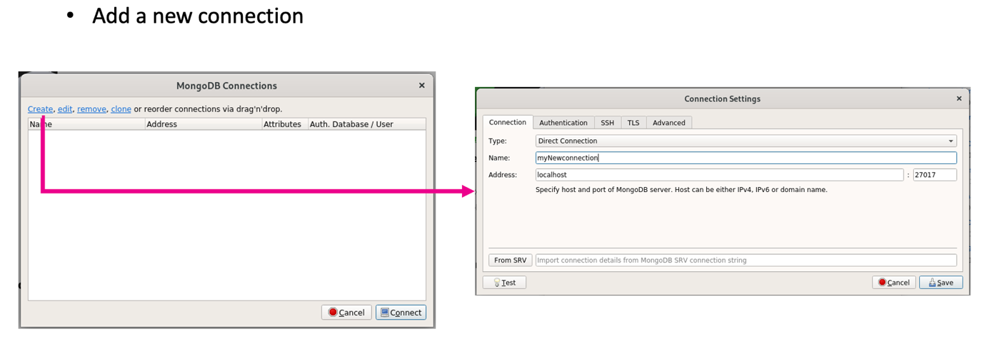

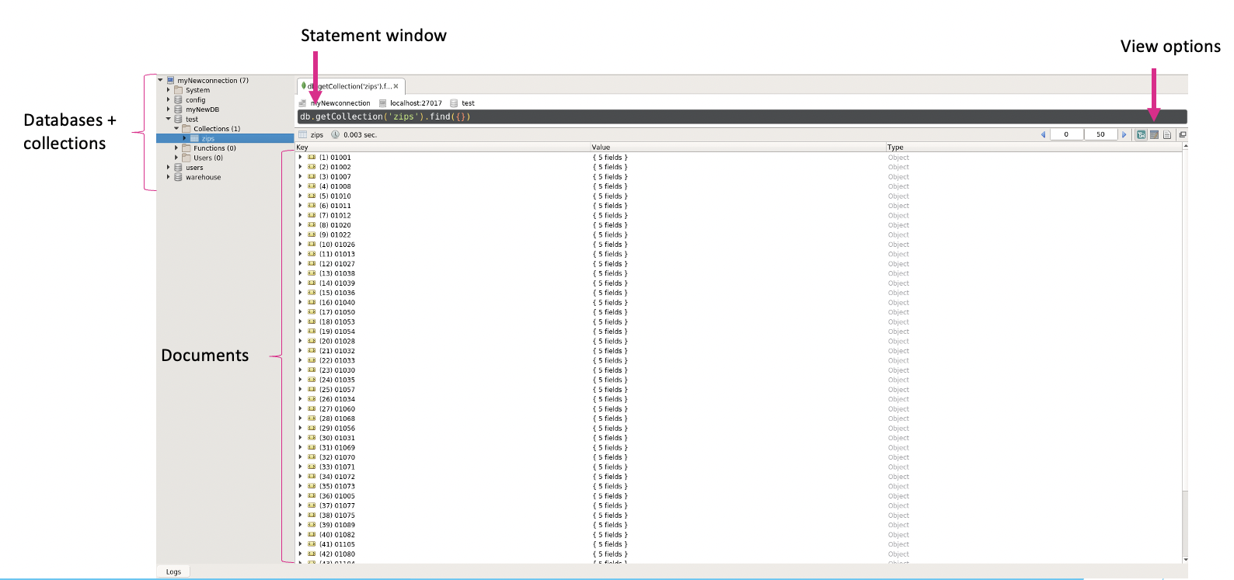

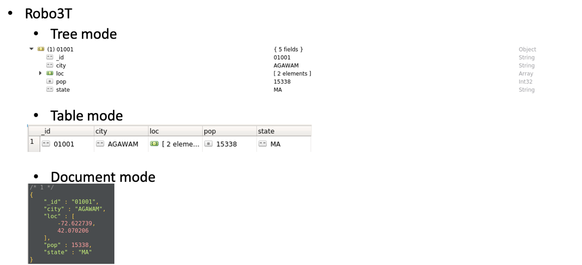

→ use symbols on the top right to switch between different modes.

→ in document mode: /* */ comment shows the document number.

**Exercises**

1. **Import the beer information from *beers.json***

$mongoimport beers.json

1. **How many beers are there in the database?**

>db.beers.find().count()

→ if you want to make sure you do not count double entries:

>db.beers.aggregate([

{$group:{_id:”$beer”}},

{$count:”number_of_beers”}

])

→ $count will count the remaining records after the grouping and store the result in a field called “number_of_beers”

1. **Return the first 5 beers.**

>db.beers.find().limit(5)

1. **How many beers in the database are of type “blond troebel”?**

>db.beers.find({type:”blond troebel”})

Better solution:

>db.beers.find({type:{$in:[“blond troebel”] } } )

Type is an array, in this case it is better to use the $in. If you want to make sure that it can only be “blond troebel” and not for example “blond troebel bier”, you should use $all

1. **Of these “blond troebel” beers, only return the name.**

>db.beers.find({type:{$in:[“blond troebel”]}} , {_id:0, beer:1})

1. **How many beers have a percentage alcohol of more than 8 degrees?**

>db.beers.find({alcoholpercentage:{$gt:8}}).count()

1. **How many beers have low alcohol (“alcoholarm”)?**

>db.beers.find({type:{$in:[“alcoholarm”] } } ).count()

Note: if you cannot see in which attribute this belongs, you can open the file in nano and use ctl+w to open a search and type alcoholarm!!!

If you want to make it case insensitive you can use regex:

>db.beers.find({type:{$in:[“**/^alcoholarm$/i**”] } } ).count()

1. **What is the average alcoholpercentage per brewery?**

>db.beers.aggregate([

{$group:{_id:”brewery”, avgAlcohol:{$avg:”$alcoholpercentage”} } }

])

1. **What is the average alcoholpercentage per type of beer? Sort by alcoholpercentage.**

>db.beers.aggregate([

{$group:{_id:”type”, avgAlcohol:{$avg:”$alcoholpercentage”}}},

{$sort:{avgAlcohol:-1}}

])

1. **What is the range (max - min) of alcoholpercentage for beers per brewery that brews more than 1 beer?**

>db.beers.aggregate([

{$group:{_id:”$brewery”, nbeers:{$sum:1}, minA:{$max:”$alcoholpercentage”}, maxA:{$max:”$alcoholpercentage”} } },

{$match:{nbeers:{$gt: 1} } },

**{$addFields:{alcoholRange:{$subtract:[“$maxA”, “$minA”]} } },**

**{$project:{alcholRange:1} }**

])

→ to calculate the range you have use the $addFields, this allows you to add extra fields to the cursor. Always use this for adding some calculation.

→ subtract uses an array, since you are calculating based on something from upstream in the pipeline you need to use the “$maxA”: quotation marks and dollar sign!

→ the $project can be used, to only show some specific fields, specify a field with the name and then 0 or 1 for true or false resp. Not part of the exercise.

**Exercises extra**

1. **Import genes.json into a database called “genome”**

(Hint: use mongoimport --help to find how to import data into a specific database)

$mongoimport -d genome genes.json

1. **Show the unique symbols of the genes.**

>db.genes.find({}, {symbol:1})

>db.genes.distinct(“symbol”)

1. **How many organisms are in this collection?**

>db.genes.find().count()

→ this will give you the amount of records which is genes

>db.genes.aggregate([

{$group:{_id:”$taxname”}},

{$count:”number_of_organisms”}

])

→ $count will count the number of documents remaining after the previous pipes and store this value in “number_of_organisms” (you name it yourself) and returns this field!

>db.genes.distinct(“tax_name”).length

→ distinct(“tax_name”) returns an array; the .length returns the number of elements in the array.

1. **How many genes do not have synonyms?**

>db.genes.find(

{synonyms:{$exists:0} }).count()

**Afterwards: show the symbols of these genes.**

>db.genes.find([

{synonyms:{$exists:0}},

{_id:0, symbol:1}

])

1. **How many genes are there per gene type? (Hint: gene type, not transcript types).**

>db.genes.aggregate([

{$group:{_id:”$type”, count:{$sum:1}}}

])

**Afterwards: show only the types if there are more than 10 genes for this type.**

>db.genes.aggregate([

{$group:{_id:”$type”, count:{$sum:1}}},

{$match:{count:{$gt:10}}}

])

1. **How many transcripts are there per gene?**
   * Hint: not all genes have transcripts! You might have to filter these out first!

>db.genes.aggregate([

{$match:{transcripts:{$exists:1}}},

{$group:{_id:{”$gene_id”, “$transcripts”} } },

{$project:{number_of_transcripts:{$size:”$_id.transcripts”} } }

])

* + Show only the gene_id and transcript count.

>db.genes.aggregate([

{$match:{transcripts:{$exists:1}}},

{$group:{_id:{”$gene_id”, “$transcripts”} } },

{$project:{number_of_transcripts:{$size:”$transcripts”}, gene_id:1} }

])

* + Order the results by transcript counts.

>db.genes.aggregate([

{$match:{transcripts:{$exists:1}}},

{$group:{_id:{”$gene_id”, “$transcripts”} } },

{$project:{number_of_transcripts:{$size:”$transcripts”}, gene_id:1} },

{$sort:{number_of_transcripts:-1}}

])

* + Show only the third and fourth result from the previous query.

>db.genes.aggregate([

{$match:{transcripts:{$exists:1}}},

{$group:{_id:{”$gene_id”, “$transcripts”} } },

{$project:{number_of_transcripts:{$size:”$transcripts”}, gene_id:1} },

{$sort:{number_of_transcripts:-1}}

{$skip:2}, {limit:2}

])

→ note that you first skip and the limit!

1. **How many exons are there per transcript?**
   * Hint: take a look at the $unwind operator

>db.genes.aggregate([

{$unwind:“$transcripts”}

])

→ $unwind operator will take the transcripts array and unwind it into an embedded document. It will take every value from the array and create a separate document for each one, but retain all the other information from the original document! Now you have a document with each gene-transcript combination!!!!

* + Show the gene_id, transcript.accession_version and the amount of exons.

>db.genes.aggregate([

{$unwind:{“$transcripts”}},

{$project:{gene_id:1, “transcripts.accession_version”:1, nExons:{$size:”$transcripts.exons.range”} } }

])

Databases, APIs, version control

**Exercises**

1. **Import the protein coding genes from file protCodingGenes.bson**

**$ mongorestore --collection protCodingGenes --db test protCodingGenes.bson**

1. **Return the first 10 genes (alphabetically) on chromosome 22**

>db.protCodingGenes.find(

{“Chromosome Name”:22}

).sort({“Associated Gene Name”:1}).limit(10)

1. **Return the last but one group of 10 genes (by position) on chromosome 12.**

>db.protCodingGenes.find(

{“Chromosome Name”:12}

).sort({“Gene Start (bp)”:-1}).limit(10)

1. **Return the number of unique gene names.**

>db.protCodingGenes.distinct(“Associated Gene Name”)**.length**

**IMPORTANT: no curly brackets inside the distinct function!!!!!!!!!!!!!!!!!!**

**Use .length to calculate the number of elements in an array!!!!!!!!!!!!!!!!**

1. **Return the 50 most common genes and their number of occurrences.**

>db.protCodingGenes.aggregate([

{$group:{_id:”$Associated Gene Name”, occurences:{$sum:1} } },

{$sort:{occurences:-1}},

{limit:50}

])

1. **Return a sorted list of the number of genes per chromosome.**

>db.protCodingGenes.aggregate([

{$group:{_id:”$Chromosome Name”, nGenes:{$sum:1} } },

{$sort:{nGenes:-1}}

])

**Databases in bioinformatics**

**Why?**

* Make biological data available for scientists (=Findable/Accessible).
  + Collect data in a central location/single place.
  + Published data may be difficult to find.
* Make biological data available in computer-readable form (=Interoperable).
  + Needed for analysis.
* Link to data collection (Reproducible).
  + How was data produced.
* Adhere to the **FAIR** principles.

**Types of databases**

* Characterization based on several properties
  + Type of data
  + Data entry and quality control
  + Primary or derived data?
  + Technical design
  + Maintainer status
  + Availability

1. **Type of data**

* Nucleotide sequences
  + GenBank, ENA, DDBJ
* Protein sequences
  + NCBI protein, UniProt
* Gene expression data
  + GEO, Expression Atlas, The Human Protein Atlas
* Metabolic pathways
  + KEGG, Reactome, BioCyc
* 3D structures
  + RCSB PDB, NCBI Structure, PDBe

1. **Data entry and quality control**

* Data deposited directly
* Appointed curators add and update data
* Treatment of errors in data: removed and marked. Curators check for errors and mark/remove the errors.
* Type and degree of error checking
* E.g. Trembl (automatically annoted) vs SwissProt (manually annotated)

1. **Primary or derived data**

* Primary databases contain raw data, directly from the machine. E.g. SRA database contains Short Reads from sequencing
* Secondary databases: results of analysis of primary databases
  + Processed data
* Aggregate of many databases
  + Consolidation of data
  + Combination of data
  + Collection of multiple databases linked together
  + E.g. NCBI, EBI

1. **Technical design**

* Most databases use a flat file format
  + GenBank, UniProtKB/SwissProt
* Relational databases
  + Links between databases in NCBI
* Object oriented databases
  + Ensembl

1. **Maintainer status**

* Large, public institution
  + NCBI, EMBL
* Quasi-academic institution
  + Swiss Institute of Bioinformatics, TIGR, UCSC
* Academic group or scientist
* Commercial company

1. **Availability**

* Publicly available, no restrictions
* Available, with copyright
* Accessible, not downloadable
* Academic, not freely available
* Commercial

**Identifiers and accession codes**

Most databases use an identifier and/or accession code to identify records in the database.

→ Identify an entry in two different ways:

* Identifier
  + String of letters and digits (understandable)
  + Can usually change
* Accession code (or number)
  + Number that uniquely identifies an entry in the database
  + Stable (fixed), cannot be changed!

**Primary nucleotide databases**

3 main databases

* EMBL (ENA), GenBank, DDBJ
* Little error checking
* Lots of redundancy
* Synchronized on a daily basis
* No legal restrictions

**European Nucleotide Archive (ENA)**

* Contains both RNA and DNA sequences
* Contains 3 databases:
  + Sequence Read Archive (SRA): raw reads
  + Trace Archive (discontinued, but still accessible via FTP)
  + EMBL Nucleotide Archive
* Maintained by European Bioinformatics Institute (EBI)
* Data available in many formats:
  + XML, HTML, FASTA, FASTQ
* <https://www.ebi.ac.uk/ena/browser/>

**GenBank**

* Open access
* Publicly available nucleotide sequences and their protein translations
* 243654 distinct organisms
* Maintained by National Center for Biotechnology Information (NCBI)
* Entries retrievable by NCBI GenBank webpage or FTP
* <https://www.ncbi.nlm.nih.gov/genbank/>
* Flatfile with 3 main sections:
* Header
* Features
* Sequence

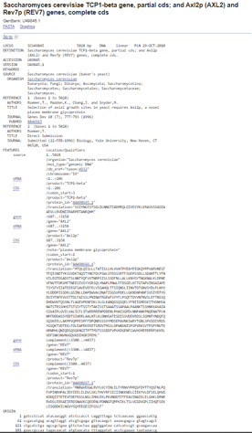

**DNA DataBank of Japan (DDBJ)**

* Only contains DNA sequences
* Only nucleotide sequence database in Japan
* <https://www.ddbj.nig.ac.jp/index-e.html>

**Secundary nucleotide sequence databases**

* RefSeq database
  + DNA, RNA and protein sequences
  + Annotated and curated
  + Single record for each natural biological molecule
* OMIM
  + Catalog of human genes and genetic disorders and traits
  + Based on selection and review of published peer-reviewed literature
* HapMap
  + Haplotype map of the human genome
  + Genetic variants affecting health, diseases, response to drugs and environmental factors

**Other nucleotide databases**

* Gene expression databases
  + Mostly microarray data
  + E.g. Gene Expression Omnibus (GEO), Expression Atlas, etc.
* Gene ontology (GO)
  + Unify gene and gene products attributes (controlled vocabulary, annotation)
  + E.g. Amigo, etc.
* Genome databases
  + Annotated and analyzed genome sequences
  + E.g. Ensemble Genomes, NCBI Genomes, Flybase, Wormbase, etc.
* Phenotype databases
  + Link between genotype and phenotype
  + E.g. PheGenl, etc.
* RNA databases
  + Specific non-coding RNA
  + E.g. miRbase, LNCipedia, etc.

**Sequencing databases**

* Datasets from sequencing experiments
  + Sequence Read Archive (SRA)
    - Hosted by NCBI
    - Data in FASTQ- or BAM-format
    - Experimental metadata available
* European Genome-phenome Project
  + Hosted by EMBL-EBI
  + Data not publicly available

**Protein databases**

* Protein sequences
  + Derived from translation of nucleotide sequences
    - Secondary databases: NCBI Protein and trEMBL
  + Computational analysis, manual review and annotation
    - SwissProt
* Protein Structure
  + E.g. Protein Data Bank (PDB), NCBI Structure

**The general feature format**

Format often used in bioinformatics. Is a file that describes features of a particular gene, DNA or protein sequence.

* TAB delimited.
* One line per feature.
* All but final in each feature line must contain a value; “empty” columns should be denoted with a dot (.)
* Version 3: GFF3

Overview of columns:

* **seqname**: name of the chromosome or scaffold; chromosome names can be given with or without the 'chr' prefix.

**Important note**: the seqname must be one used within Ensembl, i.e. a standard chromosome name or an Ensembl identifier such as a scaffold ID, without any additional content such as species or assembly.

* **source** - name of the program that generated this feature, or the data source (database or project name)
* **feature** - feature type name, e.g. Gene, Variation, Similarity
* **start** - Start position of the feature, with sequence numbering **starting at 1**.
* **end** - End position of the feature, with sequence numbering **starting at 1**.
* **score** - A floating point value.
* **strand** - defined as + (forward) or - (reverse).
* **frame** - One of '0', '1' or '2'. '0' indicates that the first base of the feature is the first base of a codon, '1’ that the second base is the first base of a codon, and so on..
* **attribute** - A semicolon-separated list of tag-value pairs, providing additional information about each feature.

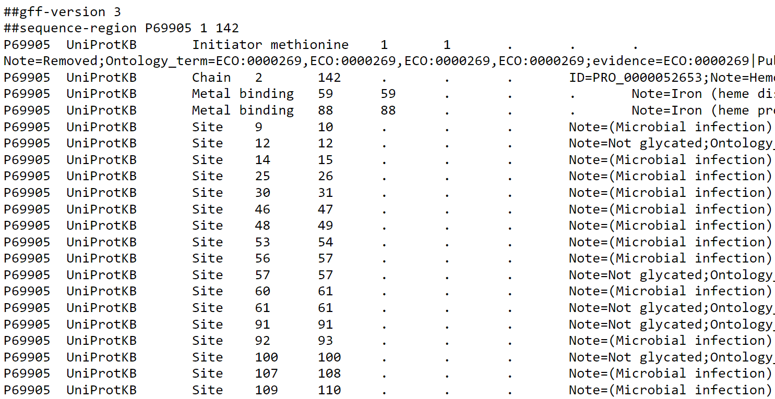

**Genome browsers**

* Graphical interface for genomic data
* USCS Genome Browser
  + Search by gene name
  + Search by location (chrN:startPosition:stopPosition)
  + [Genome browsers](https://genome.ucsc.edu/cgi-bin/hgTracks?db=hg38&lastVirtModeType=default&lastVirtModeExtraState=&virtModeType=default&virtMode=0&nonVirtPosition=&position=chr16%3A176680%2D177522&hgsid=985212017_b13p4uj8IVna7IRLoQcaaTQiWDTx)

Download a sequence: select the gene/region > View > DNA > select options > get DNA

* Ensembl Genome Browser
  + Annotated genes aligned to a reference genome
  + Export data in multiple formats (FASTA, GFF, EMBL, …)

**Exercises**

1. **What information about the rabies virus sequence can you obtain from its annotations in the NCBI Sequence Database? Give the accession number, definition, organism and PubMed ID of the record.**

Select All databases and look for Rabies virus; or look directly in gene.

Accession number: NC_001542

Definition: Rabies virus, complete genome.

Organism: [Rabies lyssavirus](https://www.ncbi.nlm.nih.gov/Taxonomy/Browser/wwwtax.cgi?id=11292)

Viruses; Riboviria; Orthornavirae; Negarnaviricota; Haploviricotina; Monjiviricetes; Mononegavirales; Rhabdoviridae; Lyssavirus.

# PubMed ID: 9627197

1. **How many nucleotide sequences are there from the bacterium Chlamydia trachomatis?**

Start from Taxonomy: look for bacterium Chlamydia

→ 77197 nucleotide sequences (including subspecies) in Nucleotide database

1. **How many nucleotide sequences are there from the bacterium Chlamydia trachomatis in the RefSeq part of the NCBI Sequence Database?**

Start from Taxonomy: look for bacterium Chlamydia

If you click on the link (Nucleotide), on left you can select RefSeq.

→ 571 sequences

1. **How many nucleotide sequences were submitted to NCBI by Matthew Berriman?**

Look for Matthew Berriman in NCBI database Nucleotide

Lefthand side: make sure only nucleotide is selected

→ 1

1. **How many nucleotide sequences from the nematode worms are there in the RefSeq Database?**

Taxonomy > Nematode > Nucleotide

→ 1914025

1. **How many nucleotide sequences for collagen genes from nematode worms are there in the NCBI Database?**

Taxonomy > Nematode > Nucleotide (subtree)

… AND collagen

→ 3848

1. **How many mRNA sequences for collagen genes from nematode worms are there in the NCBI Database?**

Taxonomy > Nematode > Nucleotide (subtree)

… AND collagen

Lefthand side: mRNA

→ 867

1. **How many protein sequences for collagen proteins from nematode worms are there in the NCBI database?**

Taxonomy > Nematode > Protein (subtree)

… AND collagen

→ 8471

Or from previous query and select Protein database

1. **What is the accession number for the Trypanosoma cruzi genome in NCBI?**

NCBI Nucleotide > Trypanosoma cruzi AND genome

#### Genome assembly: [ASM1503365v1](https://www.ncbi.nlm.nih.gov/assembly/GCA_015033655.1) > In graphic representation: click graphics or GenBank

→ NW_001849447.1

1. **How many fully sequenced nematode worm species are represented in the NCBI Genome database?**

Taxonomy > Nematode > Genome

→ 140

1. **Find the accession number of human beta-globin mRNA sequence. What is the accession number of the encoded protein ? How many amino acids does it contain?**

Taxonomy > human > Nucleotide (direct link)

Lefthand side: mRNA and RefSeq

→ NM_000518

**Query MySQL databases directly**

* **UCSC**
  + Hostname: genome-mysql.cse.ucsc.edu
  + User: genome
  + Password:

From command line:

**$mysql -h genome-mysql.cse.ucsc.edu -u genome -p**

→ When asked for password, just press enter.

→ Now you can just check and use databases from UCSC via your mysql-monitor!

→ Example: hg38 is the human genome.

* **Gene Ontology**
  + Hostname: mysql-amigo.ebi.ac.uk
  + User: go_select
  + Password: amigo
  + Database: go_latest
  + Port: 4085

From command line:

**$mysql -h mysql-amigo.ebi.ac.uk -u go_select -p**

→ When asked for password, enter: **amigo** and press enter.

→ Now you can just check and use databases from Gene Ontology via your mysql-monitor!

* **Ensembl**
  + Hostname: ensembldb.ensembl.org
  + User: anonymous
  + Password:
  + **$mysql -h ensembldb.ensembl.org -u anonymous -p**

→ When asked for password, just press enter.

Downside of these databases is that they use complex database schemas and are often not suited for retrieving sequences! This is where APIs can provide a solution.

**APIs**

* **Application Programming Interface**
* Uniform method of access to data. Same query for every user.
* Reusable in different systems. Across different programming languages.
* Reliable. E.g. if there is an update they ensure the API can handle it.
* Insulates developers to underlying database changes. E.g. if a table name is changed, they would ensure that the API handles it so that an old query still works.

Ensembl API

* Perl API, written in perl.
* Installation instructions on website
* Different versions based on Ensembl release
* Use Registry to find Ensembl database and connect to them
* We will use different way to accessing them, so not Perl
* **Several databases:**
  + **Core (genes, transcripts, translations, assembly, sequence)**
  + **Compara (SNVs, CNVs, somatic variations, phenotypes)**
  + **Variation (gene trees, homologies, multiple and pairwise genomic alignments)**
  + **Regulation (regulation, motifs, array probes)**

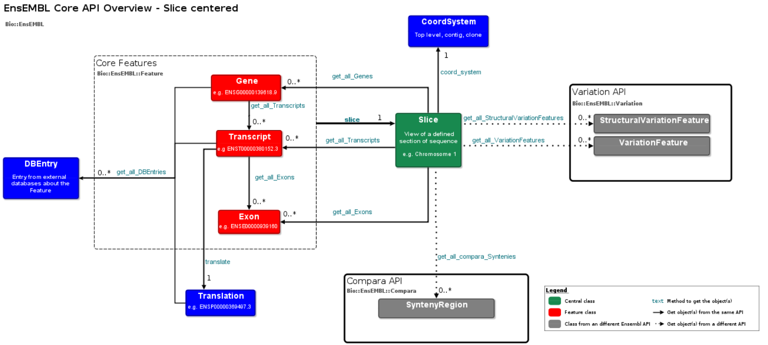

**Core database**

* Has information for every organism in Ensembl.
* And are species specific databases. (You can only ask for human, not human and mouse.)

**Compara database**

* Cross-species database
* Genome-wide comparisons
  + DNA sequence level
    - Whole genome alignments
    - Synteny regions
    - Conservation scores/constrained elements
* Gene level
  + Phylogenetic trees are stored
  + Homology predictions

**Variation database**

* Contains all information pertaining to variation
  + Areas of the genome that differ between individual genomes
  + Associated disease and phenotype information
  + Different types of variants
    - Sequence variants
      * SNP (single nucleotide polymorphisms)
      * Insertion (one or more nucleotides)
      * Deletion (one or more nucleotides)
      * Indel (insertion and deletion, affecting 2 or more nucleotides)
      * Substitution (no change in length)
    - Structural variants
      * CNV (copy number variants)
      * Inversion
      * Translocation

**Regulation database**

* Gene expression and its regulation in human and mouse
* Focus on transcriptional and post-transcriptional mechanisms

**REST API**

* Representable State Transfer
* Is a web API that adheres to specific rules: called RESTful APIs
* Base URI (URL) e.g. <http://api.example.com/>
* Uses standard HTTP methods (CRUD)
  + GET: list or retrieve data
  + PUT: replace or create
  + POST: create a new entry
  + DELETE: remove
  + OPTIONS: determine options/requirements/capabilities of server

**Ensemble REST API**

* [http://rest.ensembl.org](http://rest.ensembl.org/) is the base URL where you start from. The base URL also links to the documentation.
* Language agnostic bindings to Ensembl data
  + No requirement for a specific programming language
  + Independent of programming language
* Able to create a REST client in
  + JAVA
  + Perl
  + Python
  + R
  + Ruby
  + …
* Client is short program that can interact with the database where you can include some scripts to interact with the database

URL structure:



* + 0 or more required parameters
  + 0 or more optional parameters
  + In standard URL required parameters are flagged with a “:” e.g. “:species”
  + Optional parameters should go into the request body when performing a POST or as key-value pairs after “?” if performing a GET

You can get the URL structure from the website!

When you click on the links you can see what is required and what is optional. What is on the base documentation site.

Example:

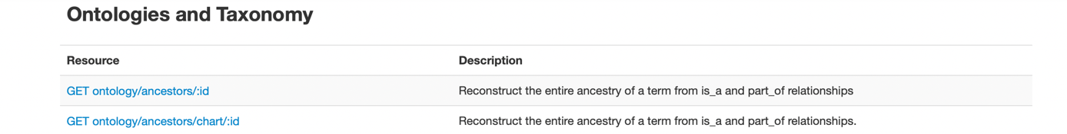

GET ontology/ancestors/:id

→ GET just notes that this is a GET request!

→ Ontology/ancestors/:id is what will be put after the base URL:

<http://rest.ensembl.org/ontology/ancestors/:id>

→ the **:** indicates some value that needs to be provided, here an id. So not actually type :id but replace :id with the id of the organism

Example:

http://rest.ensembl.org/ontology/ancestors/GO:0005667

→ everything you see on the base documentation site will be required

→ additional options can be specified after the standard URL, click on the link to see which optional parameters are available for a specific request.

→ when performing a GET request you can specify optional parameters after a question mark (?) as a key-value pair.

Example:

http://rest.ensembl.org/ontology/ancestors/GO:0005667?content-type=application/json

→ when performing a POST you will need to provide the optional parameters in the request body, since they are not in the URL itself:

* Here you use **curl = Client URL**
* Allows command line interaction with URLs

**$curl <URL> [-H <header>] [-X <request_method>] [-d data]**

**-H <header>**  can be provided to fool a website that you are sending the request from a browser

**-X <request_method>** POST or GET

**-d data** the data (script)

**Parameters**

* Specify what is required and type of returned data from REST API
* Different parameters are available
  + id
  + region
  + species
  + symbol
  + external_db
  + object_type
  + callback

Output formats

* JSON, FASTA, BED, XML, …
* Depends on client and operation. Other APIs may support other file formats.
  + GET → different options to specify the output header:
    - Content-type HTTP header on the command line

curl -H "Content-Type: application/json" http://rest.ensembl.org/info/ping

* + - Content-type HTTP parameter, in the URL after the?

curl http://rest.ensembl.org/info/ping?content-type=application/json

* + - Accept HTTP header, on the command line

curl -H "Accept: application/json" http://rest.ensembl.org/info/ping

* + - File extension

curl <http://rest.ensembl.org/info/ping.json>

* POST
  + Accept HTTP header

Examples for retrieving sequences:

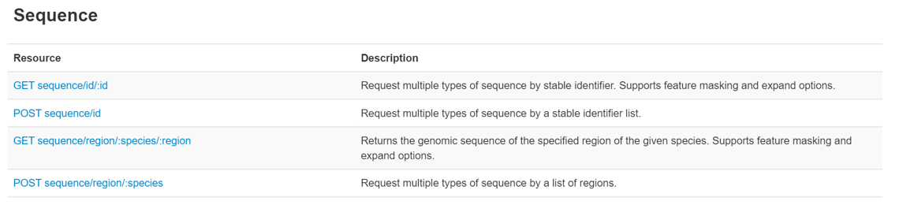

Example:

$curl 'https://rest.ensembl.org/sequence/id/ENSG00000157764' -H 'Content-type:text/plain'

**Exercises**

Always start from the website (<https://rest.ensembl.org>) and look for an example to start from.

1. **Return the archived sequence with Ensembl id *ENSG00000141510***

Example from the website:

1. curl 'http://rest.ensembl.org/archive/id/ENSG00000157764?' -H 'Content-type:application/json'

$curl ‘http://rest.ensembl.org/archive/id/ENSG00000141510?’ -H ‘Content-type:application/json’

1. **Return the archived sequence for both *ENSG00000012048* and *ENSG00000136997***
2. curl 'http://rest.ensembl.org/archive/id' -H 'Content-type:application/json' \
3. -H 'Accept:application/json' -X POST -d '{ "id" : ["ENSG00000157764", "ENSG00000248378"] }'

$curl ‘http://rest.ensembl.org/archive/id’ -H ‘Content-type:application/json’ \

-H ‘Accept:application/json’ -X POST -d ‘{“id” : [“***ENSG00000012048”, “ENSG00000136997”***]}’

1. **Return a condensed XML-list of all orthologues in Mus musculus for *ENSG00000159763***
2. curl 'https://rest.ensembl.org/homology/id/ENSG00000157764?format=condensed;type=orthologues' -H 'Content-type:text/xml'

$curl 'https://rest.ensembl.org/**homology/id/**ENSG00000159763?format=condensed;type=orthologues;target_taxon=10090'

-H 'Content-type:text/xml'

1. **Do the same for BRCA2**
   * + *HINTS: type=orthologues*
     + *target_taxon=<taxon_id>*
     + *format=condensed*

$curl 'https://rest.ensembl.org/**homology/symbol/human/**BRCA2?format=condensed;type=orthologues;target_taxon=10090'

-H 'Content-type:text/xml'

→ BRCA2 is a human gene, needs to be specified, otherwise error. The previous was also human; but the ID itself already refers to a human gene!!!!!!!

1. **Retrieve the genomic FASTA sequence for *ENST00000288602.10***

*$curl ‘http/rest.ensembl.org/sequence/id/ENST00000288602?type=genomic’*

*-H ‘Content-type:text/x-fasta’*

*→ leave out the version number (.1); it will always get the latest version; this is actually .11.*

1. **Get a sequence from 100 nucleotides located on human chromosome 2 starting at position 100000.**

$curl ‘http://rest.ensembl.org/sequence/region/human/2:100000..100100?’

-H ‘Content-type:text/plain’

→ you can also specify the strand:

$curl ‘http://rest.ensembl.org/sequence/region/human/2:100000..100100**:1**?’

-H ‘Content-type:text/plain’

$curl ‘http://rest.ensembl.org/sequence/region/human/2:100000..100100**:-1**?’

-H ‘Content-type:text/plain’

1. **Show the taxonomy information of the mouse.**

$curl ‘http://rest.ensembl.org/taxonomy/name/mouse’ -H ‘Content-type:text/plain’

1. **Find the species and the database for *ENSMUSG00000059552.***

*$curl ‘http://rest.ensembl.org/lookup/id/ENSMUSG00000059552?’*

*-H ‘Content-type:application/json’*

1. **Return the length of following chromosomes in human and mouse**
   * **2**
   * **7**
   * **X**
   * **Which are the longest?**

$curl ‘http://rest.ensembl.org/info/assembly/homo_sapiens/2?content-type:text/plain’

$curl ‘http://rest.ensembl.org/info/assembly/homo_sapiens/7?content-type:text/plain’

$curl ‘http://rest.ensembl.org/info/assembly/homo_sapiens/X?content-type:text/plain’

$curl ‘http://rest.ensembl.org/info/assembly/mus_musculus/2?content-type:text/plain’

$curl ‘http://rest.ensembl.org/info/assembly/mus_musculus/7?content-type:text/plain’

$curl ‘http://rest.ensembl.org/info/assembly/mus_musculus/X?content-type:text/plain’

Version control (GIT)

<https://github.com/git/git/blob/e83c5163316f89bfbde7d9ab23ca2e25604af290/README>

**Version control manager**

→ track and store revisions/versions of files

→ track changes to scripts

* **Help**

**$git help [command]**

* **Configuration**

**$git config**

→ you can create a directory and whenever you change a file in this directory, git will now and automatically save/track these changes.

→ First create a directory and go into this directory:

**$mkdir dirname**

**$cd dirname**

→ to make this a git directory, just use the $git init command inside the folder:

**$git init**

→ now a .git directory is created inside this folder.

* This directory contains all information for git
* Contains the changes that git tracks overtime
* Do NOT delete after creating!
* You do not need to access this folder!
* Use $ls -a to see the dir (is a hidden directory)

**$ls -a**

→ to check the status of the directory, use the $git status command. This will provide information on:

* Branch
* Commits
* Files that aren’t commited yet

**$git status**

Output:

*On branch master → current branch you are in*

*No commits yet → no files commited*

*Nothing to commit → nothing to commit since there are no files in the directory*

→ When you create a file in the directory, git will know, but will not yet track the file!

**$git status**

Output:

*On branch master → current branch you are in*

*No commits yet → no files commited*

*Untracked files: → files in the directory that are not yet being tracked!*

*Nothing added to commit, but untracked files present*

→ You need to tell git to track a file:

**$git add name.file**

**$git status**

Output:

*On branch master → current branch you are in*

*No commits yet → no files commited*

*Changes to be committed: →files that are flagged for tracking*

→ But you still need to commit the file. This means that any changes to the file wil be saved. If you do not do this, then changes will still not be saved!

Note: the changes will be saved in the file itself, but will not be tracked by git!

→ everytime you made changes and want to track them, you commit the file.

**$git commit -m “comment describing the changes”**

Use the -m option to add a comment in which you specify what changes are being made.

→ to see what changes have been comitted, you use the $git log command:

**$git log**

Output:

*Commit bb360a1s3456d3979879 (HEAD -> master)*

*Author: guest* [*guest@localhost.localdomain*](mailto:guest@localhost.localdomain)

*Date: Sun May 2 19:14:58 2021 +0200*

*Comment describing the changes*

→ the commit is given a identifier (called a commit hash), you will see who (author) and when (date) the commit was made and the comment specified in the commit will be displayed!

→ if you know make new changes to the file:

**$git status**

Output:

*On branch master*

*Changes not staged for commit: → you will see that changes have been made to the*

*modified: file.name → file, but they have not been committed yet!*

*No changes added to commit.*

→to commit the new changes, you first need to add the file again and the commit:

$git add file.name

$git commit -m “message”

→ use **$git commit -am “message”** to do this in one go!!!!!

→ Note that only using the $git commit -m “message” without adding again does not work!

→ to see the changes that have been made:

**$git diff *hash.from.previous.commit hash.from.new.commit***

→ changes will be shown in a separate color!

→ when there are multiple files, it will show any changes made across both

**Branching**

* + Default: master branch. Will be automatically created.
  + Different versions of same project (for example when making changes to a script that you are not sure are going to work, and you want to keep the original one. Or when multiple people are working together on same project)
  + Create new branches
  + The files from the original branch will be in the new branches, they are copies!
  + Merge branches back into master

→ to see branch the available branches:

**$git branch**

→ the branch you are on will be highlighted.

→ to create a new branch:

**$git branch** branchName

→ to switch to another branch:

**$git checkout** branchName

**→ changes made in the file in one branch will not be made in another branch after committing the script on a specific branch! When you make a change, the change will be visible in all copies (all branches). You will also see that a commit is available for all the branches for this file. But you can commit on a specific branch (while on the branch) and then the changes will only be made on the file for this branch and not on the other branches!**

→ the change will also only be visible in the log for the branch where the change has been committed!!!!

→ when you want to add the changes made on one branch to another branch (merge branches) you can do this with:

**$git merge** branchName

→ **IMPORTANT that you do this from the branch you want to keep!!!!**

→ the merged branch is not removed, but will keep existing, but all files from this branch are now merged with the version on the branch where merged.

→ to remove a branch:

**$git branch -d branchName**

**Remotes**

* cloud based storage of GIT repositories
* Biggest host: [GitHub](https://github.com/)
* Ability to work with multiple people on the same project

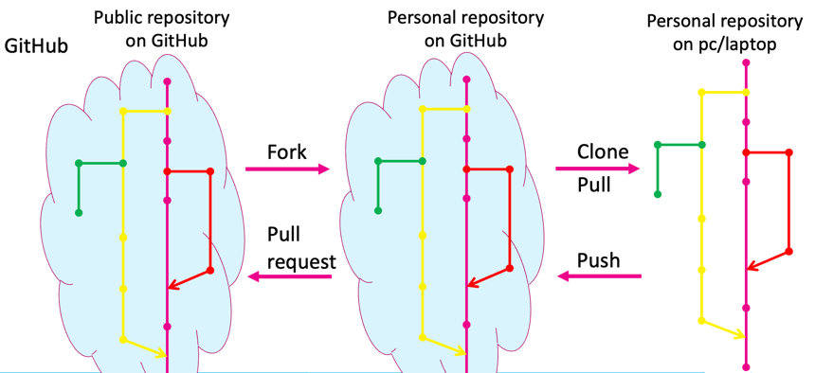

**Setup GitHub**

* Create an account
* In terminal:

$ git config --global --edit

* + Uncomment name and email lines
  + Change name and email to the ones from github
  + Save file
  + Update settings using (from git directory):

$ git commit --amend --reset-author

**Create a GitHub repository**

* Start from website (easiest)
* Give repo a name
* Optional: give a description
* Choose if it’s a public or private repo
* Recommended: add a README file
* Optional: Add .ignore file; this will create a file listing all files you do not wish to track.
* Optional: Choose a License: tells other users what they can and cannot do with your scripts
* Click create repository

**Clone the repository to a local computer**

* Click on Code (on website, on your repository)
  + >HTTP or SSH depending on what you have set up
  + Copy link = <url>

$git clone <url> [<local directory name>]

→ if you don’t specify a directory name, name from GitHub will be used

→ now you have a local repository linked to your github account = called a remote

$git remote

→ show the remote name

$git remote -v

→ verbose: show more info

Perform changes to the repository

* Add/remove files
* Add/commit changes to the files

→ when done locally the commits will not show up in the online repository, you need to push them to the online repository!

→ check remote connections:

$git remote

Default=origin

→ push changes to GitHub:

$git push <remote name> <branch name>

→ provide GitHub login information (username and password); not necessary when connected via SSH

→ on GitHub remote the master is called main

You can also edit files on GitHub and then pull the changes from GitHub into your local repository.

When something is added/changed on GitHub, they will not show up on your local repository with $git status. You can use fetch to see changes on GitHub without committing:

$git fetch <origin> <remote branch>

$git status

Output:

*Your branch is behind ‘origin/main’*

→ fetch will get the info, check this with status

→ Note that fetch will compare your current branch (local) with the specified branch (remote)

→ to download the changes from GitHub you need to pull them from GitHub

$git pull <remote name> <remote branch>

→ also does a fetch

When some project/repository is public, you can also copy this to your own remote personal repository = fork

→ on GitHub from the repository you wish to copy, select fork on the top right

→ now you have a copy (personal repository) on you page. You can make changes (add scripts, etc.). These changes will only be made on your version, but you can send a pull request (bottom on top) to the original owner. If they accept, your scripts could be added to their original repository. Called a pull request, because you are asking the developer to pull the changes from your repository to their version.

To remove a repository from your GitHib, go to the repository, settings and to the danger zone and click delete.

**Exercises**

1. Go to <https://github.com/> and create a new repository db_github
   * Add the README file
2. Clone the GitHub repository to your local machine.
3. Create a new branch and switch to the branch.
4. Place some (course) files in the repository and add/commit the changes
5. Edit the README file with information about the added files
6. Include the changes from the branch in the main branch
7. Delete the second branch
8. Send your changes to GitHub
9. Check the commits on the GitHub website

**SSH**

* Secure shell
  + Secure network protocol for connecting to servers even on unsecured networks.
  + Unique key
  + No password needed when pulling from personal repositories

**Check for existing keys**

$ls -s ~/.shh

* Check if any of the following files already exist
  + *id_rsa.pub*
  + *id_ecdsa.pub*
  + *id_ed25519.pub*

**If key doesn’t exist, create a key**

$ ssh-keygen -t ed25519 -C [github_emailadres@something.com](mailto:github_emailadres@something.com)

* + When asked for a filename: press enter (default name will be given)
  + Enter a passphrase (=password for the SHH key)

→ P1cklerick!

* + Key is now generated

**Adding key to ssh-agent**

* Start ssh-agent

$eval $(ssh-agent -s)

* Add key to ssh-agent

$ssh-add ~/.ssh/id_ed25519

→ enter passphrase

**Adding the key to GitHub account**

* Open public ssh key in text editor

$ gedit ~/.ssh/id_ed25519.pub

* Copy the content of the file
* On GitHub, go to settings -> SSH and GPG keys -> new SSH key
* Give key a name (for example: Virtualbox Fedora)
* Paste key in the key field
* Save

**Test the connection**

$ ssh -T git@github.com

→ Confirm the RSA key fingerprint (type “yes”)

**Changing existing remotes from https to ssh**

* In existing git directory

→ Look at existing remotes

$ git remote –v



* Name of remote we want to change

→ Here: origin

→ the url here is https://... from previous lecture

* On GitHub: copy the ssh connection link from the corresponding repository

→ Click on Code (on website, on your repository)

* + - >SSH
    - Copy link
    - remotename=origin
    - USERNAME=username from GitHub
    - REPOSITORY=name of the repository on GitHub

$ git remote set-url remotename git@github.com:USERNAME/REPOSITORY.git

* Check remote again

$git remote -v

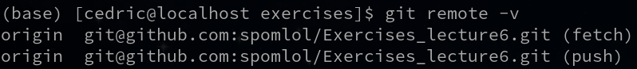

→ changed https://... To git@github....

**Cloning repositories with ssh**

* Similar to https, but now with ssh “url”

$git clone git@github.com:smoothmathninja/HowestRepo.git

→ Sometimes pop-up:

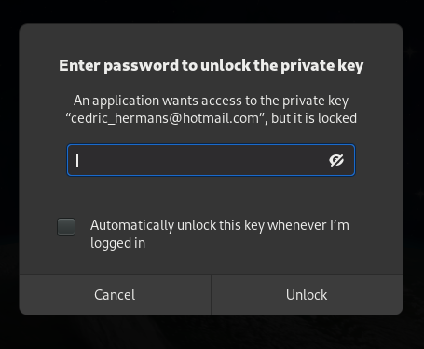

* + This is the passphrase, not host password!
  + Can be allowed automatically by checking  
    the checkbox.

**Visual Studio Code**

→ Options like branches, changing remotes, pulling, pushing, cloning….

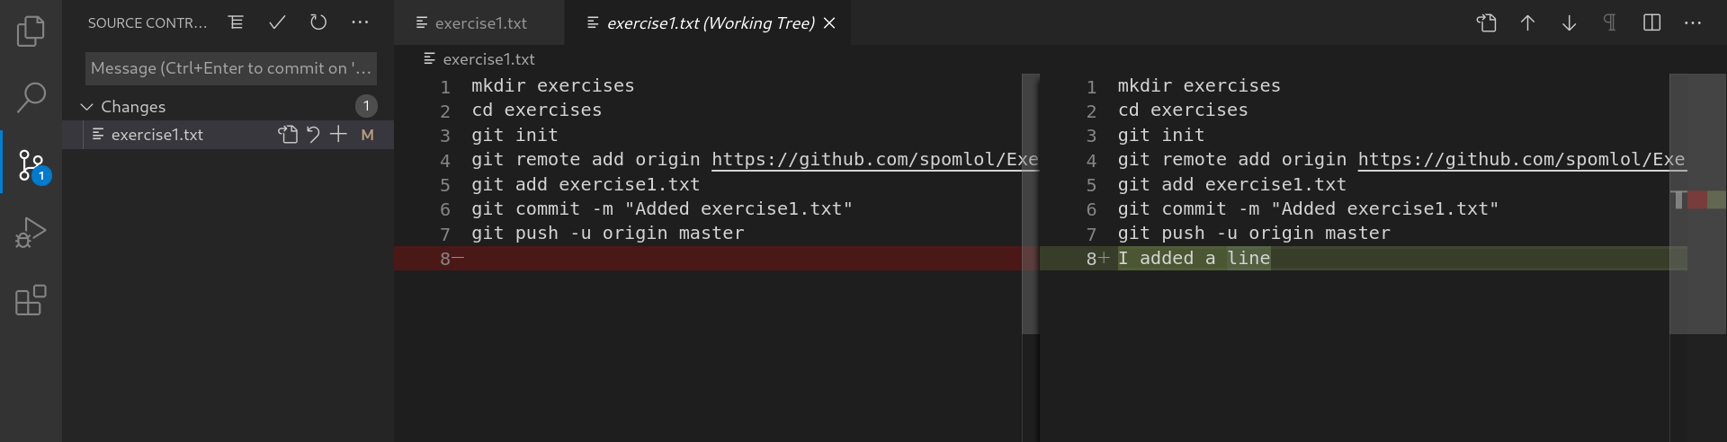

**R Studio**

Will only be available when you create a project (e.g. RMarkdown file, Shiny app, etc.)

Look for Git tab.

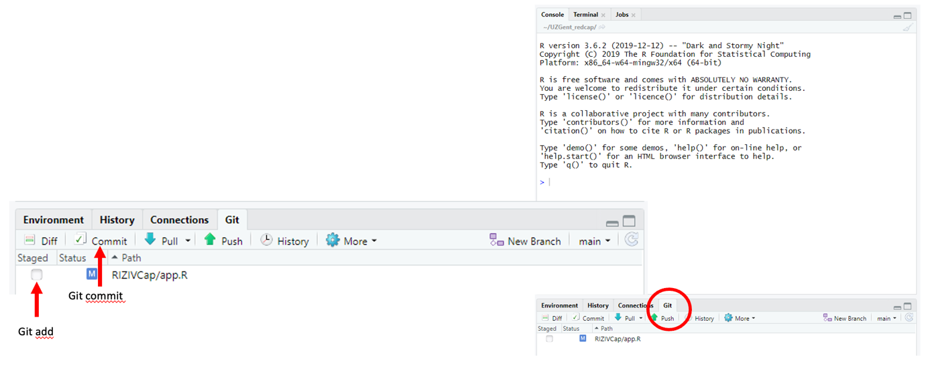

Data management

**FAIR = Findable Accessible Interoperable Reusable**

→ Guidelines for how to manage data correctly!

**Findable**

Data and metadata should be easy to find for both humans and computers!

Data should be assigned a Persistent Identifier (PID) and be described with rich metadata that are available online in a searchable tool.

Example: PIDs for scientific articles, UniProt accession numbers, etc.

Metadata is data about the data.

* Use standard data formats. You can look up standard data formats here: <https://fairsharing.org/>.
* Use a standard schema.

<https://www.dublincore.org/>, or use a tool: [dublin core generator](https://nsteffel.github.io/dublin_core_generator/index.html) to easily create them.

**Accessible**

The user needs to know how the data can be accessed.

(Meta)data should be retrievable by their identifier using a standardized communication protocol. Especially metadata should always be available, for data this is not always necessary.

* For example, http(s)/ftp link to download data.
* It should be clear who, under which conditions, is allowed to access data. Especially with sensitive data, good care should be taken on how the data (and by who) the data can be accessed (e.g. patient data).
* The person from the article should be able to be contacted and should know and provide the correct ways for accessing the data.
* FAIR does not mean that data should free or open. Data can be protected and FAIR. It should be clear who can access the data and under which conditions.

**Interoperable**

Data needs to be integrated with other data, be used by applications or workflows for analysis, storage and processing.

(Meta)data should use a formal, accessible, shared and broadly applicable language for knowledge representation. So basically, use a standardized format that can be widely recognized and used. Don’t create your own format, unless there is no existing standard.

→ (Meta)data needs to be in a standard format that is commonly used:

* TSV, JSON, CSV, FASTQ, SAM, BAM, RDF, OWL
* Depends on the data type, look up standards on <https://fairsharing.org/>
* Simpler is better in most cases e.g .CSV better than .XLSX

**Reusable**

Reusability is the goal of FAIR. The data/results should be able to be replicated by using the (meta)data.

Metadata are richly described with a plurality of accurate and relevant attributes:

* How was the data created (which instruments, software, protocol, etc.).
* Who created the data.
* Why was it created.
* When was it created.

Data should be licensed, preferably open research data (but not obliged).

→ you can use license selector tool to determine which license to use: [License selector](https://ufal.github.io/public-license-selector/)

Restriction on data sharing

Data cannot always be shared openly:

* Personal data
* Confidential data
* Sensitive data
* Third-party data
* Data protected by copyright or of which you are not the sole owner
* Data with commercial/economic valorization potential

This will often need to be explained in a data management plan or your article.

**How to make data FAIR?**

Depends on the use case.

Fairifying data (example)

* Tidy up the data: e.g. convert a word document to excel or even better a CSV file where every column is a variable and every row an observation.
* Convert data to same input format (or limit the possibilities for data input = constraints).
* Set up a GIT repository with an organized structure
  + E.g. based on Cookiecutter repository (others are available)
  + Adapted for specific use case
* Make data reproducible
  + Document steps you take in a document (HTML, RMarkdown, Jupyter notebook, etc.)
* Make data interoperable/reproducible
  + Collaborative possibilities
  + Track changes to the scripts (version control)
* Document with metadata
* Bring everything together in an easy, machine readable manner
  + Publish data (make it findable)

**Data management plan**

→ ensures that data is:

* Secure
* Sustainable
* Easy to find, understand and (re)use

Why:

* Considered good practice
* Decisions made early can save a lot of problems and time in the future
* Considers resources and costs (budgeting)
* May be required for funders
* Helps making data FAIR

**Includes**

→ Planning, collecting and organizing, documenting, storing and backing up, preserving and sharing research data

* Planning
  + Think about what will be needed for the experiment. Will save time in the long run.
* Collecting and organizing
  + What data will be collected and created
  + How and where will it be stored
* Documenting
  + How will processing steps be documented
* Sorting and backing up
  + How/where/for how long is the data stored
  + How often are backups created
* Preserving
  + When project is finished where will the data be kept
* Sharing
  + How will data be shared
  + What are the sharing conditions

There are templates available online: <https://dmponline.dcc.ac.uk/>.

→ data management plan can change during the project and needs to be updated!

**Data management plan – future**

* Institutions/organizations are
  + Recruiting RDM support staff
  + RDM advocacy & training
  + Developing DMP feedback services (rubrics), check of your DMP is okay.
    - E.g. <https://github.com/DMPbelgium/Guidance/tree/master/DMPReviewRubrics>
* **Machine actionable DMPs (maDMPs)**
  + Exchange information with other research tools,  
    systems and parties.
  + Automatic generation & sharing of parts of DMP by computers.
  + In addition to human-readable plan.
  + Why
    - Improve DMP quality
    - Reduce administrative burden
    - Adds value for all RDM stakeholders

**GDPR**

General Data Protection Regulation = EU wide rules for protecting data.

Goal: modernizing and harmonizing EU data protection plans.

**For whom:**

* Data controller/processor based within the EU
  + All personal data of people from any country worldwide

→ people in the EU that handle data from any country has to abide the EU GDPR rules

* Data controller/processor outside of the EU
  + All personal data of people inside the EU

→ people outside the EU that handle data from the EU has to abide the EU GDPR rules

**When :**

* From the moment you are processing personal data
* Processing = any operation or set of operations which is performed on personal data or on sets of personal data, whether or not by automated means
  + Collecting/recording
  + Organizing/structuring
  + Storing
  + Adapting/altering
  + Retrieval/consultation/use
  + Disclosure by transmission, dissemination or otherwise making available
  + Aligning or combining
  + Restriction
  + Erasure/destruction

**What falls under GDPR?**

Personal data

* Data about natural living persons from which they can directly or indirectly be identified.

(e.g. name, address, identification number, location data, online identifier, factors specific to the physical, psychological, genetic, mental, economic, cultural, social, … identity of a natural person)

* Special category of personal data: sensitive data
  + Racial or ethnic origin, political opinions, religious or philosophical beliefs, trade union membership, genetic data, biometric data, health data, data on sex life or sexual orientation
  + Extra rules apply for sensitive data

Pseudonymized data

* Personal (sensitive or not) data that can only be associated with a person by means of a non-public (secret) key
* Only identifiable with use of additional information/identifiers that are kept separately
* Is still personal data
* Falls under GDPR

Anonymous data

* Do not relate to identified or identifiable person
* Nobody knows who the data is coming from
* Anonymized data is NOT GDPR
* But transforming data into anonymous data still falls under GDPR
* Sequencing data is never truly anonymous and still falls under GDPR (for humans)

**Impact on research**

GDPR does not apply to

* Non personal data (animals/plants)
* Personal data related to a diseased person
* Truly anonymized data

If GDPR does apply

* Conditions, requirement and guarantees need to be fulfilled throughout the entire research life cycle

**Benefits**

* Good research practice
* Responsibility, quality and reliability of the research results and the research are guaranteed
* Confidence of citizens in research/science
* No fines

**Challenges**

* Different interpretations (legal grounds, pseudonymized vs anonymous data, open data & protection of data)
* Most companies/institutions have a [data protection officer](https://www.howest.be/nl/opleidingen/postgraduaat/data-protection-officer) (**DPO**) who can be contacted for help with GDPR and DMPs

Retake exercises

Exercise 1

* Create a new folder exercises in your home directory
* Initialize a git repository in this folder
* Make sure your repository is available on GitHub
* Add the answers of the following exercises to this repository, each time with an identifying commit message.
* Save your commands you used to create this git repository in a file named “exercise1.txt” and add it to your repository.

Create folder:

$mkdir exercises

$cd exercises

$git init

→ go to GitHub

→ create a repository: exercises (does not need to be same name)

→ do not add the README, can create problems!

Create link to GitHub from your local repository

$git remote add origin <https://github.com/smoothmathninja/exercises.git>

$git remote

Output: origin (but no link)

$git push -u origin master

Provide username and password

**Exercise 2**

* Normalize the following data to BCNF.
* Describe every step of the process and save the results for every normalization step to a file called exercise2.txt.
* Add the results to your repository from exercise 1. Choose a fitting commit message.

|  |  |  |  |  |  |  |
| --- | --- | --- | --- | --- | --- | --- |
| **staffNo** | **dentistName** | **patientNo** | **patientName** | **appointment** | | **surgeryNo** |
|  |  |  |  | Date | time |  |
| S1011 | Tony Smith | P100 | Gillian White | 12-Aug-16 | 10:00 | S10 |
| S1011 | Tony Smith | P105 | Jill Bell | 13-Aug-16 | 12:00 | S15 |
| S1024 | Helen Pearson | P108 | Ian MacKay | 12-Sept-16 | 10:00 | S10 |
| S1024 | Helen Pearson | P108 | Ian MacKay | 14-Sept-16 | 10:00 | S10 |
| S1032 | Robin Plevin | P105 | Jill Bell | 14-Oct-16 | 16:30 | S15 |
| S1032 | Robin Plevin | P110 | John Walker | 15-Oct-16 | 18:00 | S13 |

Data in unstructured form:

DB(staffNo, dentistName, patientNo, patientName, appointment, surgeryNo)

→ be careful, the appointment_data, appointment_time are not repeating groups. Here the attributes are just not fully defined, so for the UNF this is not a problem.

**1NF**

No repeating groups, no empty fields, all attributes need to be defined. Determine PK.

DB(**staffNo**, dentistName, patientNo, patientName, **appDate**, **appTime**, surgeryNo)

A single dentist can only work on one patient at a time performing on type of surgery, so you only need the staffNo and data-time as PK to know all other rows

**2NF**

Data in 1NF and no partial dependency.

dentistName only need to know staffNo, violation of 2NF rule

patientNo no partial dependency

patientName no partial dependency

surgeryNo no partial dependency

DB(**staffNo**, patientNo, patientName, **appDate**, **appTime**, surgeryNo)

Dentist(**staffNo**, dentistName)

**3NF**

Data in 2NF and no transitive dependency.

DB(**staffNo**, patientNo, patientName, **appDate**, **appTime**, surgeryNo)

patientNo and patientName are dependent on each other. Violation of 3NF rule.

Dentist(**staffNo**, dentistName)

Oke

Final 3NF form:

Dentist(**staffNo**, dentistName)

Patient(**patientNo**, patientName)

DB(**staffNo**, patientNo, **appDate**, **appTime**, surgeryNo)

**BCNF**

Data in 3NF and all determinants have to be candidate keys.

BCNF = 3NF

Exercise 3

* Describe and illustrate the process of normalization for the following data to 1NF,2NF,3NF and BCNF.
* Save the results for every normalization step in a file called exercise3.txt
* Add it to the repository with a fitting commit message.

Patient No -> Full Name

Ward No -> Ward Name

Drug No -> Name, Description, Dosage, Method of Admin

Patient No, Drug No, Start Date -> Units per Day, Finish Date

